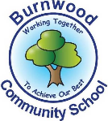
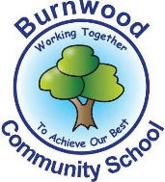
Year 1 Home Learning Week Beginning Monday 6th April
Theme: Where in the World

Literacy
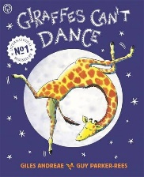
Reading:
This week our story focus is… Giraffes Can’t Dance!
To listen to the story follow this link:
https://www.youtube.com/watch?v=vZjsLK5vwNU

- Think of how Gerald felt at different times in the story – what made him happy? Compare to how you are feeling now we are not in school.

Other stories to read: (search on YouTube if you don’t have a copy)
Walking Through the Jungle (Barefoot Books song), The Selfish Crocodile, Giraffe On A Bicycle, Why Giraffes Have Long Necks, Abigail by Catherine Rayner.

Writing:
- Think of 5 things you are good at and 5 things you would like to get better at then write them in 2 lists.
- Draw a giraffe and then label it.
- Write sentences using adjectives to describe his body parts e.g. He has got a long neck.

Maths
Songs and videos for a starter/maths warm up:

Count to 100: https://www.youtube.com/watch?v=bGetqbqDVaA
Counting in 2s: https://www.youtube.com/watch?v=GvTcpfSnOMQ
Counting in 5s: https://www.youtube.com/watch?v=EemjeA2Djjw
Counting in 10s: https://www.youtube.com/watch?v=Ftati8iGQcs
Number bonds: https://www.youtube.com/watch?v=lD9tjBUiXs0
2D Shape song: https://www.youtube.com/watch?v=WTeqUejf3D0
3D Shape song: https://www.youtube.com/watch?v=2cg-Uc556-Q

This week our maths focus is: height / measure

Can your child…
- compare the height of two objects e.g their scooter and a door (repeat using other available objects), using the language tall, tallest, short, shorter, shortest etc. correctly?
- line up family members in order of height from the shortest to the tallest? Discuss – who is taller than or shorter than whom etc.

- draw around themselves on a roll of wallpaper or similar, cut it out and then use it to find objects taller or shorter. Then starting at the bottom – count how many hands tall you are by measuring hand to hand until you get to the top of your head.
- watch the Sesame Street clip https://www.youtube.com/watch?v=oqWvhs4uzPc

If you complete these tasks, there are plenty of other links and games on the Year 1 class page.
Science
- We have been learning about the difference between amphibians and reptiles.
(amphibians lay eggs in water and have wet skin, reptiles lay eggs on land and have dry, scaly skin) Can you draw and label an amphibian and a reptile?

- We have been learning about rainforests and hot places. Can you use the internet or books to research animals that live in rainforests? Write a factfile about those animals. Which animal group do they belong to? (mammal, bird, fish, reptile, amphibian)

Topic
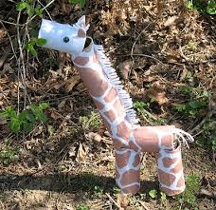
- Use available recycling boxes / tubes etc. to make your own giraffe. If you have paints or pens you could decorate it too. Remember – stay safe & wash your hands afterwards. Only use clean boxes from your own house!

- Have a dancing competition with your family or your toy animals.

PE: Please also try to enjoy some daily exercise (remember Joe Wicks is doing PE videos every morning!).

Don’t worry if you can’t complete all these activities, the most important thing is for you to stay safe and have fun learning at home.

We hope to see you very soon,

Mrs Lowell, Mrs Ellis, Mrs Reynolds and Mrs Fox

