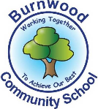
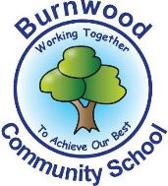
Year 1 Home Learning Week Beginning Monday 20th April
Theme: Where in the World?

Literacy
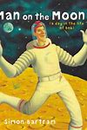
Reading:
This week our story focus is…Man on the Moon!
To listen to the story, follow this link:
https://youtu.be/Rt5zQ1UO6rE

- Think of how busy a day in the life of Bob is. Can you remember the daily tasks that Bob has to do on the moon? Have you been busy during your time at home? What jobs could you do to help around your home?

Other stories to read: (search on YouTube if you don’t have a copy)
Bob’s Best Ever Friend by Simon Bartram
The Smeds and the Smoos (read by David Schwimmer on Cbeebies Bedtime Stories)
Space Song Rocket Ride (Barefoot Books)

Writing:
- Design a poster to encourage those pesky aliens to keep the moon tidy.
- Plan what you would like to put in your lunchbox if you were the man or woman on the moon and help to prepare it.
- Draw a rocket and then label it.

Maths
Songs and videos for a starter/maths warm up:

Count to 100: https://www.youtube.com/watch?v=bGetqbqDVaA
Counting in 2s: https://www.youtube.com/watch?v=GvTcpfSnOMQ
Counting in 5s: https://www.youtube.com/watch?v=EemjeA2Djjw
Counting in 10s: https://www.youtube.com/watch?v=Ftati8iGQcs
Number bonds: https://www.youtube.com/watch?v=lD9tjBUiXs0
2D Shape song: https://www.youtube.com/watch?v=WTeqUejf3D0
3D Shape song: https://www.youtube.com/watch?v=2cg-Uc556-Q

This week our maths focus is: Time and Place Value (ordering numbers)

Can your child…
- tell the time to the hour and half past the hour? Make a daily timetable to encourage this.
- draw hands on clock faces to make a space travel schedule (ready for some imaginative play around the house or in the garden)? E.g. at 9 o’clock arrive on the Moon, at half past 10 set off for Mars, at 12 o’clock have space sandwiches and Jupiter juice for lunch…
-say the days of the week and practise writing them to make a weekly plan of ‘Space and Time’ activities?
-say the months of the year and practise writing them to make a birthday list for family and friends?
- draw 10 or 20 planets and give each one a number from 1, cut them out and put them around the house or garden, then visit each planet in the right order with a space travelling toy or a cut-out rocket?
- be a mission control officer and count down from ten to zero (lift off!) as different toys zoom into space in their cardboard box rockets?

- follow a recipe to make Space Rock Cakes (see Rainy Day Mum website) and set a timer for how long they take to bake?

If you complete these tasks, there are plenty of other links and games on the Year 1 class page.
Science
- We have been learning about everyday materials such as wood, metal, plastic, glass and fabric. What materials might be used to make a real rocket? What might an astronaut’s suit be made from?
Can you make a rocket and an astronaut suit for one of your toys to pretend to visit the moon in? What materials do you have around your house that you could use? Do you want the rocket to be heavy or light? Do you want the astronaut suit to be warm (insulating)? Does your rocket and astronaut suit need to be waterproof? If so, which materials could you use? Do you want your rocket to be shiny or dull? Which materials could you decorate it with?
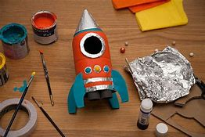

Topic
- Find out about Apollo 11, the first moon landing and watch real footage on YouTube.
- Think of three questions you would ask Neil Armstrong, the first person to step onto the moon.
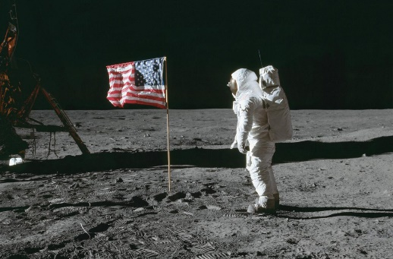

PE: Please also try to enjoy some daily exercise (remember Joe Wicks is doing PE videos every morning!).

- Bob is often left ‘out of puff’ after entertaining the tourists. Can you make some super shapes and bouncy movements that you could do on the moon? How many high moon jumps can you do?

Don’t worry if you can’t complete all these activities, the most important thing is for you to stay safe and have fun learning at home.

We hope to see you very soon,

Mrs Lowell, Mrs Ellis, Mrs Reynolds and Mrs Fox

