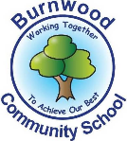
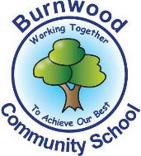
Year 1 Home Learning Week Beginning Monday 27th April
Theme: Ocean Adventures

Literacy
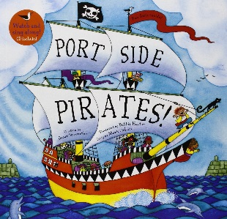
Reading:
This week our song focus is… Portside Pirates!
Follow this link to learn the song:
https://www.youtube.com/watch?v=_qAngsMJD3I

- Learn the song and put some actions to it!

Other stories to read: This week we are looking at pirate poems! Read the poems on our class page, discuss them with your family and say which is your favourite and why.

Writing:
- Make your own pirate word bank to help you with your writing. Write a list of words linked to pirates and ask an adult to help you to spell them correctly. You could draw pictures next to the words to help you to remember them.
- Write your own pirate poem. You could do an acrostic poem, where each line begins with a letter from the word ‘pirate’. Use your word bank to help you to write it.

Maths
Songs and videos for a starter/maths warm up:

Count to 100: https://www.youtube.com/watch?v=bGetqbqDVaA
Counting in 2s: https://www.youtube.com/watch?v=GvTcpfSnOMQ
Counting in 5s: https://www.youtube.com/watch?v=EemjeA2Djjw
Counting in 10s: https://www.youtube.com/watch?v=Ftati8iGQcs
Number bonds: https://www.youtube.com/watch?v=lD9tjBUiXs0
2D Shape song: https://www.youtube.com/watch?v=WTeqUejf3D0
3D Shape song: https://www.youtube.com/watch?v=2cg-Uc556-Q

This week our maths focus is: sharing and dividing into groups

- Ask your child what they know about sharing, what does sharing look like? Can they show you how they can share their toys/food/crayons with you? Encourage your child to say ‘One for me, one for you etc.’
- Now you know what sharing means to your child, discuss the meaning of the words ‘sharing’, ‘groups’ and ‘equal’. Explain to your child that sharing is making groups of objects, those groups need to equal.
- Introduce the concept of sharing into groups by watching the Numberblocks clip ‘Lair of shares’ https://www.youtube.com/watch?v=ES9k0VUlObU on YouTube. Discuss the groups being equal, can your child say it as a sentence e.g. ‘There are 3 equal groups of 5 shells.’

- The pirates have found some treasure, they need to share it equally so that they do not fight over it. Use coins or other available resources to show these number sentences:
6 coins shared by 2 pirates
10 coins shared by 5 pirates
15 coins shared by 3 pirates
18 coins shared by 2 pirates
21 coins shared by 7 pirates
Can you think of your own? Can you complete the sentence ‘There are __ groups of __’?

If you complete these tasks, there are plenty of other links and games on the Year 1 class page.
Science
This week’s science Big Question is:

Which season should the pirates go sailing in?

- Watch the video ‘The Great British Year- Four Seasons BBC Teach’ on YouTube. https://www.youtube.com/watch?v=VYpGBtR8Lbs discuss the changes that occur.
- Using paper or a drawing app, divide it into 4 rectangles. Write the names of the four seasons, one in each rectangle. Discuss the seasons and what they make you think of. Draw or write the types of weather we would experience in each season. Can some types of weather go in more than one season?
- Draw a pirate ship sailing on the sea. Draw the weather that you think would be best to sail in. Write some sentences about the season you have chosen to sail in and why.

Topic
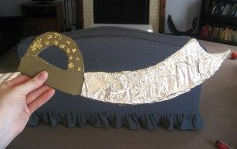
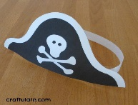
- Now the pirates have taken over the house we need some pirate rules! Write some fun pirate rules for your household, what would pirates think were important rules?
- We need to dress like a pirate too! Make your own pirate costume, you could make a hat using paper/card or a sword using tinfoil.

PE: Please also try to enjoy some daily exercise (remember Joe Wicks is doing PE videos every morning!).

Don’t worry if you can’t complete all these activities, the most important thing is for you to stay safe and have fun learning at home.

We hope to see you very soon,
Mrs Lowell, Mrs Ellis, Mrs Reynolds and Mrs Fox

