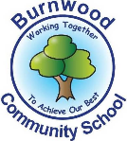
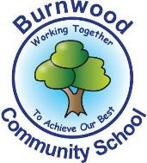
Year 1 Home Learning Week Beginning Monday 4th May
Theme: Ocean Adventures

Literacy
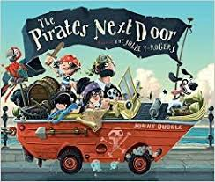
Reading:
This week our story focus is… The Pirates Next Door!
Follow this link to listen to the story:
https://www.youtube.com/watch?v=3LSJWKHoXDw
- Listen to the story. Then talk about the characters – is your favourite the same as your mum’s or family’s? Say why you like your character.

Other stories to read: Try out the couple of story links here-
https://www.youtube.com/watch?v=R8bl8WyLOuQ
https://www.youtube.com/watch?v=y4m_BW5yddU

Writing:
- Make your own pirate word bank to help you with your writing. Write a list of words to describe pirates or what they like to do or what they like to eat.
- Draw a pirate – is it like Jim? Or is it like a Captain?
- Write your own “Wanted” poster for your pirate. Base it on the example below.
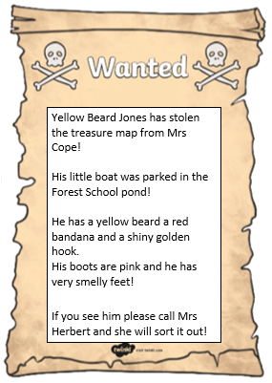
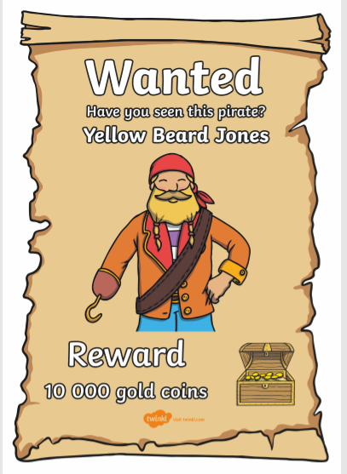

Maths
Songs and videos for a starter/maths warm up:

Count to 100: https://www.youtube.com/watch?v=bGetqbqDVaA
Counting in 2s: https://www.youtube.com/watch?v=GvTcpfSnOMQ
Counting in 5s: https://www.youtube.com/watch?v=EemjeA2Djjw
Counting in 10s: https://www.youtube.com/watch?v=Ftati8iGQcs
Number bonds: https://www.youtube.com/watch?v=lD9tjBUiXs0
2D Shape song: https://www.youtube.com/watch?v=WTeqUejf3D0
3D Shape song: https://www.youtube.com/watch?v=2cg-Uc556-Q

This week our maths focus is: position and direction

This video might give ideas on the kinds of words / activities needed for position and direction. You can watch it yourself (for ideas) or together with your child. https://www.youtube.com/watch?v=aZw59uKfvCM

Watch the position song - https://www.youtube.com/watch?v=XfLjhLiR-mA
- Check out which directional words your child understands – can they take 2 steps forward, 3 steps to the left, 5 steps backwards. Can they do a full turn / half a turn?
- Make up little routines for your child to follow e.g Take 9 steps forward, then turn to the left and take 5 steps backwards, then do a full turn and take 2 steps forwards. Can they make up their own routine to get a toy from one place to some “treasure”?
- Play hiding a toy or some treasure in different places then take turns to give positional clues to find it e.g. “The coins are on the third stair up under a book”.

If you complete these tasks, there are plenty of other links and games on the Year 1 class page.
Science
This week’s science Big Question is:

What is my treasure like?

- Watch the video Year 1 Science - An introduction to the Science topic 'Everyday Materials'. https://www.youtube.com/watch?v=XnkQcP-RHCw
- Collect a range of treasure items from around your home and garden (about 12 would be best)
- Can you sort them into different groups e.g. a set of shiny treasure or a set of squashy treasure. Label your sets. Can you guess why your helper has sorted their treasure in a particular way? Have you got more hard objects or more soft?
- Name and label the materials that your treasure is made from?
Topic
- Now that you understand position and direction words, can you make a treasure map to replace the one that has been stolen from Mrs Cope?
Include trees, a beach, a volcano, maybe a river or mountains. You could even make it look old by staining it with an old tea bag.
Can you mark the treasure off on the map?
- Can you draw a compass on your map? What is a compass? What does it tell you? How do you use one?
Geography – look at the map of the British Isles – can you name the countries? The capital cites? The seas that surround us? Where is Stoke On Trent?

https://12ee0b5a-abb3-9812-7a54-6dc8dc507f17.filesusr.com/ugd/5cd6ef_80d13dc1963b41a8943cd62e2bd93b77.pdf

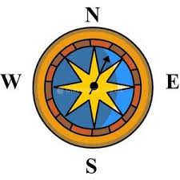
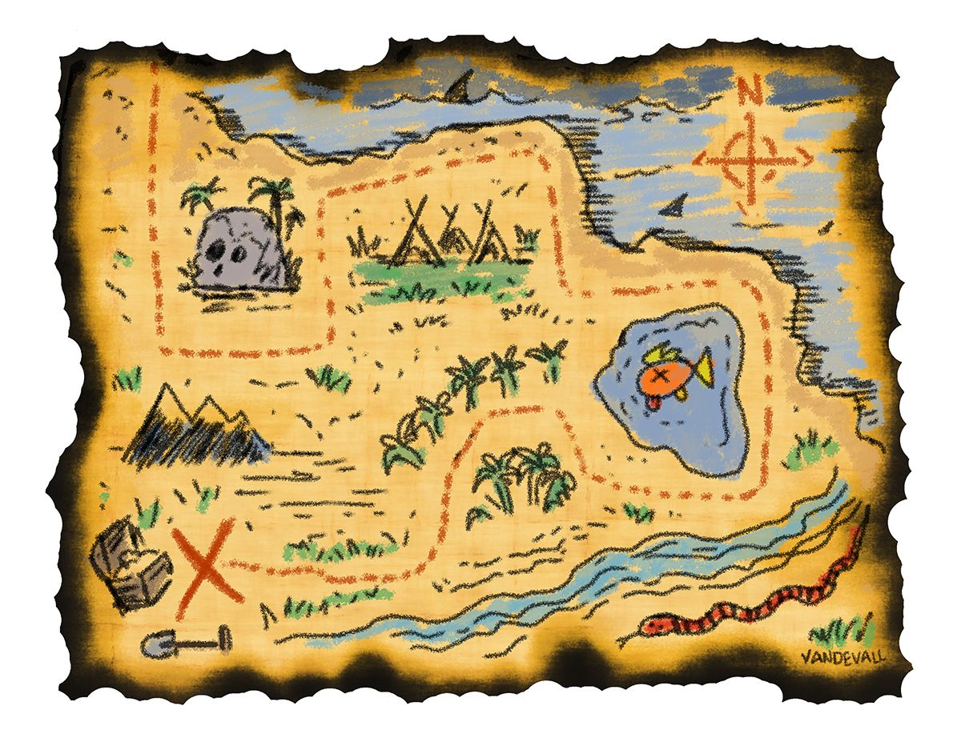

PE: Please also try to enjoy some daily exercise (remember Joe Wicks is doing PE videos every morning!).

Don’t worry if you can’t complete all these activities, the most important thing is for you to stay safe and have fun learning at home.

We hope to see you very soon,
Mrs Lowell, Mrs Ellis, Mrs Reynolds and Mrs Fox

