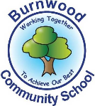
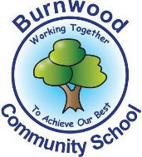
Year 1 Home Learning Week Beginning Monday 11th May
Theme: Pirates

Literacy
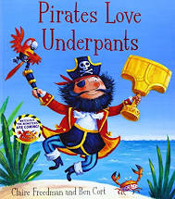
Reading:
This week our story focus is… Pirates Love Underpants
To listen to the story follow this link:
https://www.youtube.com/watch?v=Vd8_Y1bEzA8

Other stories to read:
Goodnight Pirate https://www.youtube.com/watch?v=4um3J66t8gI
Penguins Make Bad Pirates https://www.youtube.com/watch?v=usMEVqz4CrU

Writing:
Can you spot the exclamation marks in the story? Can you write some of them?
Hooray! We’ve found Big Knickers Bay!
Can you describe the different places they visited?
(ocean, beaach, swamp)
Choose a pair of under pants from the story.
Can you write questions using a question mark? Which is your favourite pair? Why? Can you desribe them in a sentence?
I like the green and blue strippy pants because they are bright.
(spotty, stripy, frilly, massive, long)
Maths
Songs and videos for a starter/maths warm up:
Number bonds: https://www.youtube.com/watch?v=lD9tjBUiXs0

This week our maths focus is: Fractions- Shapes and Amounts

Can your child…
- cut their apple/pizza in half? quarters?
Find objects to draw round in the house- i.e a tin of bean and draw round it then a line down the middle to make half and then a quarter. Find other shapes around your house.
Make a collage pizza and cut it into fractions.

Count out sweets, grapes, dried pasta, leaves, coins etc
Find half of 2,4,6,8,10,12,14 sharing into two equal groups or with two people
Find a quarter of 4,8,12,16, sharing into four equal groups

White Rose Maths
You could look at White Rose Maths
Summer Term Week 1 Lesson 2 and 3 Grouping and lesson 4 Find half.
There are videos and worksheets to look at/ complete.
https://whiterosemaths.com/homelearning/year-1/

If you complete these tasks, there are plenty of other links and games on the Year 1 class page.
Science
Boat Experiment
Thinking about the materials you looked at last week, which material would be best for a boat? You could try making a boat out of tin foil or an old yogurt pot, sponge, paper or part of an egg box.
Make boats out of different materials and test them in your bath or sink. Which was the best one? Why? What material was best?

Topic
-Write/make a treasure trail around your garden, give directions to the treasure; forwards 3 steps backwards, turn left or right, look under the stone or behind the tree, over, next to.
-Create your own pair of underpants using either- paint, collage, chalk or on the computer.
-Make a Healthy snack for your family-you could make boat using an apple and cheese. How many boats did you get out of one apple?
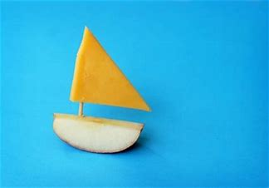

PE: Please also try to enjoy some daily exercise Zumba kids and Go noodle have lots of ideas online.

Don’t worry if you can’t complete all these activities, the most important thing is for you to stay safe and have fun learning at home.

We hope to see you very soon,
Mrs Lowell, Mrs Ellis, Mrs Reynolds and Mrs Fox

