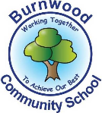
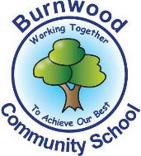
Year 1 Home Learning Week Beginning Monday 18th May
Theme: Pirates

Literacy
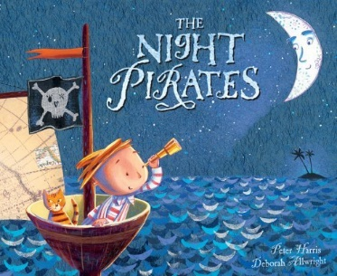
Reading:
This week our story focus is…The Night Pirates!
To listen to the story, follow this link:
https://youtu.be/KnVP6iBAvHg

- Can you remember which parts of the story were quiet and which parts of the story were noisy? What did the girl pirates do when they were being quiet? What did they do when they were being noisy? Can you think of times when you are quiet and when you are noisy?

Other stories to read: (search on YouTube if you don’t have a copy)
Blackbeard the Pirate https://youtu.be/vjMgssGTWYM
The Pirate Cruncher by Jonny Duddle https://youtu.be/0rJ6PBPa45M

Writing:
- What do the girl pirates, Captain Patch and the grown-up pirates wear? Draw a pirate of your own and label its pirate accessories such as hat, eye patch, bandana, belt, buckle, boots, sword, telescope and parrot.

Maths
Songs and videos for a starter/maths warm up:

Count to 100: https://www.youtube.com/watch?v=bGetqbqDVaA
Counting in 2s: https://www.youtube.com/watch?v=GvTcpfSnOMQ
Counting in 5s: https://www.youtube.com/watch?v=EemjeA2Djjw
Counting in 10s: https://www.youtube.com/watch?v=Ftati8iGQcs
Number bonds: https://www.youtube.com/watch?v=lD9tjBUiXs0
2D Shape song: https://www.youtube.com/watch?v=WTeqUejf3D0
3D Shape song: https://www.youtube.com/watch?v=2cg-Uc556-Q

This week our maths focus is: Addition with Money (2p, 5p and 10p coins)

Can your child…
- practise counting in twos, fives and tens, This will help you when you are counting your pirate coins.
- ask a grown up to hide some real or pretend (made with paper or card) 2p, 5p and 10p coins in different parts of a room. You can pretend to be a ‘rough, tough little girl or boy pirate captain’ and sail the seven seas to find the treasure. (You can ask family members or use some of your toys to be your pirate crew.)
- remember the Portside Pirates song from a few weeks ago? Watch it again if you’d like to. Pretend to be the captain counting your coins in his or her cabin just like in the song.
-write down or draw around your coins on a folded piece of paper (your captain’s log book) -how many 2p coins have you found? What is the total?
-how many 5p coins have you found? What is the total?
-how many 10p coins have you found? What is the total?
-what is the total amount of all your coins?
-share your coins evenly so that everyone in your pirate crew gets a fair share of the treasure.
-how much money did each pirate in your crew get?

If you complete these tasks, there are plenty of other links and games on the Year 1 class page.
Science
- Find out how pirate ships moved before engines and motors had been invented.
-Can you make a pirate’s sailboat similar to the one below using materials that are available in your home?
Explore the question: Will the sailboat go further in stronger wind?
-Have fun having sailboat races with a family member using a water container for the sea, such as a washing up bowl, paddling pool or even the bath. How can you make your sea stormy?
-What do you notice about the sea when you make a strong wind? How does the boat move in windy weather?
-What do you notice about the sea when there is no wind? Does the boat move in calm weather?
-Revisit the first question? Will a sailboat go further in stronger wind?
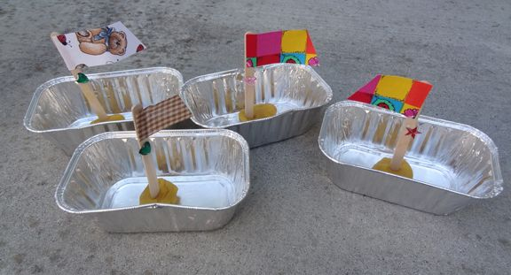

Topic
- Find out about two famous pirates from long ago: Anne Bonny and Blackbeard.
-Here is a useful Youtube link to find out lots of information about Anne Bonny: https://youtu.be/qSRrPqpWLzM
-Here is a useful Youtube link to find out lots of information about Blackbeard: https://youtu.be/vjMgssGTWYM

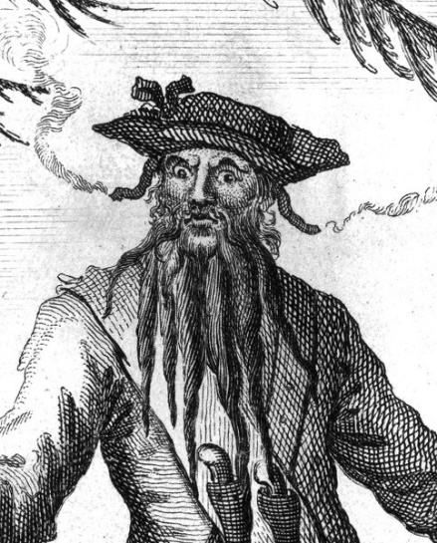
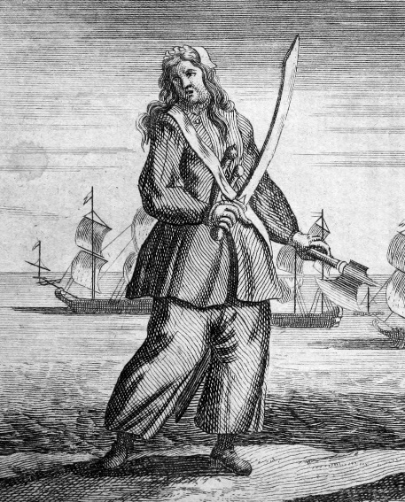

Do you know which bird is often a pirate’s pet? Draw around your hands and a foot to make a parrot like the ones below.



PE: Please also try to enjoy some daily exercise (remember Joe Wicks is doing PE videos every morning!).

- Have fun dancing to some pirate music such as the Pirates of the Caribbean theme tune. Can you do some pirate actions such as climbing the rigging, steering the helm (ship’s wheel) and looking for land in the distance.

Don’t worry if you can’t complete all these activities, the most important thing is for you to stay safe and have fun learning at home.

We hope to see you very soon,

Mrs Lowell, Mrs Ellis, Mrs Reynolds and Mrs Fox

