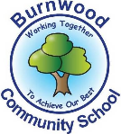
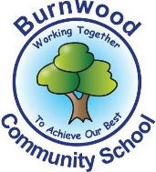
Year 1 Home Learning Week Beginning Monday 1st June
Theme: Ocean Adventures

Literacy
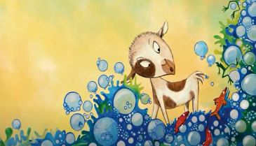
Reading:
This week our story focus is…The Bubble Mystery
To listen to the story, follow this link:
https://www.youtube.com/watch?v=zV203lxqPz8

- What kind of animal is Toot-Toot? Why was she scared of the water? What is a mystery? What was the solution? Why didn’t Toot-Toot tell his sister?

Other stories to read: (search on YouTube if you don’t have a copy)
Bubble Trouble https://www.youtube.com/watch?v=WPTcmVGhDTc

Phonics:
Mrs Ellis’ group: Choose your favourite Phase 5 games on Phonicsplay to revise the sounds.
Mrs Reynolds’ group: Choose your favourite Phase 4 and 5 games on Phonicsplay to revise the sounds.
Mrs Lowell’s group: Choose your favourite Phase 3 games on Phonicsplay to revise the sounds.

Writing:
- Imagine you were floating away in a bubble. How did you get there? Where would you go? What might happen? How would you get out?
- Draw yourself inside a bubble. Write a caption for your picture.

Maths
Songs and videos for a starter/maths warm up:
2D Shape song: https://www.youtube.com/watch?v=WTeqUejf3D0
3D Shape song: https://www.youtube.com/watch?v=2cg-Uc556-Q

This week our maths focus is: Position and direction

Turns: quarter turn, half turn, whole turn.
- Using your body, can you complete these turns? Can you instruct others to complete the turns?
- Using a toy or plastic shape, lying it flat on the floor or table, can you complete these turns?
- Complete the sentence to describe these turns-

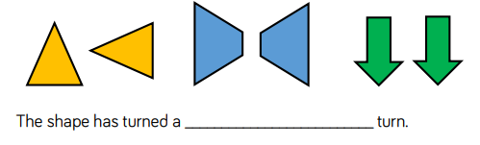

Position: left, right, forwards, backwards.
- Play a game, such as Snakes and Ladders or Twister, to explore the language of position.
- What different directions can we move in? How would I get to the…? How would I get to … from the …?
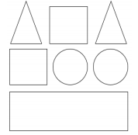
- Find a selection of coins and place them in a line. Can you describe their position?
E.g. the £1 coin is to the left of the 10p coin.
- Draw some shapes and use instructions to colour them.
E.g. The circle to the right of the square is green.
The triangle up from the square is blue.

If you complete these tasks, there are plenty of other links and games on the Year 1 class page.
Science
Which wand will make the biggest bubble? Best bubble?
Make wands
1. Use a straw and feed string through.
2. A plastic cup with the bottom cut out.
3. A wire coat hanger.
4. Half a plastic bottle.
Bubble Mixture Ideas
1. Warm water, washing up liquid and sugar or glycerine
2. 2 cups water, 1 tablespoon vegetable oil, 4 tablespoons dish washing liquid

Topic
Get arty with bubbles!
- Paint a piece of paper and blow bubbles using a wand onto it before it dries.
- Mix food colouring and water in a pot or bowl and blow bubbles using a straw. Lay a piece of paper over the top to print the bubbles onto it.
- Paint some bubble wrap and print the pattern onto some paper.
- Use your bubble paintings to make a picture.

PE: Please also try to enjoy some daily exercise (Joe Wickes PE, Cosmic Kids Yoga).

Don’t worry if you can’t complete all these activities, the most important thing is for you to stay safe and have fun learning at home.
We hope to see you very soon,
Mrs Lowell, Mrs Ellis, Mrs Reynolds and Mrs Fox

