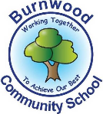
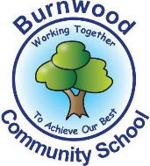
Year 1 Home Learning Week Beginning Monday 8th June
Theme: Under the Sea

Literacy
Phonics:
This week we are focusing on the ai family. Play games on phonicsplay
Mrs Ellis’ group: eigh, a, ei, ea
Mrs Reynolds’ group: ai, ay,a-e, ey
Mrs Lowell group: ai

Reading:
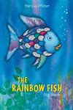
This week our story focus is… The Rainbow Fish
To listen to the story follow this link:
https://www.youtube.com/watch?v=feytIwOzgns

Other stories to read:
Barry The Fish with Fingers
https://www.youtube.com/watch?v=5yQPruodTjM

Writing:
Write a list of words to describe The Rainbow Fish- beautiful, bright, shiny, sparkling
Write sentences to describe the rainbow fish using ‘and’.

Maths
Songs and videos for a starter/maths warm up:
Number bonds: https://www.youtube.com/watch?v=lD9tjBUiXs0

This week our maths focus is: Place Value- numbers to 100
Can your child…
Choose 6 numbers from a pack of cards and make three two digit numbers, can they change the tens and ones around to make a different number? Can they order them from the biggest to smallest and smallest to biggest?
Play Snakes and Ladders- you could make your own game.
Play number bingo.

If you complete these tasks, there are plenty of other links and games on the Year 1 class page.
Science
Types of animals

Ask your child what they know about the animal groups we have already looked at this year- mammals, birds, reptiles and amphibians. Can they name any of each? Look at BBC Bitesize (KS1 Science) for videos about each type.

Watch the video about fish on BBC Bitesize:
https://www.bbc.co.uk/bitesize/topics/z6882hv/articles/zxgq2hv

Complete the quiz on BBC Bitesize about fish.
Make notes from the video- what makes a fish a fish?

Topic
Art
Make a fish using play dough, put sequins etc on.
Listen to some calm sea music – paint/draw a picture to go with the music.
Listen to some stormy sea music– paint/draw a picture to go with the music.

PE: Please also try to enjoy some daily exercise- Zumba kids and Go Noodle have lots of ideas online.

Don’t worry if you can’t complete all these activities, the most important thing is for you to stay safe and have fun learning at home.

We hope to see you very soon,
Mrs Lowell, Mrs Ellis, Mrs Reynolds and Mrs Fox

