

Year 1 Home Learning Week Beginning Monday 15th June
Theme: Under the Sea

Literacy
Phonics:
This week we are focusing on the ee family. Play games on phonicsplay
Mrs Ellis’ group: ee, ea, e-e, ie, y, ey
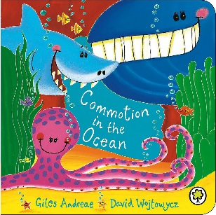
Mrs Reynolds’ group: ee, ea, e-e
Mrs Lowell’s group: ee

Reading:
This week our story focus is…Commotion in the Ocean
To listen to the story, follow this link:
https://www.youtube.com/watch?v=9pRhgZ8Jffs

- What animals did we read about it the story? What is special about this story? Listen to some of it again, can you pick out the words that rhyme?

Other stories to read: (search on YouTube if you don’t have a copy)
https://www.youtube.com/watch?v=2g9-nvBzEIA This is a fun non-fiction book about ocean animals!

Writing:
- Draw some sea creatures (crab, starfish, shark etc.). Around the outside of the picture write some adjectives to describe the animal.
- Use the lists of adjectives to make acrostic poems for the sea creatures.

Maths
Songs and videos for a starter/maths warm up:
2D Shape song: https://www.youtube.com/watch?v=WTeqUejf3D0
3D Shape song: https://www.youtube.com/watch?v=2cg-Uc556-Q

This week our maths focus is: Measurement (Length)

Vocabulary to encourage your child to use: longer, shorter, longest, shortest, same.

- Find some objects from around your house and compare the length. Discuss that length goes across, not up, so the objects must lie flat. Can your child order them by length?
- Use non-standard units of measurement to measure the length of the objects. You could use hands, cubes, pasta twirls, anything that you can find in the house that are the same size. How many pasta twirls long is the pencil? How many pasta twirls long is the book?

- Have a go at making a bar chart of your families favourite sea creatures. Write the creatures across the bottom of the page- starfish, crab, seahorse, dolphin, and shark. Ask as many people as you can (ring your friends and family) which is their favourite and record the results as a bar chart.

If you complete these tasks, there are plenty of other links and games on the Year 1 class page.
Science
Print off or draw some of your favourite sea creatures, write their names.
Sort them into these different groups:
- Mammal or fish
- Fins or no fins
- Legs or no legs
- Can/cannot breathe underwater
Can you think of any other ways of sorting them?
Topic
Design and Technology

- Make a mobile with straws / cotton with several different sea creatures. Attach the creatures that you have drawn, made or printed.

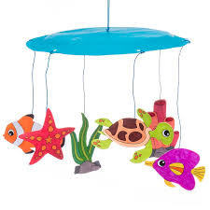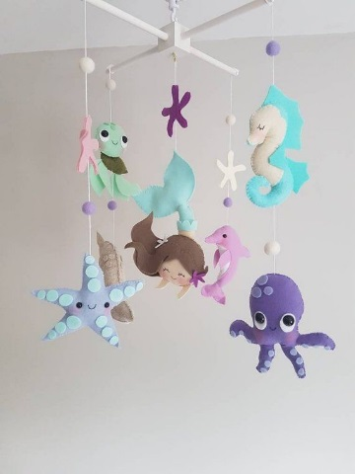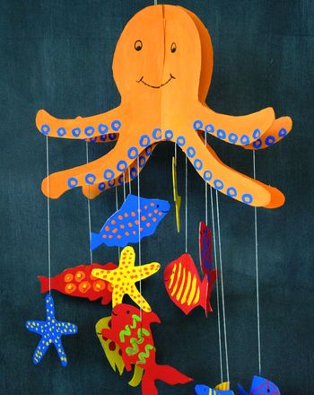

PE: Please also try to enjoy some daily exercise (Joe Wickes PE, Cosmic Kids Yoga, Go Noodle dances).

Don’t worry if you can’t complete all these activities, the most important thing is for you to stay safe and have fun learning at home.

We hope to see you very soon,

Mrs Lowell, Mrs Ellis, Mrs Reynolds and Mrs Fox

