

Year 1 Home Learning Week Beginning Monday …
Theme: Under the Sea

Literacy
Phonics:
This week we are focusing on the ow family. Play games on phonicsplay
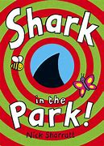
Mrs Ellis’ group: ow, ou
Mrs Reynolds’ group: ow, ou
Mrs Lowell’s group: ow

Reading:
This week our story focus is… Shark in the Park
To listen to the story, follow this link:
https://www.youtube.com/watch?v=Ketu-SWDyD0

Other stories to read: (search on YouTube if you don’t have a copy)
The Fish Who Could Wish
The Shark in the Dark

Comprehension
What things did he think were a shark? What did Timothy Pope shout each time? Why did he think they were a shark? Would you see a shark in a park? What else did he see?
Can you spot some of the rhyming words in the story- no, crow, might, sight, say, today, ground, around

Writing:
Find these words- boy, shark, park, toy, cat, crow, hair Can you spell them?
Write sentences- Timothy Pope saw a huge, black crow in the park and a man with pointy hair. Or write There was a ….
Pause the video at different points, write a list of other things you can see in the pictures- a girl, ducks, a baby etc.
Pause the video and the cover it, can you draw what is in the picture?

Maths
Songs and videos for a starter/maths warm up:
Count to 100: https://www.youtube.com/watch?v=bGetqbqDVaA
Counting in 2s: https://www.youtube.com/watch?v=GvTcpfSnOMQ
Counting in 5s: https://www.youtube.com/watch?v=EemjeA2Djjw
Counting in 10s: https://www.youtube.com/watch?v=Ftati8iGQcs
Number bonds: https://www.youtube.com/watch?v=lD9tjBUiXs0

This week our maths focus is: Addition and Subtraction
Write and complete these number sentences. Use objects to help you to find the missing number. If your child struggles on a number sentence, do not move on to the next one, give them more examples of that type to work through. (number line at the bottom of the page- could do jumps on a number line)

9 + 5 = __ 14 – 7 = __
11 + 6 = __ 19 – 12 = __
14 + __ = 19 16 - __ = 9
12 + __ = 20 20 - __ = 11
__ + 9 = 15 __ - 4 = 8
11 + 3 = 8 + __ 17 – 6 = __ - 7

If you complete these tasks, there are plenty of other links and games on the Year 1 class page.
Science
Write a fact file about sharks. Use the internet to find out about their:
- Body parts
- Diet
- Habitat
- Interesting Facts

These websites might help you:
https://www.bbc.co.uk/programmes/articles/3PQHSqX4NkFpsCysvfdbf5c/what-makes-a-shark
https://www.sharksider.com/50-amazing-shark-facts/
https://www.coolkidfacts.com/shark-facts-for-kids/
Topic
D.T-Make a telescope- what can you see in the your garden?

Use it to look around your garden.
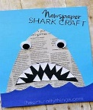
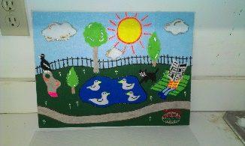
Art-Make a shark picture or collage.

Play Kims Game hide some obects under a tea towel-the leader takes one away child guesses which one is missing.

PE: Please also try to enjoy some daily exercise (Joe Wickes PE, Cosmic Kids Yoga, Go Noodle dances).

Don’t worry if you can’t complete all these activities, the most important thing is for you to stay safe and have fun learning at home.

We hope to see you very soon,

Mrs Lowell, Mrs Ellis, Mrs Reynolds and Mrs Fox



