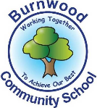
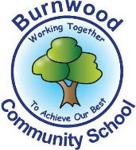
Year 1 Home Learning Week Beginning Monday 6th July
Theme: Under the Sea

Literacy
Phonics:
This week we are focusing on the oo family. Play games on phonicsplay
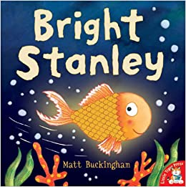
Mrs Ellis’ group: oo, ew, ue, u-e, ui, ou
Mrs Reynolds’ group: oo, ew, ue, u-e
Mrs Lowell’s group: oo

Reading:
This week our story focus is… Bright Stanley
To listen to the story, follow this link:
https://www.youtube.com/watch?v=HnzQr7106KQ

- What happened to Bright Stanley? What made him scared? What made him sad? What made him happy again?

Other stories to read: (search on YouTube if you don’t have a copy)
Barry the Fish with Fingers

Writing:
Get your child pretend for a moment that they are Stanley under the ocean. Ask them to draw a picture of what they see from his perspective. Are there fish and lots of colors? Or is it dark with sharks? Is their coral? Schools of fish? Have them draw in detail what the view looks like. Get them to write sentences to describe what they can see.

Go on a hunt around your house, what bright/shiny things ca you find? pearls, coins, jewels, ring, broach, sequins. Can you describe them?

Maths
Songs and videos for a starter/maths warm up:
Count to 100: https://www.youtube.com/watch?v=bGetqbqDVaA
Counting in 2s: https://www.youtube.com/watch?v=GvTcpfSnOMQ
Counting in 5s: https://www.youtube.com/watch?v=EemjeA2Djjw
Counting in 10s: https://www.youtube.com/watch?v=Ftati8iGQcs
Search for ‘Supermovers’ online and practise the 2, 5 and 10 times tables.

This week our maths focus is: Multiplication

- Use the hundred square at the end of this document to practise counting in 2s, 5s and 10s. Do you notice any patterns in the numbers as you count up? Where are they on the grid? What do they end in?
- Using coins, pasta shapes or counters can you make equal groups of 2? Make 4 groups of 2, count up how many there are altogether (e.g. 2, 4, 6, 8). Make 7 groups of 2. Make 10 groups of 2. Repeat this activity with equal groups of 5s and 10s.
- We have been adding equal groups. Can you record some of them as a number sentence? E.g. 4 groups of 2 is 2 + 2 + 2 + 2 = 8
- Take your equal groups of 2s, 5s and 10s and put them into columns or rows to make an array. Count in 2s, 5s and 10s using the array that you have created.
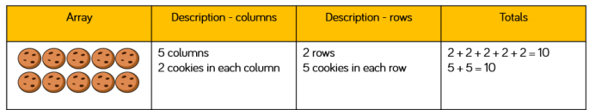

If you complete these tasks, there are plenty of other links and games on the Year 1 class page.
Science
Can you draw and label the parts of an octopus?
Labels to include:
- head - mantle
- suckers - mouth
- eye
(If you have access to a printer there are labelling worksheets online)

Use the internet to answer this question?
Does an octopus have arms, legs or tentacles?

Topic
Talk about litter and how if can hurt animals. Look at clips/ videos of litter in the sea.
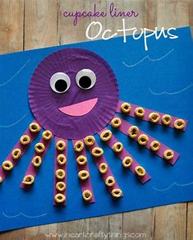
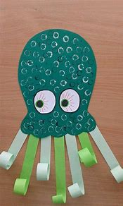
What can be do to help? https://www.youtube.com/watch?v=HQTUWK7CM-Y
Go on a local litter pick- use gloves.

Sea Creature Facts (below)
Answer the questions. Can you think of your own questions.

Octopus crafts.

PE: Please also try to enjoy some daily exercise (Joe Wickes PE, Cosmic Kids Yoga, Go Noodle dances).
Don’t worry if you can’t complete all these activities, the most important thing is for you to stay safe and have fun learning at home.
We hope to see you very soon,
Mrs Lowell, Mrs Ellis, Mrs Reynolds and Mrs Fox


