
Year 5 Home Learning Week Beginning 04/05/20

English |  | Maths
Lesson 1  Reading (30min) Read pages 32-34 of ‘Black Beauty’ https://drive.google.com/file/d/1BPjYBBSrhygwgWWTEu2E_PhDZJf60-SP/view  Spelling (30min) Play on Spelling Shed  https://www.spellingshed.com/en-gb  Lesson 2:  Reading (30min) Read pages 35-37 of ‘Black Beauty’  https://drive.google.com/file/d/1BPjYBBSrhygwgWWTEu2E_PhDZJf60-SP/view  Literacy task (30min)  Use your prior knowledge to complete the sheet attached below on prefixes.  Lesson 3:  Spelling shed (15min) Play on Spelling Shed  https://www.spellingshed.com/en-gb  Literacy task (45min)  Complete the sheet below on active and passive voice. Use the example to help you.  Lesson 4:  Reading (30min) Read pages 38-40 of ‘Black Beauty’  https://drive.google.com/file/d/1BPjYBBSrhygwgWWTEu2E_PhDZJf60-SP/view  Writing (30min) Have a go at writing a non-chronological report on dinosaurs (this links with your history task). Attached below are the key features of a non-chronological report to help you with this!  Lesson 5:  Reading (15 mins) Read page 41 of ‘Black Beauty’  https://drive.google.com/file/d/1BPjYBBSrhygwgWWTEu2E_PhDZJf60-SP/view  Writing/ handwriting (30min) Write your non-chronological report up in your very best cursive handwriting. Once you have edited and improved it, read it out to someone in your house hold. Remember to use expression in your voice when reading out loud. |  | Follow the link to complete the daily maths tasks. There are videos that you can follow to help you with how to complete each days learning.  https://whiterosemaths.com/homelearning/year-5/  Don’t forget to complete times table rock starts (15 minutes Daily). Look out for further challenges!  
Science | History |  | Art
Record in the table attached below how long it takes different types of leaves to fall to the ground. Repeat each test three times to ensure a fair test. Think about your variables before you start.  Controlled variable: Everything you want to remain the same during the experiment.  Independent variable: The thing that you change in the experiment.  Dependent variable: The change that happens because of the independent variable.  Conclusion: What leaf fell to the ground the quickest? What affected the rate at which the leaf fell? | This week, we are going way back in time- around 65 million years ago!  Research five dinosaurs of your choice and create a model of your favourite one!  To do this you might want to use card, plastic bottles, newspaper, cardboard, toilet roll rolls or anything else that you can think of!  Good luck and have a roarsome time!  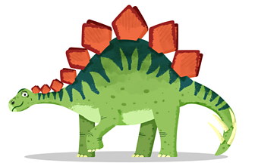 |  | Competition time!!  Show your support and design your very own external banner, thanking the NHS and other key workers for their dedication! 5 Winners will have their design recreated and produced to proudly display on your school gates!  To find out more, see the image attached below under art resources!
PE  Follow these links to take part in these fun and exciting at home PE activities.  Introduction:  https://www.youtube.com/watch?v=o0PH0Z88SMs  Activity 1:  https://www.youtube.com/watch?v=_JlpNSOp8x8 | PSHE  Can you create your family tree? Use the resources that are attached below to create a family tree. This is a tree that is all about your family. If you want to be really creative, why not draw and paint your own tree and leaves!  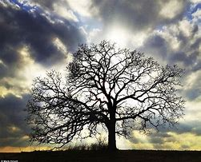 |  | Design and Technology  Task 1- Use the link below to bake a delicious lemon drizzle cake to share with your family!  https://www.bbcgoodfood.com/recipes/lemon-drizzle-cake    Task 2- Write down the recipe with step by step instructions so that you can bake it again and again whenever you fancy!
Geography  Have a go at drawing a map of the area in which you live. Try to add in street names and features such as bus stops, canals, churches etc. Draw symbols for these on your map and create a key. A worksheet is attached below under geography resource. | Music  Listen to this song on YouTube and answer the following questions.  https://www.youtube.com/watch?v=3BeKhlUzPUc  What is the song called?  What instrument can you hear?  How does the song make you feel and why? |  | Computing  Have a go at creating a project on Scratch or ScratchJr, whichever you feel more comfortable with!  

English resources-
Lesson 2- LO: To add the prefixes dis, de, mis, over and re to verbs
Change the verb to a prefix by adding dis, de, mis, over or re
Example:
Amy disabled the software on her computer.

- As the windows didn’t fit into the building, the builders had to align their plans.
misalign/ disalign/ dealign/ overalign/ realign

- The waiter heard the gentleman on the telephone.
disheard/ misheard/ overheard/ reheard/ deheard

- Because the prize was not substantial, the players felt motivated.
demotivated/ overmotivated/ remotivated/ dismotivated/ mismotivated

- At the Grand National, the horse judged the fence.
overjudged/ disjudged/ misjudged/ rejudged/ dejudged

- As the white van was approaching a sharp bend, it dangerously took the car.
retook/ detook/ mistook/ distook/ overtook

- Once the MI6 agents had returned from their mission, they were briefed.
disbriefed/ misbriefed/ debriefed/ overbriefed/ rebriefed

- I calculated how much petrol I would need, meaning that I had to refuel.
overcalculated/ miscalculated/ decalculated/ recalculated/ discalculated

- Jessica’s decision to turn to ballet was a successful one as she now dances at The Royal Ballet School in London.
return/ disturn/ misturn/ deturn/ overturn

- Kyle was frustrated with himself as he cooked the steak.
discooked/ recooked/ decooked/ overcooked/

- In order to protect the environment, you should always cycle plastic bottles.
Decycle/ discycle/ recycle/ miscycle/ overcycle

Lesson 3- LO: To accurately use the active and passive voice.
Remember – in active sentences, the subject performs the action to the object. e.g.
In passive sentences, the word order is reversed and the subject changes.
Passive – The ruler was used by the teacher.
Active – The teacher used the ruler.
Change these sentences from the passive voice to the active voice.
1. The door was knocked on by the highwayman.
2. The date and learning objective was written by Gracie.
3. In the garden, a mouse was being chased by a cat.
4. Jack’s book was being marked by Mr Jones.
5. At the concert, songs were performed by the school choir.
6. Photographs of the countryside were taken by Ryan.

Change these sentences from the active voice to the passive voice.
1. Bess shed lots of tears.
2. In the barn, Tim tidied up the hay.
3. A vampire bit the victim.
4. My grandfather built a house in Chell Heath.
5. During the day, Alicia completed a lot of work in her English and Maths books.
6. The bank was robbed by Kenny.

Lesson 4- LO: To identify the key features of a non-chronological report

Heading
This tells the reader what the text is going to be about.

Sub-headings
Sub-headings organise the text into sections so that the reader can find information easily.

Introductory Paragraph
An introduction giving the reader some brief background information about the subject.

Effective Adjectives
Describing words that are used to engage the reader.

Factual Information
True information, not someone’s opinion. Dates, times, statistics and facts are used.

Effective Punctuation
Punctuation is used to make the writing more interesting to read and emphasise certain points.
Art resource
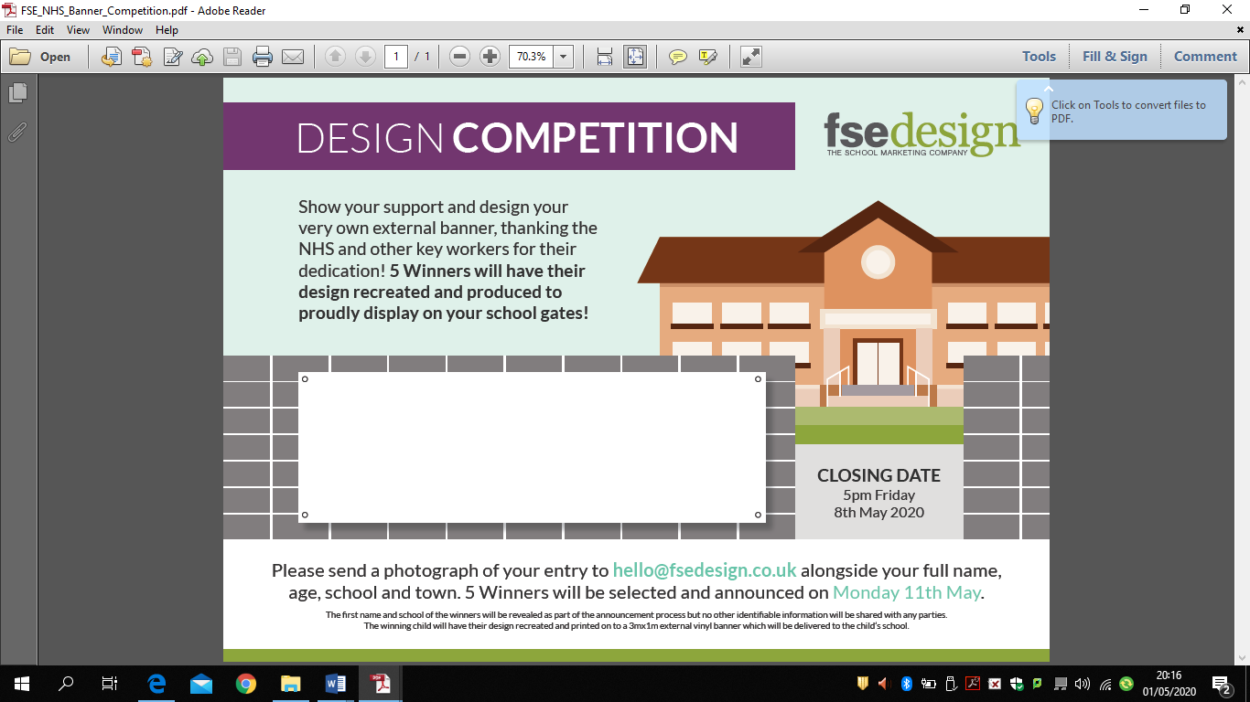
PSHE resources
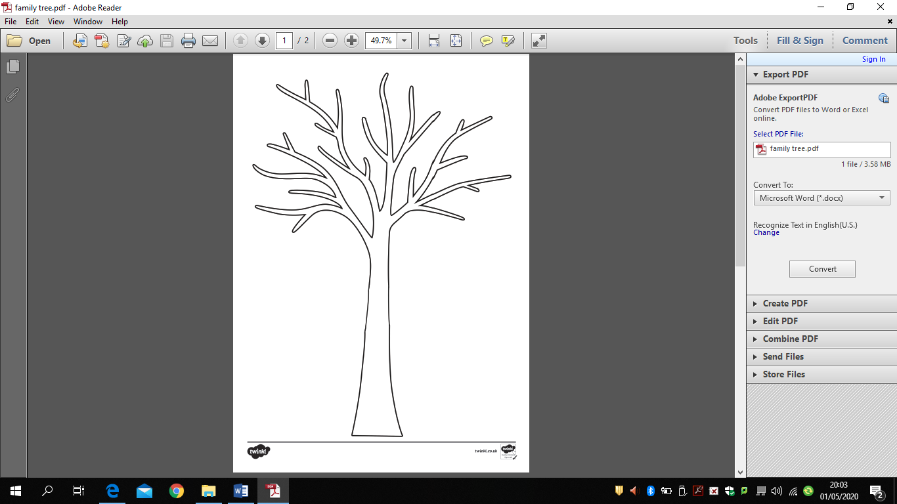
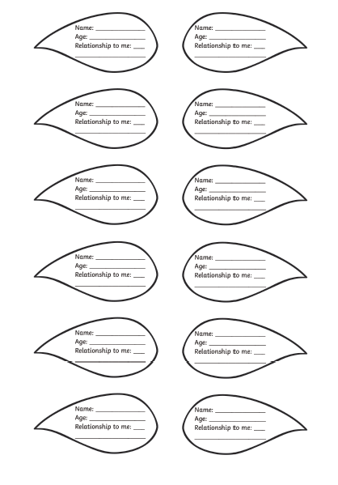
Geography resource
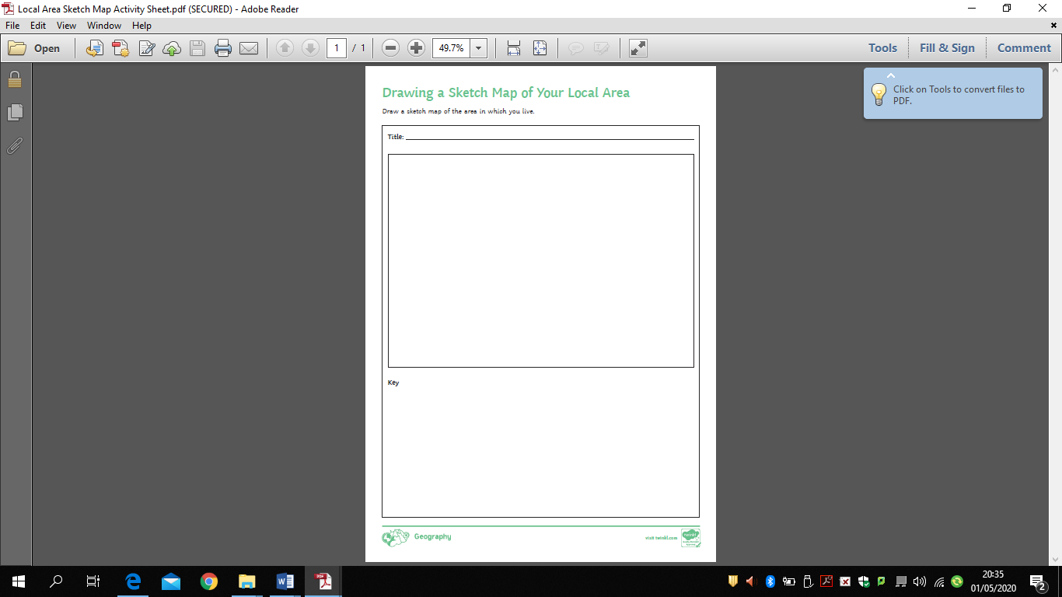
Science resource

Type of leaf | Test 1 (seconds) | Test 2 (seconds) | Test 3 (seconds)

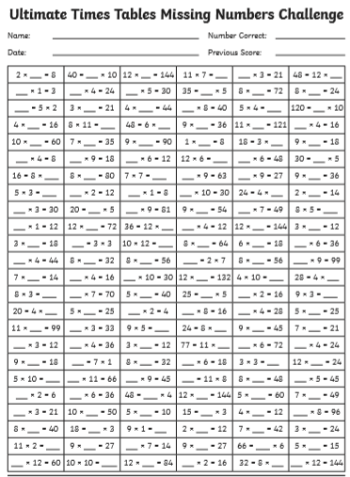
Additional Maths Resources.



