Monday | Tuesday | Wednesday | Thursday | Friday
Segmenting blending phase 2 sounds | Segmenting blending phase 2 sounds | Segmenting blending phase 2 sounds | Segmenting blending phase 2 sounds | Segmenting blending phase 2 sounds
Phonics play https://www.phonicsplay.co.uk  Recap sounds- Flash Card Speed Trial-Phase 2 | Phonics play https://www.phonicsplay.co.uk  Recap sounds- Flash Card Speed Trial-Phase 2 | Phonics play https://www.phonicsplay.co.uk  Recap sounds- Flash Card Speed Trial-Phase 2 | Phonics play https://www.phonicsplay.co.uk  Recap sounds- Flash Card Speed Trial-Phase 2 | Play the tricky word songs  https://www.youtube.com/watch?v=TvMyssfAUx0  https://www.youtube.com/watch?v=ri4u0TjAZ38
Phonics play – phase 2  Make a match  Satp inmd  gock | Phonics play – phase 2  Make a match  ckeur | Phonics play – phase 2  Make a match  hbfl ff ll ss | Phonics play – phase 2  Pick a picture | Tricky Words Phase 2 –  Play game on Phonics Play  Tricky Word Trucks
Look at the picture. Write an initial sound, CVC and /or sentence about the picture.  Use the tricky and the pre teach words.   | Look at the picture. Write an initial sound, CVC and /or sentence about the picture. Use the tricky and the pre teach words.   | Look at the picture. Write an initial sound, CVC and /or sentence about the picture. Use the tricky and the pre teach words.   | Look at the picture. Write an initial sound, CVC and /or sentence about the picture. Use the tricky and the pre teach words.   | Matching pairs Write some of tricky words on paper (duplicate).  Put them face down on the table and play the matching pair game.
Phonics play – sentences phase 2 – week 5 - ck | Phonics play – sentences phase 2 – week 5 - e | Phonics play – sentences phase 2 – week 5 - u | Phonics play – sentences phase 2 – week 5 - r | Use an online timer. How many tricky words can you read in a minute?

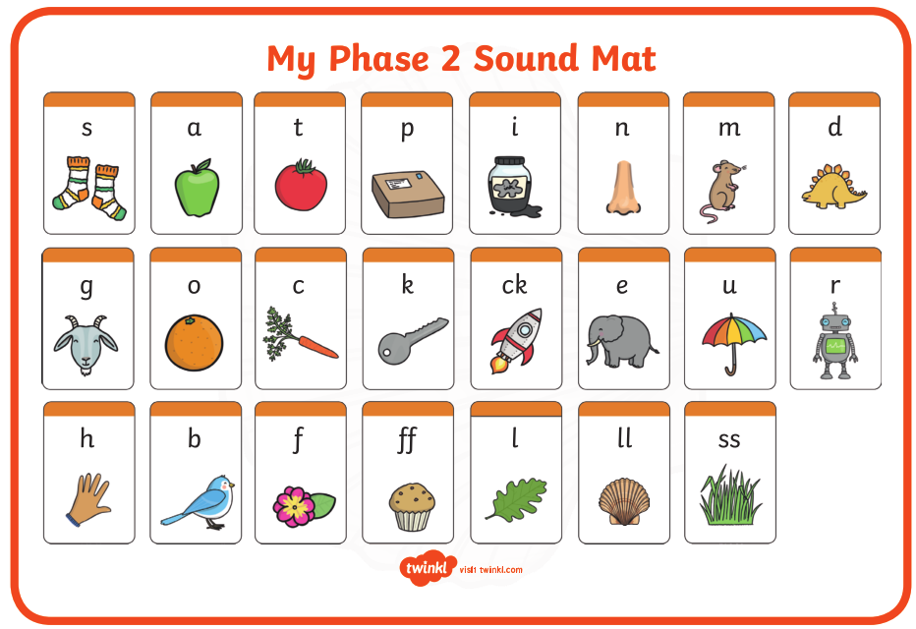

Pre phase 2 words

in | it | is
on | up | of
am | as | us

Phase 2 tricky words

I | no | the
into | go | to
and

Phoneme frames



