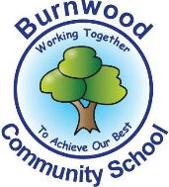
Reception Home Learning Pack – Monday 20th April 2020
Literacy – Once upon a time

Literacy
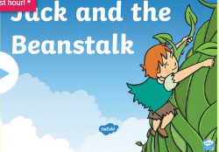
Reading:
This week our story focus is… Jack and the Beanstalk
To read the story follow this link:
https://www.twinkl.co.uk/resource/t-t-5096-jack-and-the-beanstalk-story-powerpoint

Writing:
- Write a list of the items Jack took from the Giant’s castle.
- Draw and label the Giant’s castle.
- If you had some magic beans, what would you wish for?
- Write a few sentences using your phonics to explain why you liked this story.
- Practise writing your name.

Maths
Focus of the week- counting,recognising, ordering and writing numbers to 20.
Watch this episode of numberblocks- https://www.youtube.com/watch?v=5dqGDSOMHRo
You can hop, clap whisper or shout your numbers to 20.
On small pieces of paper write the numbers 0- 20 and see if you can put them in order.
Once you have put them in order, close your eyes and get an adult to remove a number. Can you guess which number it is?
Get some papar and write your numbers to 20 on it. Under each number can you draw an object to represent the amount?
1 2 3

Listen to the 2D Shape song on YouTube- https://www.youtube.com/watch?v=WTeqUejf3D0&t=1s
Can you draw your favourite shapes and write the number of side and corners next to them
Go on a shape hunt around your house, what shapes can you find?
Make a list and draw them.
Topic
We all planted a blub for Mother’s Day, most of us were able to take them home.
Can you draw a pictures of your plant now?
Has it grown?
Is it taller now?
Can you see any flowers?
How have you been looking after it?
Can you remember what it needs? (Sun, warmth, water etc.).
If you didn’t take your blub home, can you see changes in your garden or where you live? You could draw a picture!
Miss Zahoor can see lots of pink blossom on the trees where she lives.
Miss Wedgwood has been growing blubs with her daughter at home.
Mrs Treasure has seen some daffodils in her garden.

PE: Please also try to enjoy some daily exercise (remember Joe Wicks is doing PE videos every morning!).
Also guided mediation and Cosmic Kids Yoga is a great way to have some quiet time.
https://www.youtube.com/watch?v=DWOHcGF1Tmc

https://www.youtube.com/watch?v=xlg052EKMtk

We miss you very much and hope to see you very soon,
Miss Zahoor, Miss Wedgwood and Mrs Treasure.

