Monday | Tuesday | Wednesday | Thursday | Friday
Phonics Focus- ck | Phonics Focus- e | Phonics Focus- u | Phonics Focus- r | Tricky Words
Children - Say the phase 2 sounds that we have learnt in school.  Adult - You can point to them in random order or in the order on the sound mat.  See and use sound mat below  Children – read the phase 2 tricky words and the pre phase 2 words  Adult –show the children a word at a time. Remember the tricky words are sight words and you cannot segment and blend them.  See and use the word lists below | Children - Say the phase 2 sounds that we have learnt in school.  Adult - You can point to them in random order or in the order on the sound mat.  See and use sound mat below  Children – read the phase 2 tricky words and the pre phase 2 words  Adult –show the children a word at a time. Remember the tricky words are sight words and you cannot segment and blend them.  See and use the word lists below | Children - Say the phase 2 sounds that we have learnt in school.  Adult - You can point to them in random order or in the order on the sound mat.  See and use sound mat below  Children – read the phase 2 tricky words and the pre phase 2 words  Adult –show the children a word at a time. Remember the tricky words are sight words and you cannot segment and blend them.  See and use the word lists below | Children - Say the phase 2 sounds that we have learnt in school.  Adult - You can point to them in random order or in the order on the sound mat.  See and use sound mat below  Children – read the phase 2 tricky words and the pre phase 2 words  Adult –show the children a word at a time. Remember the tricky words are sight words and you cannot segment and blend them.  See and use the word lists below | Play the tricky word song-phase 2  Google  Phase 2 tricky word song or use this  https://www.bing.com/search?q=tricky+words+song+phase+2&form=EDNTHT&mkt=en-gb&httpsmsn=1&msnews=1&plvar=0&refig=40eadad2dbc34571a3ab30ad92f94c13&sp=5&qs=SC&pq=tricky+words+sou&sk=PRES1SC3AS1&sc=8-16&cvid=40eadad2dbc34571a3ab30ad92f94c13&cc=GB&setlang=en-US  Children – read the phase 2 tricky words and the pre phase 2 words  Adult –show the children a word at a time. Remember the tricky words are sight words and you cannot segment and blend them.
Watch the video Mr Thorne does phonics sound ‘ck’.  Google  Mr Thorne does phonics episode ck  and or watch  https://www.twinkl.co.uk/resource/t-l-53365-phase-two-phonemes-set-4-ck-video | Watch the video Mr Thorne does phonics sound ‘e’.  Google  Mr Thorne does phonics episode e  and or watch  https://www.twinkl.co.uk/resource/t-l-53366-phase-two-phonemes-set-4-e-video | Watch the video Mr Thorne does phonics sound ‘u’.  Google  Mr Thorne does phonics episode u  and or watch  https://www.twinkl.co.uk/resource/t-l-53368-phase-two-phonemes-set-4-u-video | Watch the video Mr Thorne does phonics sound ‘r’.  Google  Mr Thorne does phonics episode r  and or watch  https://www.twinkl.co.uk/resource/tgv-e-36-phase-two-phonemes-set-4-r-video | Play the game  Tricky Words Phase 2 –  Play game on Phonics Play  Tricky Word Trucks
Write the ck sound on a piece of paper / in the air.  Collect some items beginning with ck.  Children - Segment and blend these words below  Adult - write these words on a piece of paper the children can add sound buttons and segment and blend them.  kick sock sack dock  pick sick pack lick  lock | Write the e sound on a piece of paper / in the air.  Collect some items beginning with e.  Children - Segment and blend these words  Adult - write these words on a piece of paper the children can add sound buttons and segment and blend them.  get pet ten net  pen peg met men  neck  Children could find some of these items as the adult segments the word. | Write the u sound on a piece of paper / in the air.  Collect some items beginning with u.  Children - Segment and blend these words  Adult - write these words on a piece of paper the children can add sound buttons and segment and blend them.  up mum run mug  cup sun tuck mud  neck  The children could match the words to pictures / objects by segmenting and blending the words.  You could use the following but would need to print them.  Google  TWINKL  Phase 2  What’s in the box cards | Write the r sound on a piece of paper / in the air.  Collect some items beginning with r.  Children - Segment and blend these words  Adult - write these words on a piece of paper the children can add sound buttons and segment and blend them.  rim rip ram rat  rag rug rot run  The children could match the words to pictures / objects by segmenting and bending the words.  You could use the following but would need to print them.  Google  TWINKL  Phase 2  What’s in the box cards | Play Tricky word Bingo  Adult  Write all of the phase 2 tricky words on a piece of paper. Say a word one at a time. Children will cross off the word when you say it.
Adult say some / all of these words 1 at a time.  Segment and blend with actions.  kick sock sack dock  pick sick pack lick  lock  When you have said 1 word – ask the child to segment it and write it. Use the phase 2 sound mat to help  Use the actions we use in school when segmenting.  Repeat with the other words.  Children could use the phoneme frame (below) to write the words on if they need to.  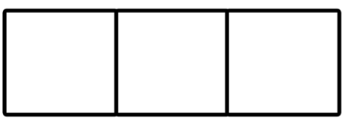  Can the children read this caption?  pack a bag | Adult write these words on a piece of paper 1 at a time.  Children will have a go at segmenting and blending with actions.  get pet ten net  pen peg met men  neck  and / or  play this game online on Phonics Play  Buried Treasure phase 2  + e  Children could have a go at writing these words as the adult segments and blends them.  get pet ten net  pen peg met men  neck  Use the phase 2 sound mat to help  Use a phoneme frame if you need to  Can the children read this caption?  ten big men | Adult segment and blend these words one at a time.  Children try to write each word on a piece of paper.  Use the phase 2 sound mat to help  up mum run mug  cup sun tuck mud  neck  Children could use the phoneme frame to write the words on if they need to.  and / or  play this game online on Phonics Play  Buried Treasure phase 2  +u  Children could have a go at writing these words as the adult segments and blends them.  up mum run mug  cup sun tuck mud  neck  Use the phase 2 sound mat to help  Use a phoneme frame if you need to  Can the children read this caption?  a big mug | Adult say some / all of these words 1 at a time.  Children try to write each word on a piece of paper.  Use the phase 2 sound mat to help  rim rip ram rat  rag rug rot run  Children could use the phoneme frame to write the words on if they need to.  and / or  play this game online on Phonics Play  Buried Treasure phase 2  +r  Children could have a go at writing these words as the adult segments and blends them.  rim rip ram rat  rag rug rot run  Use the phase 2 sound mat to help  Use a phoneme frame if you need to  Can the children read this caption?  a red rug | Adult  Show the children the phase 2 tricky words.  See below.  Use an online timer /egg timer  How many tricky words can the child read in a minute?  Can you beat last weeks score?

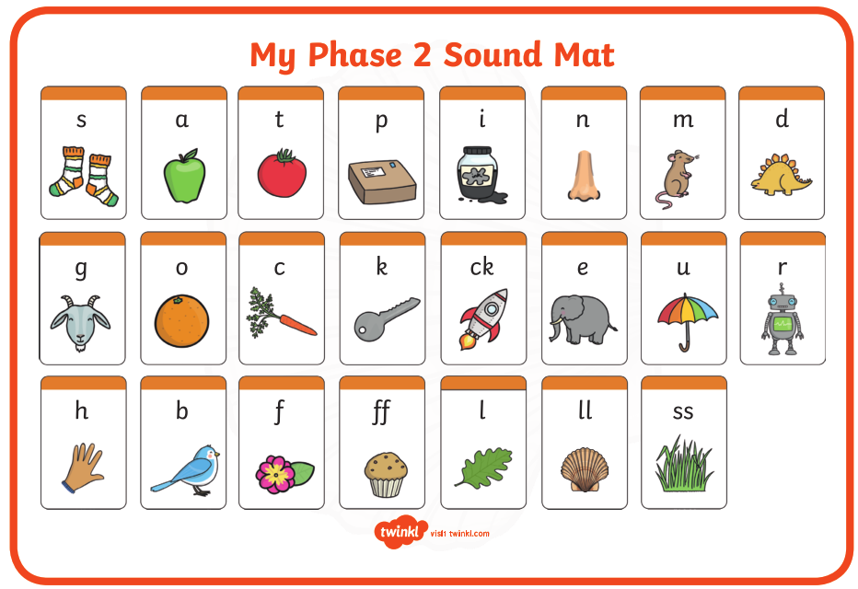

Pre phase 2 words

in | it | is
on | up | of
am | as | us

Phase 2 tricky words

I | no | the
into | go | to
and

Phoneme frames

