Monday | Tuesday | Wednesday | Thursday | Friday
Phonics Focus- J | Phonics Focus- V | Phonics Focus- W | Phonics Focus- X | Tricky Words
Phonics play https://www.phonicsplay.co.uk  Recap sounds- Flash Card Speed Trial-Phase 2 | Phonics play https://www.phonicsplay.co.uk  Recap sounds- Flash Card Speed Trial-Phase 2 | Phonics play https://www.phonicsplay.co.uk  Recap sounds- Flash Card Speed Trial-Phase 2 | Phonics play https://www.phonicsplay.co.uk  Recap sounds- Flash Card Speed Trial-Phase 2 | Play the tricky word songs  https://www.youtube.com/watch?v=TvMyssfAUx0  https://www.youtube.com/watch?v=ri4u0TjAZ38
Search ‘Geraldine the Giraffe learns the /j/ sound’ on YouTube | Search ‘Geraldine the Giraffe learns the /v/ sound’ on YouTube | Search ‘Geraldine the Giraffe learns the /w/ sound’ on YouTube | Search ‘Geraldine the Giraffe learns the /x/ sound’ on YouTube | Tricky Words Phase 2/3 –  Play game on Phonics Play  Tricky Word Trucks
Collect some items beginning with j. Can you have a go at labelling the items e.g?  Jam, jug, jet etc. | Have a go at writing some words that have the V sound e.g.  Van, vet and Viv. | Collect items that begin with W and J and play sort out the objects into the correct piles.  Jam, jug, jumper, jelly beans, wheel, water, watch etc | Write the words  Fox, box, mix and six on some paper.  Cut them up and get the children to put them back together. | Matching pairs Write some of tricky words on paper (duplicate).  Put them face down on the table and play the matching pair game.
Play Buried Treasure Phase 3 game- j – Phonicsplay | Play the V game on Education City- Free Trial  https://go.educationcity.com/content/index/34577/0/1/1/null/null/true/false/null/24//0 | Play Buried Treasure Phase 3 game- w – Phonicsplay | Play the X game on Education City- Free Trial https://go.educationcity.com/content/index/34579/0/1/1/null/null/true/false/null/24//0 | Use an online timer. How many tricky words can you read in a minute?
Access to Education City.
Type Education City into Google.
Click on find content by subject
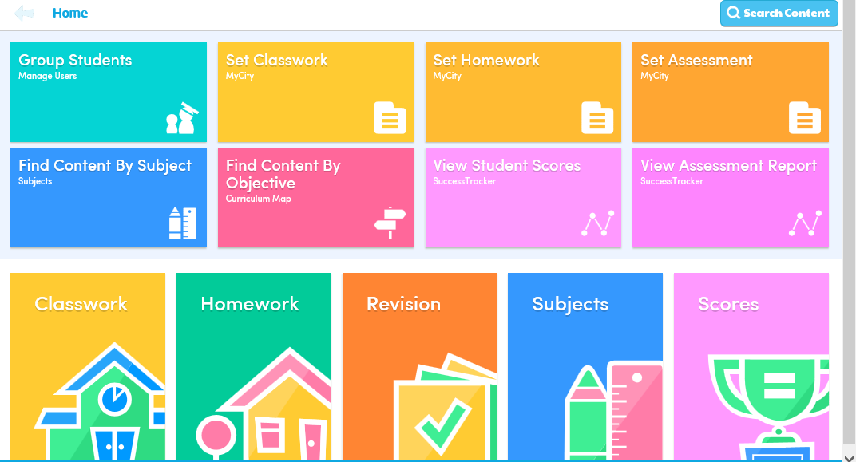
Click on English
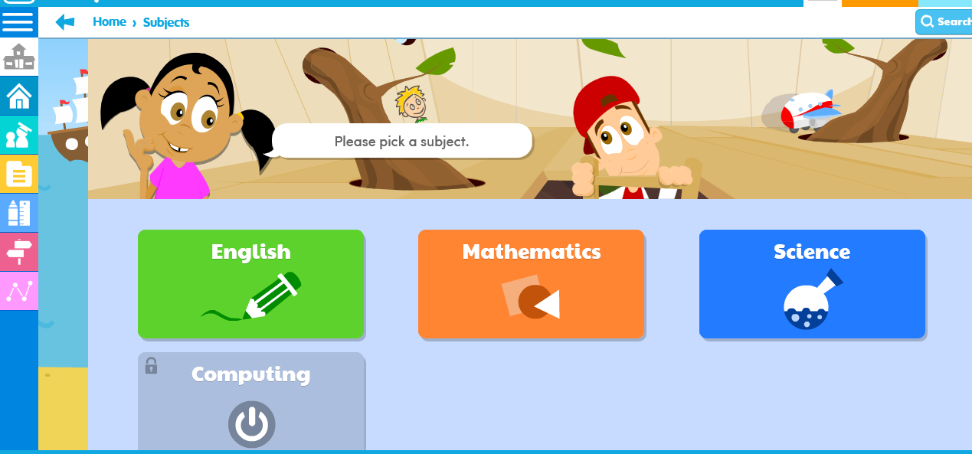
Click on EYFS
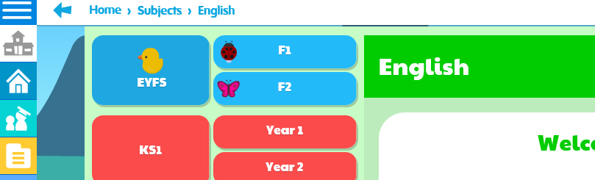

Click on Letters and Sounds

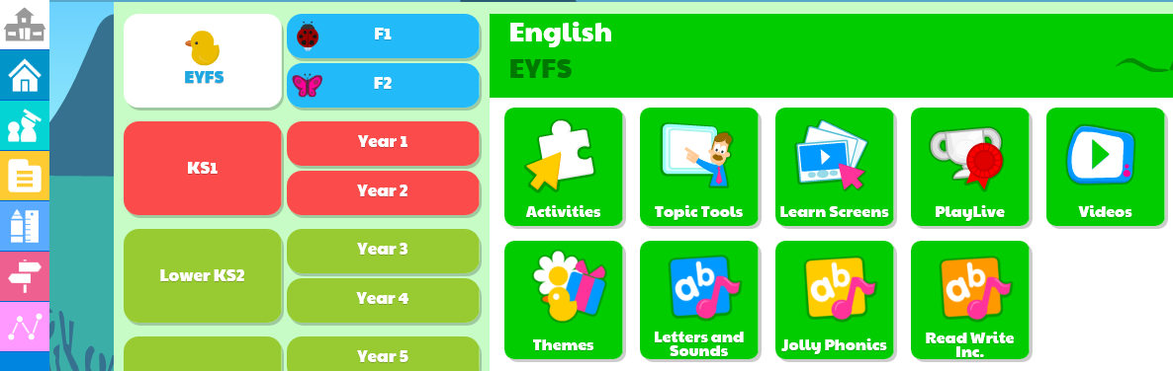
Click on Phase 2 or 3 (depending on which group your child is working in) then click on the sound you child is working on.


