Literacy Homework
Read the Gingerbread man story.
Write a sentence for each picture.
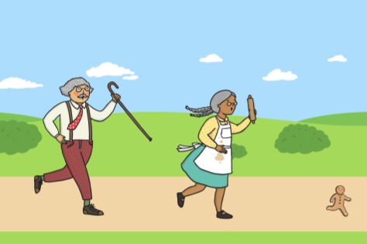

________________________________________________________________________________________________

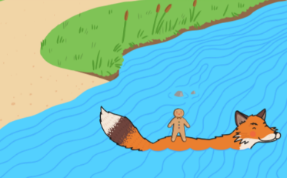

Maths Homework- Addition

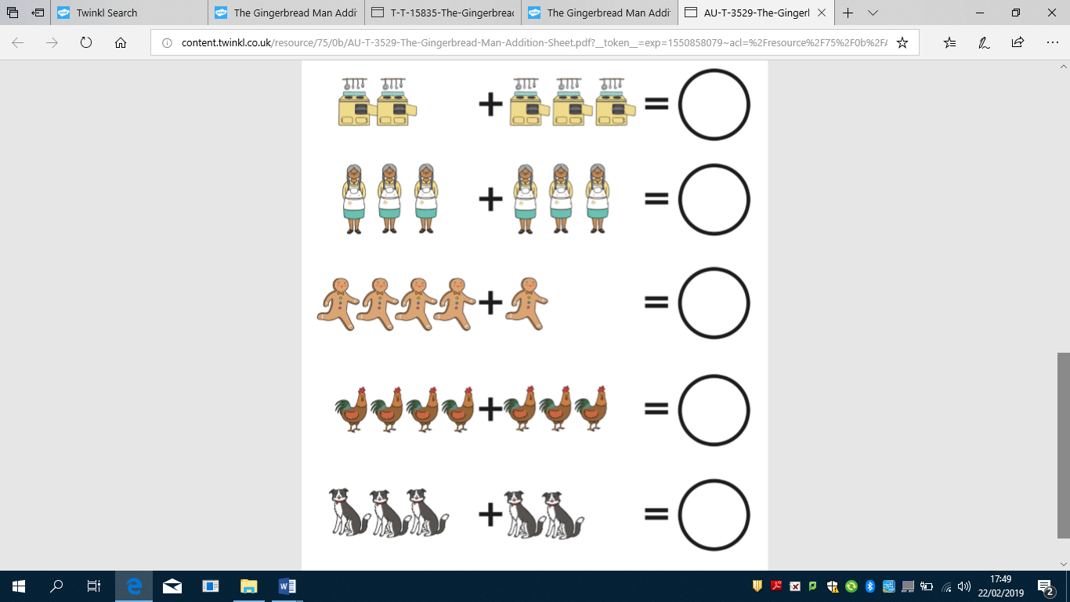

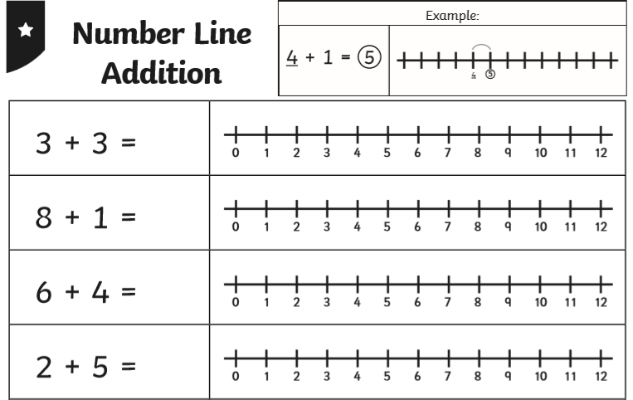
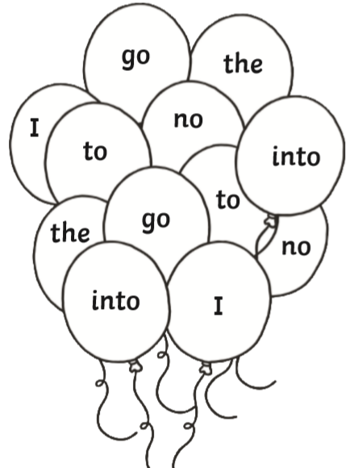
Literacy Homework
Read the tricky words and colour in the balloons using the clues below.
I = Red
to = Blue
go= Purple
the= Green
into = Orange
no = Pink

Maths Homework- Addition on a number line

Literacy Homework

Read the Three Little Pigs story.
Write a sentence for each picture.
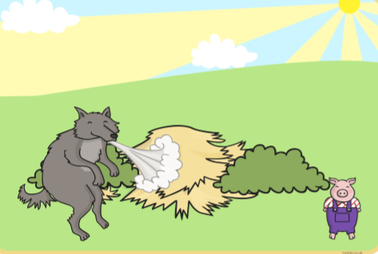

________________________________________________________________________________________________

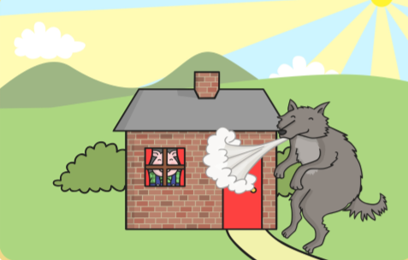

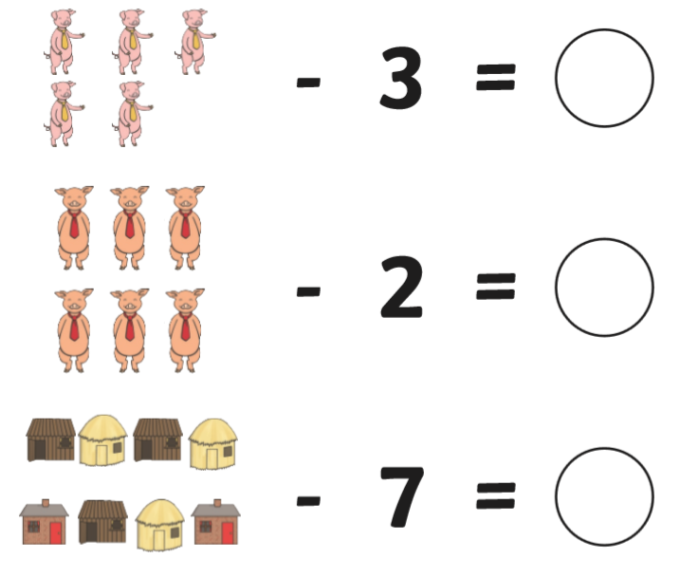
Maths Homework- Subtraction

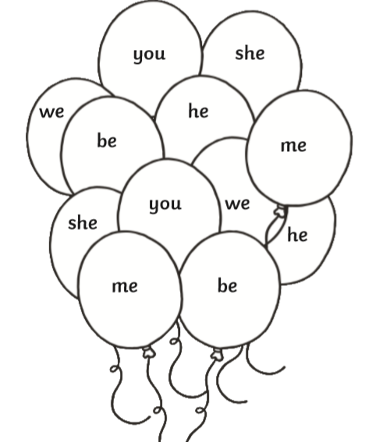
Literacy Homework
Read the tricky words and colour in the balloons using the clues below.
you = Red
me= Blue
she= Purple
he= Green
we = Orange
be = Pink

Maths Homework- Subtraction on a number line

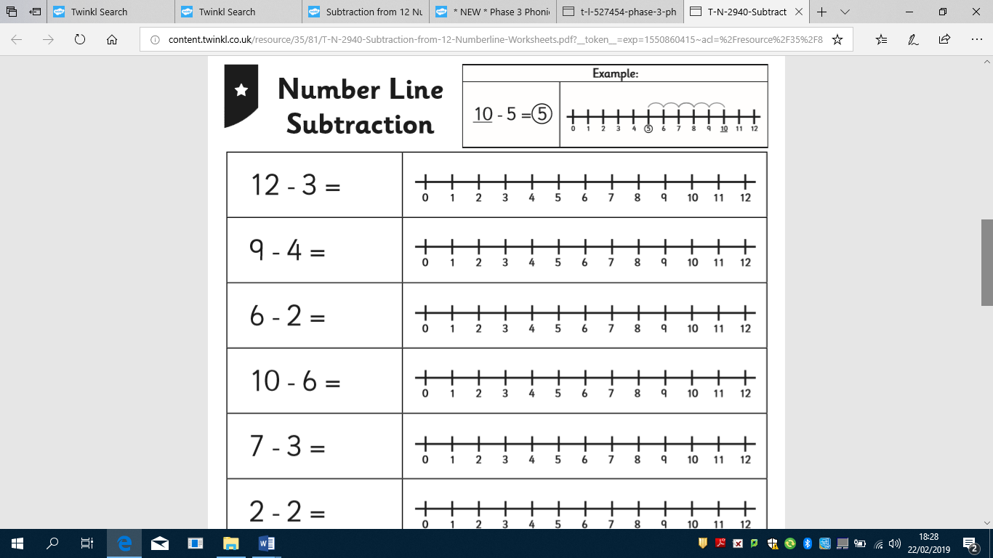

Tuesday 26th March 2019
Literacy Homework Tuesday 26th March 2019
Read the Three Billy Goats Gruff.
Write a sentence for each picture.
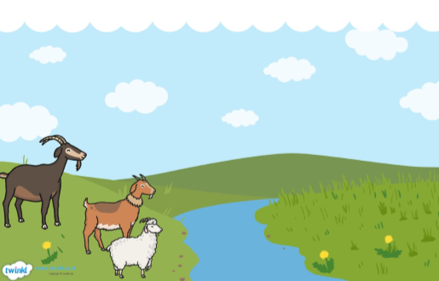

________________________________________________________________________________________________

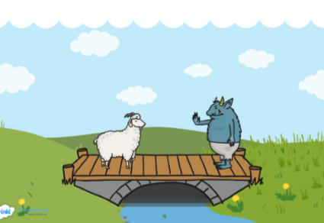

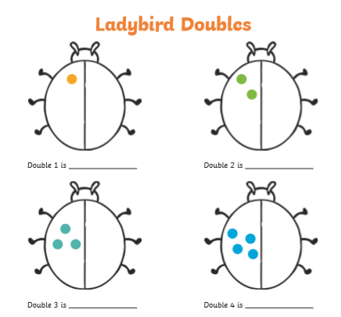

Maths Homework – Doubling

Add the same number of spots to the ladybird’s other wing. Count how many spots you have altogether and write the number underneath.

Literacy Homework
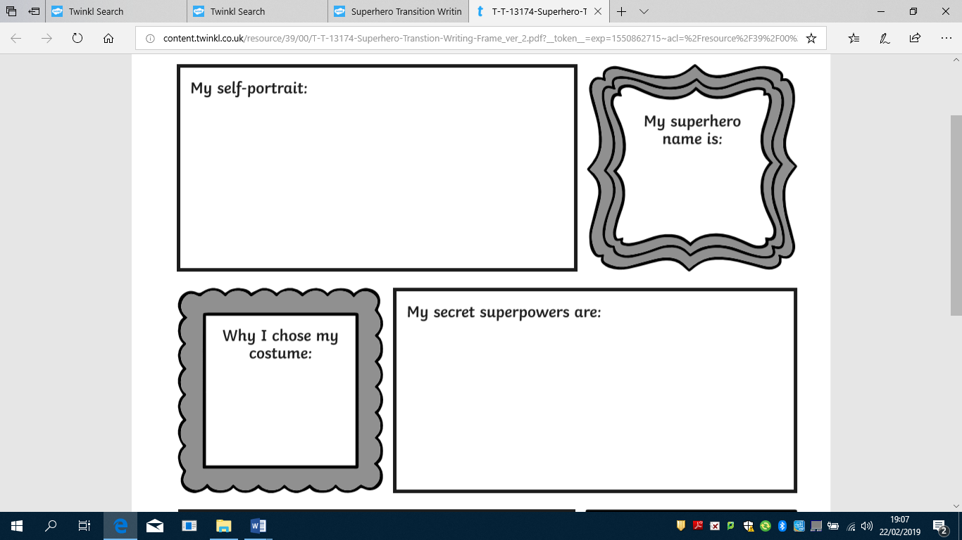
My Superhero Profile

My transport

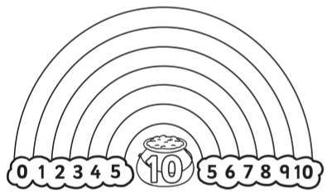

Maths Homework-Number bonds to 10.
We are getting really good at adding 2 numbers together to make 10. Colour in the rainbow and write 4 addition number sentences to match the rainbow.
Example- 10 + 0 = 10
9 + 1 = 10

 | + |  | =
 | + |  | =
 | + |  | =
 | + |  | =

