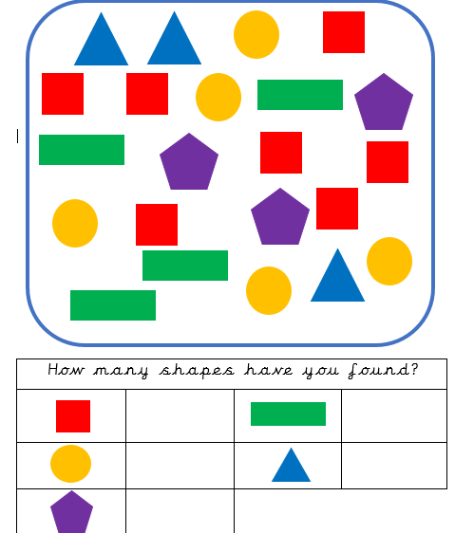
Literacy Homework
Maths Homework- 2D Shapes

Write your name in the box below.

Join the pictures to the words. =
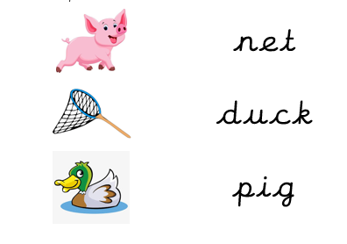

Literacy Homework
Maths Homework- 3D Shapes

Join the 3D shapes to their label.
Complete the pencil control
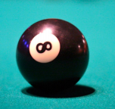 | 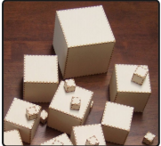 | 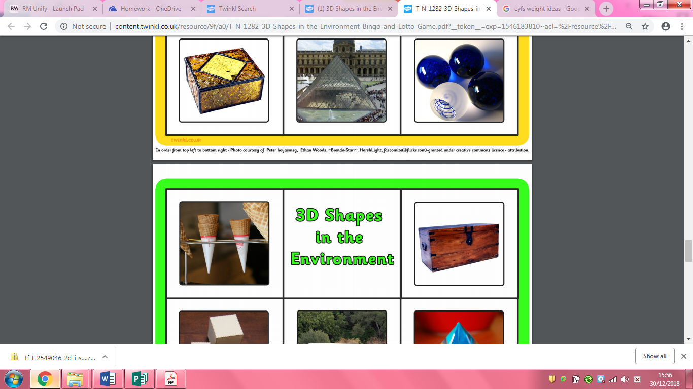 | 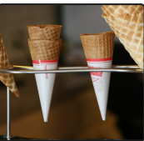
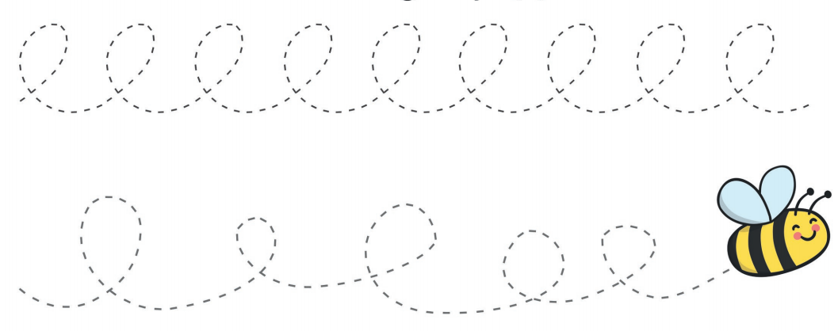

Cube | Cone | Cuboid | Sphere

Can you find a cylinder in your house? __________

What is the object? ________________________________________________

Can you find a sphere in your house? __________

What is the object? ________________________________________________
Can you find a cone in your house? ___________

What is the object? _______________________________________________

Join the pictures to the words
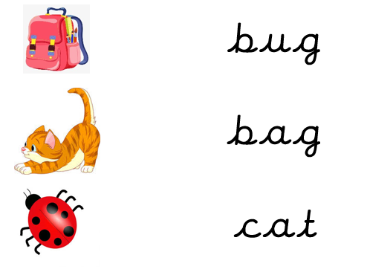
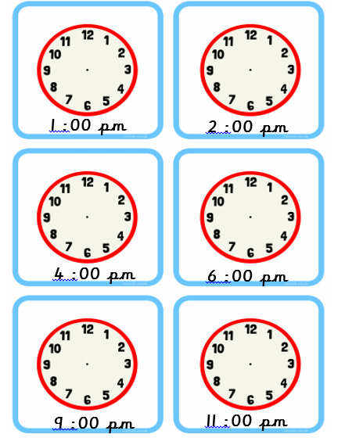
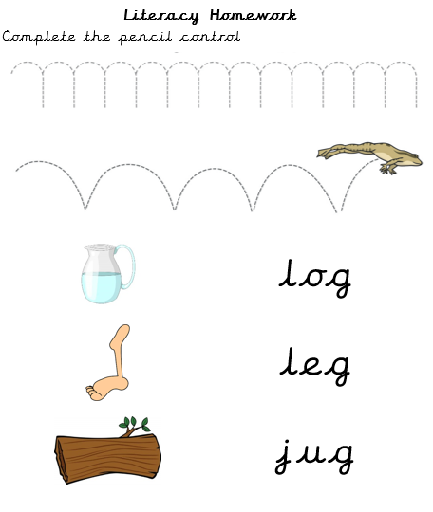
Maths Homework- Time
Draw hands on the clock to make the correct time.
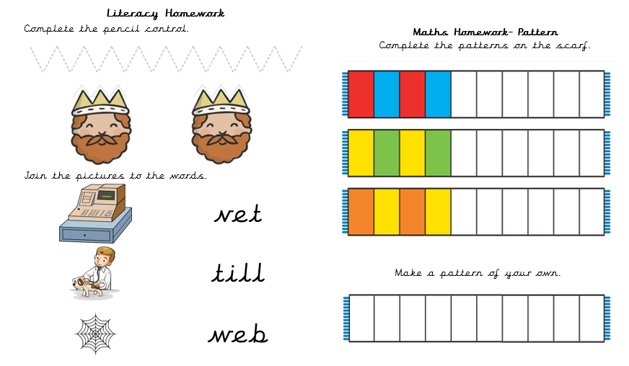

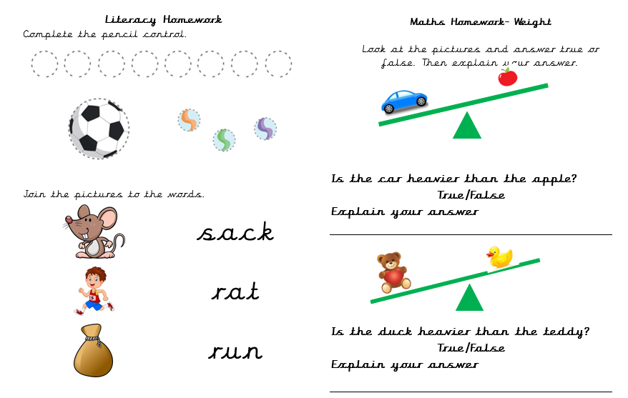

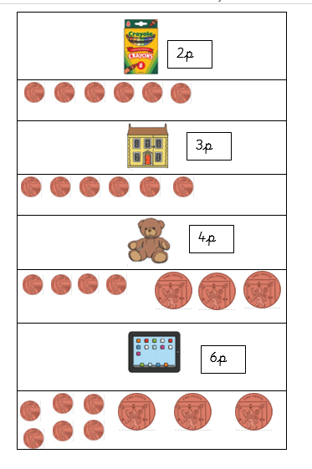
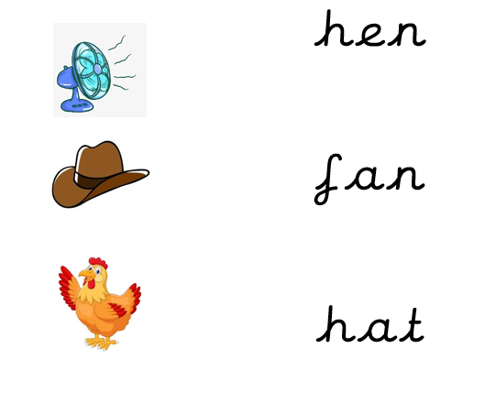
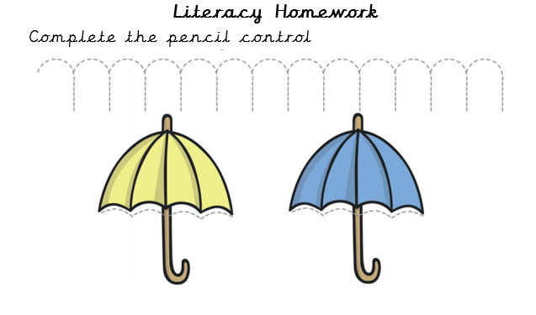
Maths Homework- Money
Circle the correct number of coins to make the amount.

