Monday | Tuesday | Wednesday | Thursday | Friday
Phonics Focus- i | Phonics Focus- n | Phonics Focus- m | Phonics Focus- d | Tricky Words
Children - Say the phase 2 sounds that we have learnt in school.  Adult - You can point to them in random order or in the order on the sound mat.  See and use sound mat below  Children – read the phase 2 tricky words and the pre phase 2 words  Adult –show the children a word at a time. Remember the tricky words are sight words and you cannot segment and blend them.  See and use the word lists below | Children - Say the phase 2 sounds that we have learnt in school.  Adult - You can point to them in random order or in the order on the sound mat.  See and use sound mat below  Children – read the phase 2 tricky words and the pre phase 2 words  Adult –show the children a word at a time. Remember the tricky words are sight words and you cannot segment and blend them.  See and use the word lists below | Children - Say the phase 2 sounds that we have learnt in school.  Adult - You can point to them in random order or in the order on the sound mat.  See and use sound mat below  Children – read the phase 2 tricky words and the pre phase 2 words  Adult –show the children a word at a time. Remember the tricky words are sight words and you cannot segment and blend them.  See and use the word lists below | Children - Say the phase 2 sounds that we have learnt in school.  Adult - You can point to them in random order or in the order on the sound mat.  See and use sound mat below  Children – read the phase 2 tricky words and the pre phase 2 words  Adult –show the children a word at a time. Remember the tricky words are sight words and you cannot segment and blend them.  See and use the word lists below | Play the tricky word song-phase 2  Google  Phase 2 tricky word song or use this  https://www.bing.com/search?q=tricky+words+song+phase+2&form=EDNTHT&mkt=en-gb&httpsmsn=1&msnews=1&plvar=0&refig=40eadad2dbc34571a3ab30ad92f94c13&sp=5&qs=SC&pq=tricky+words+sou&sk=PRES1SC3AS1&sc=8-16&cvid=40eadad2dbc34571a3ab30ad92f94c13&cc=GB&setlang=en-US  Children – read the phase 2 tricky words and the pre phase 2 words  Adult –show the children a word at a time. Remember the tricky words are sight words and you cannot segment and blend them.
Watch the video Mr Thorne does phonics sound ‘i’.  Google  Mr Thorne does phonics episode i | Watch the video Mr Thorne does phonics sound ‘n’.  Google  Mr Thorne does phonics episode n | Watch the video Mr Thorne does phonics sound ‘m’.  Google  Mr Thorne does phonics episode m | Watch the video Mr Thorne does phonics sound ‘d’.  Google  Mr Thorne does phonics episode d | Play the game  Tricky Words Phase 2 –  Play game on Phonics Play  Tricky Word Trucks
Write the i sound on a piece of paper / in the air.  Collect some items beginning with i.  Children - Segment and blend these words below  Adult if you write these words on a piece of paper and put them around the room / on a table / floor. Adult say the word. Children will find the word you are saying.  it  is  sit  sat  pit  tip  pip  sip | Write the n sound on a piece of paper / in the air.  Collect some items beginning with n.  Children - Segment and blend these words  Adult if you write these words on a piece of paper the children can add sound buttons  an  in  nip  pan  pin  tin  tan  nap  Children could find some of these items as the adult segments the word. | Write the m sound on a piece of paper / in the air.  Collect some items beginning with m.  Children - Segment and blend these words  Adult if you write these words on a piece of paper the children can add sound buttons  am man mam mad  mat map Pam Tim  Sam  The children could match the words to pictures / objects by segmenting and blending the words. | Write the d sound on a piece of paper / in the air.  Collect some items beginning with d.  Children - Segment and blend these words  Adult if you write these words on a piece of paper the children can add sound buttons  dad sad dim dip din  did Sid and dig dog  The children could match the words to pictures / objects by segmenting and bending the words. | Play Tricky word Bingo  Adult  Write all of the phase 2 tricky words on a piece of paper. Say a word one at a time. Children will cross off the word when you say it.
Adult say some / all of these words 1 at a time.  Segment and blend with actions.  it  is  sit  sat  pit  tip  pip  sip  When you have said 1 word – ask the child to segment it and write it. Use the actions we use in school when segmenting.  Repeat with the other words.  Children could use the phoneme frame to write the words on if they need to. | Adult write these words on a piece of paper 1 at a time.  Children will have a go at segmenting and blending with actions.  pan  pin  tin  tan  nap  and / or  play this game online on Phonics Play  phase 2 Buried Treasure  +n  Children could have a go at writing these words as the adult segments and blends them.  Pan pin tin  Tan nap  Children could use the phoneme frame to write the words on if they need to. | Adult segment and blend these words one at a time.  Children try to write each word on a piece of paper.  Use the phase 2 sound mat to help  am man mam mad  mat map Pam Tim  Sam  Children could use the phoneme frame to write the words on if they need to.  and / or  play this game online on Phonics Play  phase 2 Buried Treasure  +m | Adult say some / all of these words 1 at a time.  Children try to write each word on a piece of paper.  Use the phase 2 sound mat to help  dad sad dim dip din  did Sid and dig dog  Children could use the phoneme frame to write the words on if they need to.  and / or  play this game online on Phonics Play  phase 2 Buried Treasure  +d | Adult  Show the children the phase 2 tricky words.  See below.  Use an online timer /egg timer  How many tricky words can the child read in a minute?

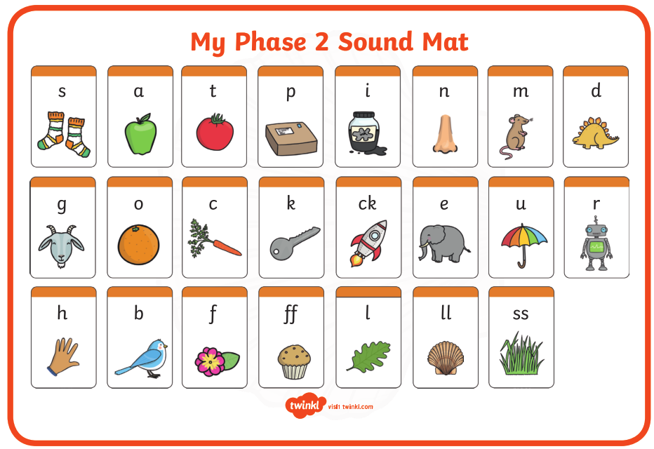

Pre phase 2 words

in | it | is
on | up | of
am | as | us

Phase 2 tricky words

I | no | the
into | go | to
and

Phoneme frames



