Literacy – Monday 13th April
Read Goldilocks and the Three Bears. If you don’t have this book at home you can access it, for free here: https://www.twinkl.co.uk/resource/t-t-5321-goldilocks-and-the-three-bears-story-powerpoint
Using the pictures, write a sentence.
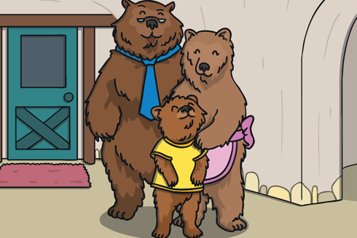

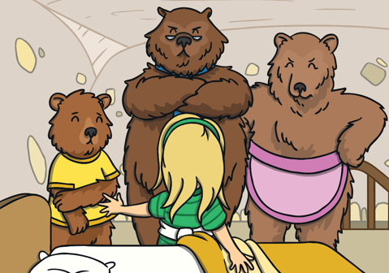

Maths Homework –Monday
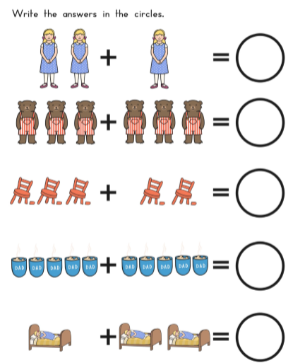

Literacy Homework – Tuesday
From reading the story, use the pictures to write a caption of what you think the character is saying.
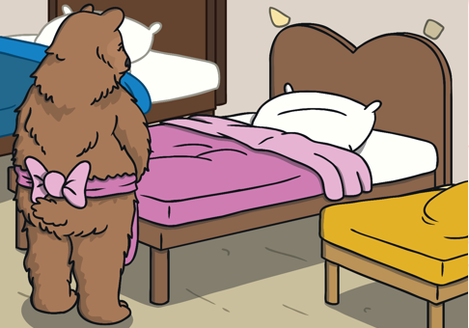

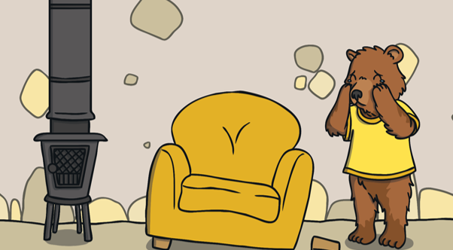

Maths Homework- Tuesday
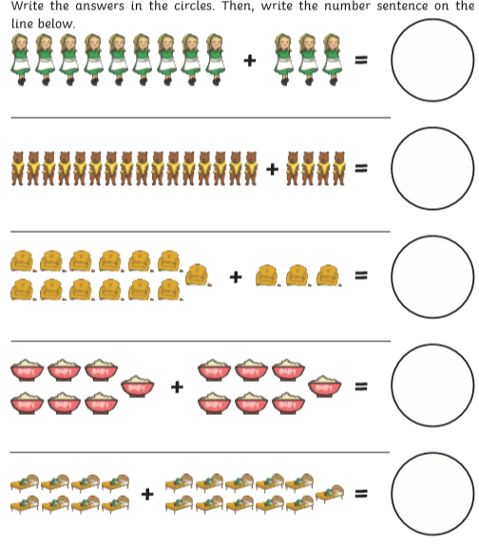

Literacy Homework – Wednesday
Read The Ugly Duckling. If you don’t have this book at home you can access it, for free here:
https://www.twinkl.co.uk/resource/t-t-5337-the-ugly-duckling-story-powerpoint
Using the pictures, write a sentence.
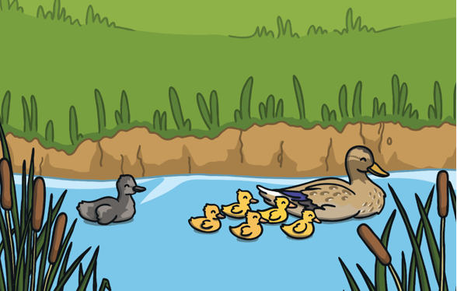

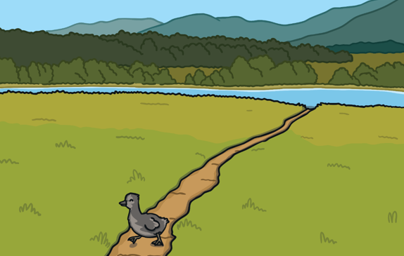

Maths Homework – Wednesday
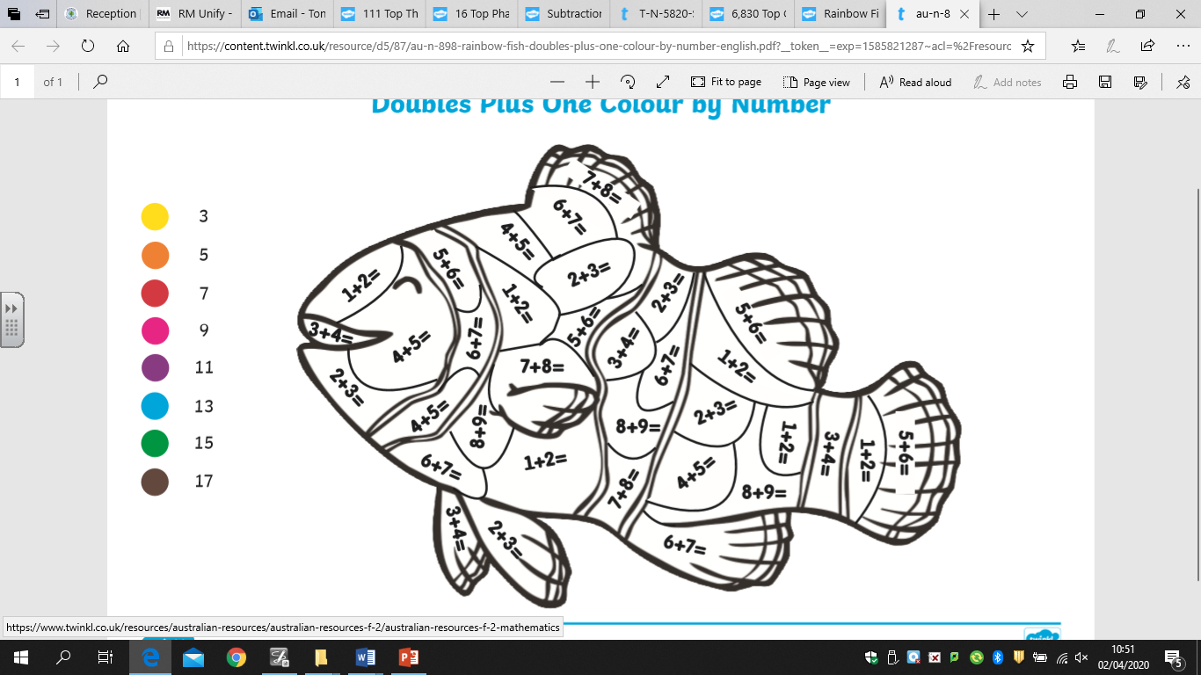

Literacy Homework – Thursday
From reading the story, use the pictures to write a caption of what you think the character is saying.
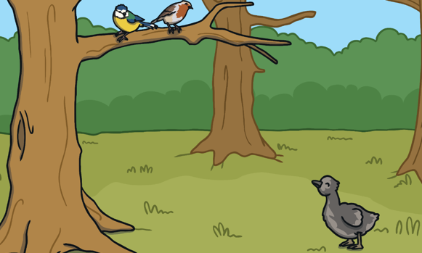

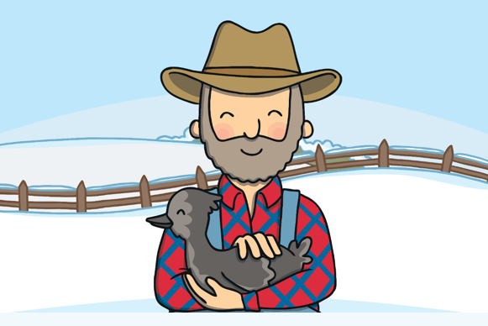

Maths Homework – Thursday
We have been learning a lot about subtraction. We know that we need to count backwards on a numberline and take away the number by crossing out if needed.
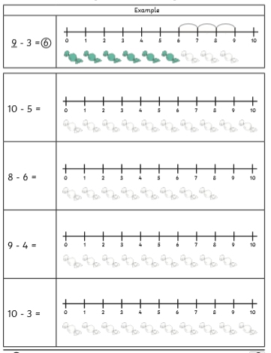

Literacy homework – Friday
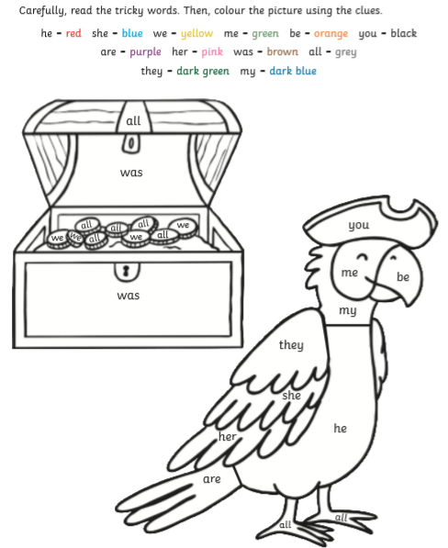

Maths Homework – Friday


