Literacy – Monday6th April
Write your full name in the box below.

Match the pictures to the words.
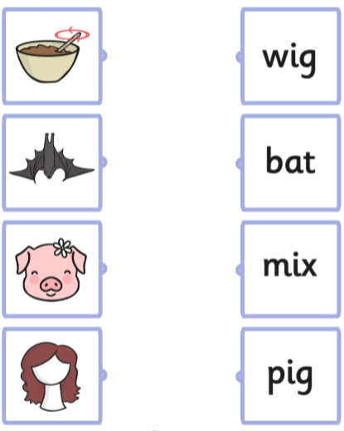

Write the words to match the picture or focus on the initial sound of the word.
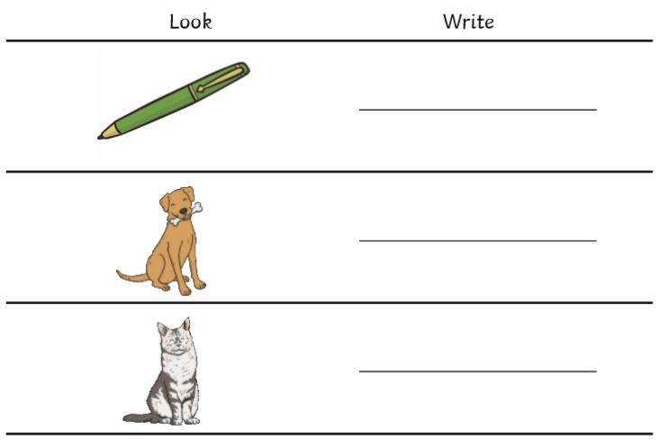

Challenge: Can you write a sentence about one of the pictures? For example, The dog is big.

Maths – Monday
Colour in the pizza using the key to help you.
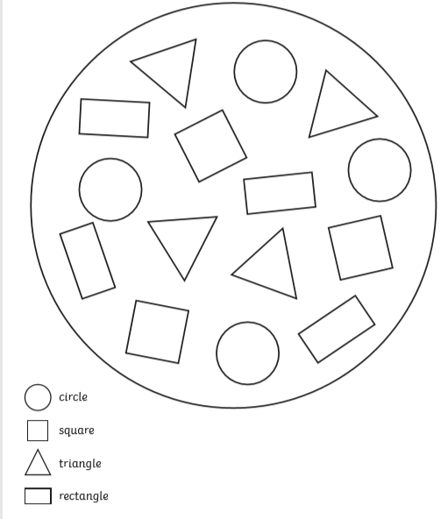

Literacy Homework - Tuesday
Complete the pencil control sheet.
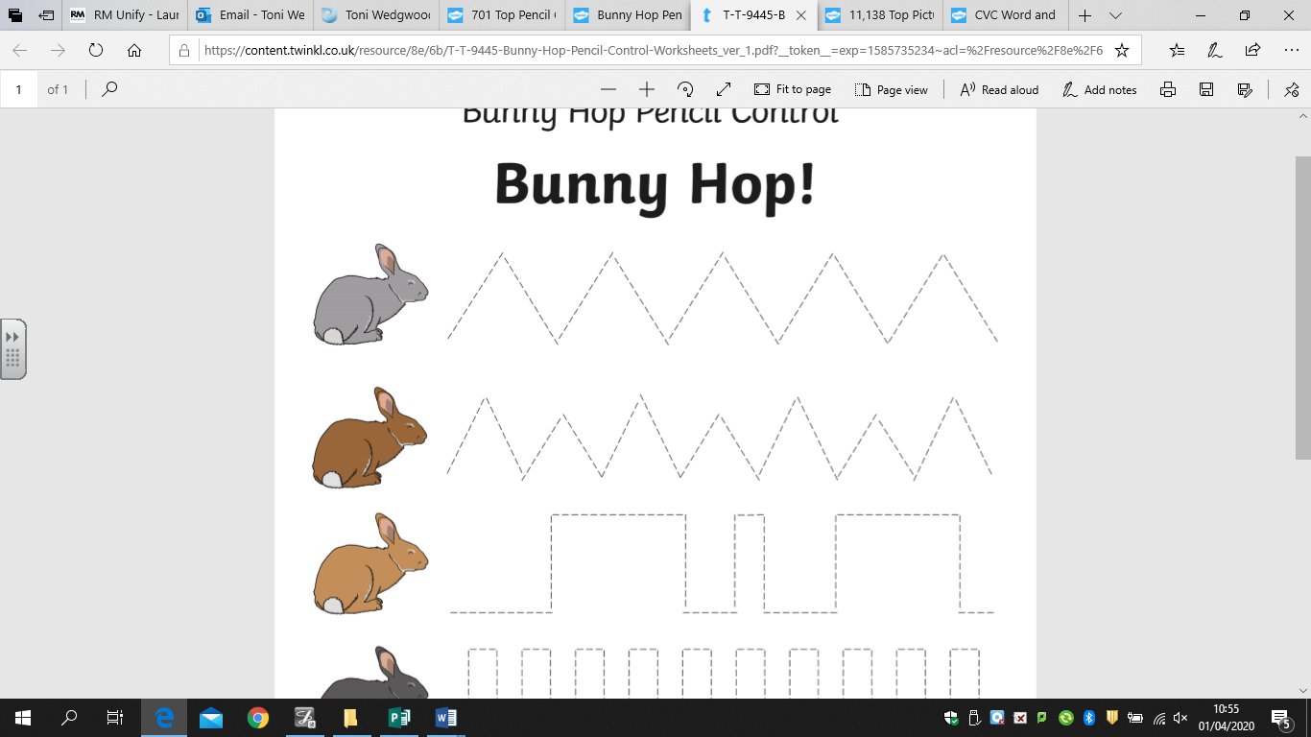
Match the pictures to the words.
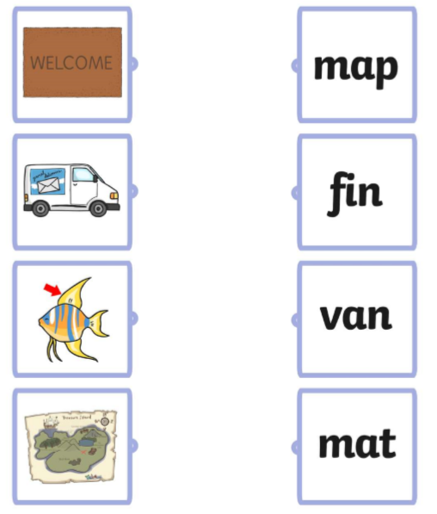
Write the words to match the picture or focus on the initial sound of the word.

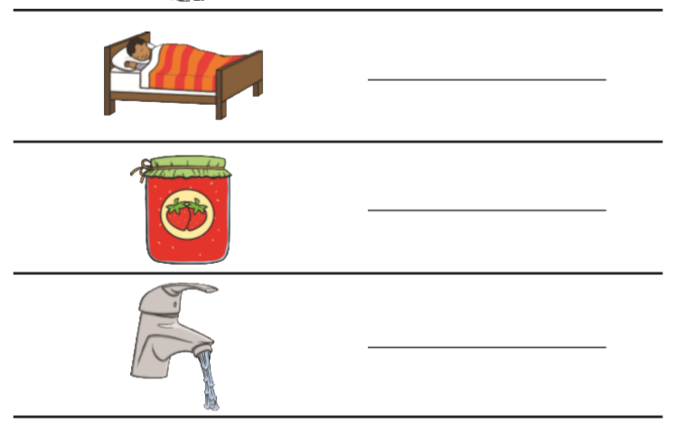
Challenge: Can you write a sentence about one of the pictures? For example, The jam is red.

Maths Homework – Tuesday
Trace the numbers and have a go yourself. This doesn’t need to be done on paper if its nice use chalk outside or even water and a paintbrush on the ground.
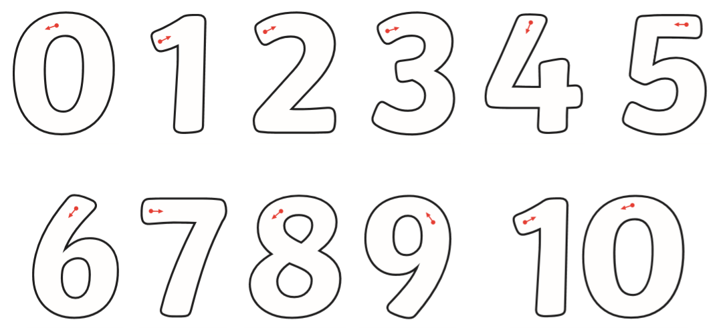
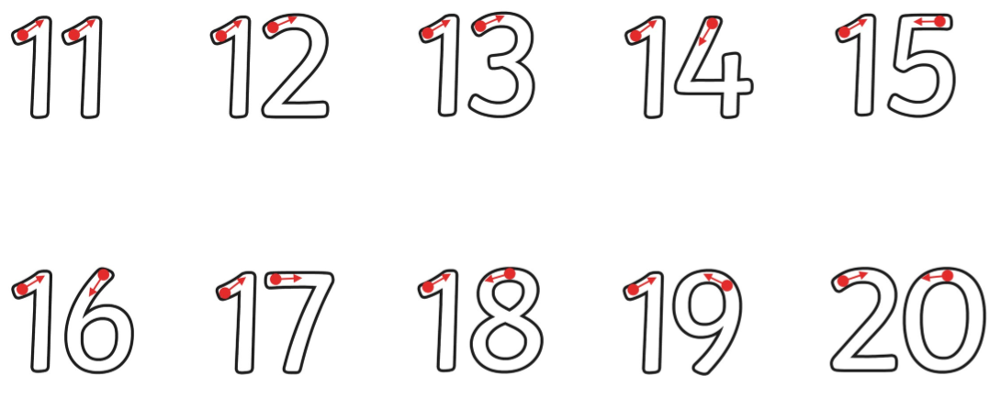

Literacy Homework - Wednesday
Write your full name in the box below.

Match the word to the picture.
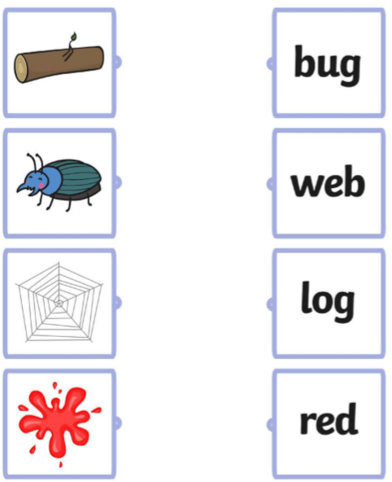

Write the words to match the picture or focus on the initial sound of the word.
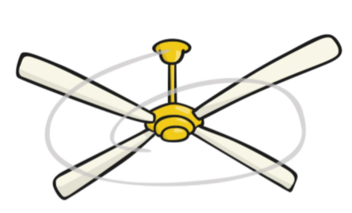____________________________________
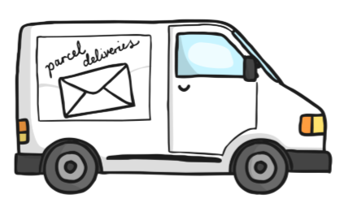____________________________________
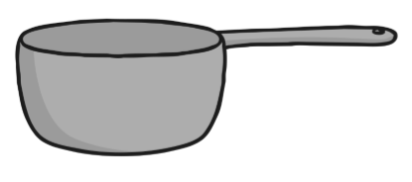_____________________________________
Challenge: Can you write a sentence about one of the pictures? For example, It is a van.

Maths Homework –Wednesday
Look at this powerpoint of 3D shapes.
https://www.twinkl.co.uk/resource/t-n-928-every-day-3d-shapes-powerpoint
Go on a 3D shape hunt in your house. Draw a pictures and label what you have found.
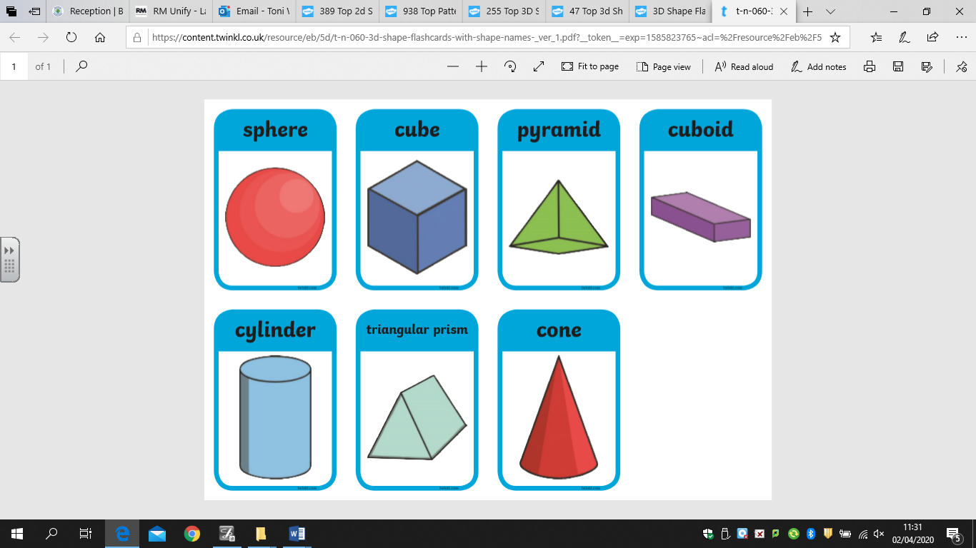

Remember – 2D shapes are flat, 3D shapes are solid.

Literacy Homework - Thursday
Complete the pencil control work sheet.
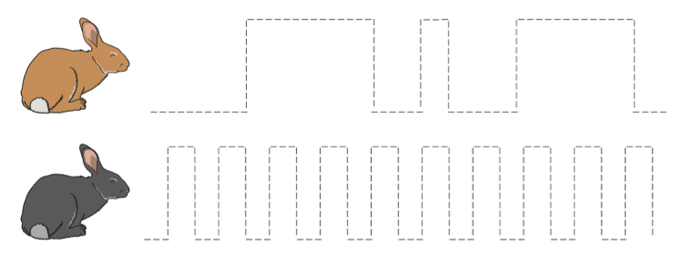
Match the word to the picture.

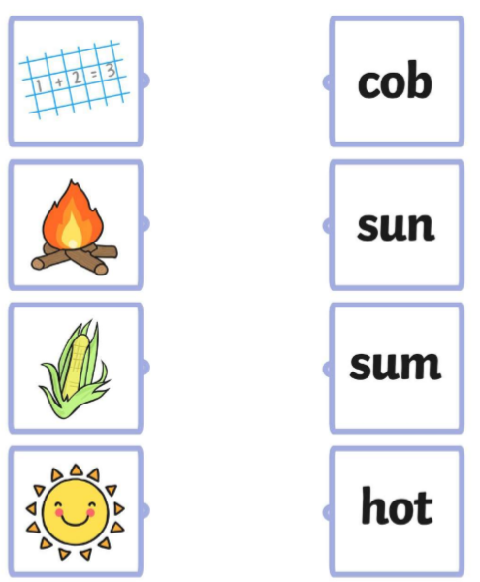
Write the words to match the picture or focus on the initial sound of the word.
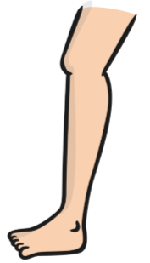___________________________________
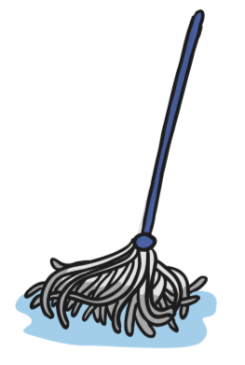_____________________________________
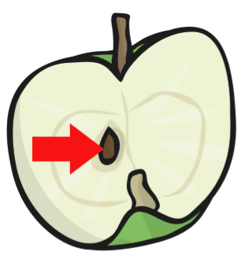_________________________________________
Challenge: Can you write a sentence about one or all of the pictures? For example, The mop is wet and the leg is big.

Maths Homework – Thursday
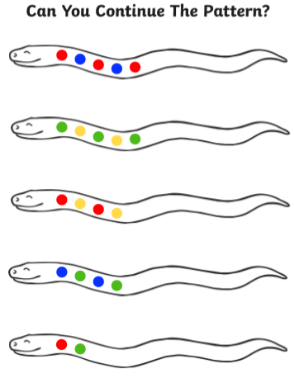

Literacy Homework - Friday
Write your full name in the box below.

Match the word to the picture.
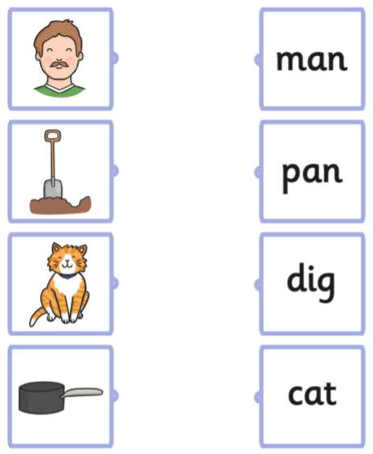

Write the words to match the picture or focus on the initial sound of the word.
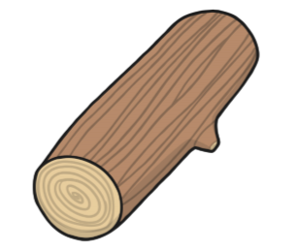____________________________________________
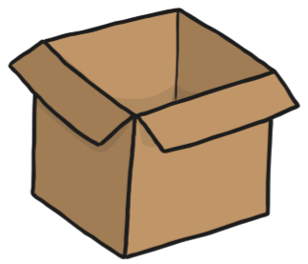_____________________________________________
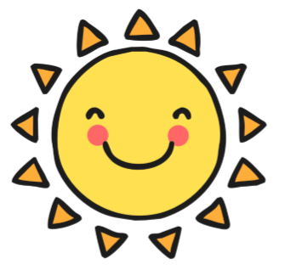____________________________________________

Challenge: Can you write a sentence about one or all of the pictures? For example, The sun is hot and big.

Maths Homework – Friday
Have a look at this powerpoint to help you.
https://www.twinkl.co.uk/resource/au-n-565-lighter-or-heavier-powerpoint

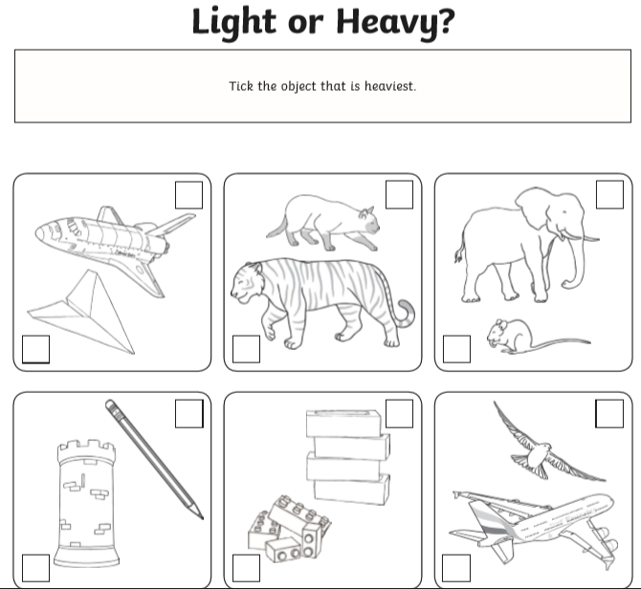
Challenge:
Go around your house and see if you can find 1 object that is light and 1 object that is heavy.

