Monday | Tuesday | Wednesday | Thursday | Friday
Phonics Focus- h | Phonics Focus- b | Phonics Focus- f | Phonics Focus- ff | Tricky Words
Children - Say the phase 2 sounds that we have learnt in school.  Adult - You can point to them in random order or in the order on the sound mat.  See and use sound mat below  Children – read the phase 2 tricky words and the pre phase 2 words  Adult –show the children a word at a time. Remember the tricky words are sight words and you cannot segment and blend them.  See and use the word lists below | Children - Say the phase 2 sounds that we have learnt in school.  Adult - You can point to them in random order or in the order on the sound mat.  See and use sound mat below  Children – read the phase 2 tricky words and the pre phase 2 words  Adult –show the children a word at a time. Remember the tricky words are sight words and you cannot segment and blend them.  See and use the word lists below | Children - Say the phase 2 sounds that we have learnt in school.  Adult - You can point to them in random order or in the order on the sound mat.  See and use sound mat below  Children – read the phase 2 tricky words and the pre phase 2 words  Adult –show the children a word at a time. Remember the tricky words are sight words and you cannot segment and blend them.  See and use the word lists below | Children - Say the phase 2 sounds that we have learnt in school.  Adult - You can point to them in random order or in the order on the sound mat.  See and use sound mat below  Children – read the phase 2 tricky words and the pre phase 2 words  Adult –show the children a word at a time. Remember the tricky words are sight words and you cannot segment and blend them.  See and use the word lists below | Play the tricky word song-phase 2  Google  Phase 2 tricky word song or use this  https://www.bing.com/search?q=tricky+words+song+phase+2&form=EDNTHT&mkt=en-gb&httpsmsn=1&msnews=1&plvar=0&refig=40eadad2dbc34571a3ab30ad92f94c13&sp=5&qs=SC&pq=tricky+words+sou&sk=PRES1SC3AS1&sc=8-16&cvid=40eadad2dbc34571a3ab30ad92f94c13&cc=GB&setlang=en-US  Children – read the phase 2 tricky words and the pre phase 2 words  Adult –show the children a word at a time. Remember the tricky words are sight words and you cannot segment and blend them.
Watch the video Mr Thorne does phonics sound ‘h’.  Google  Mr Thorne does phonics episode h  and or watch  https://www.twinkl.co.uk/resource/t-l-53365-phase-two-phonemes-set-4-h-video | Watch the video Mr Thorne does phonics sound ‘b’.  Google  Mr Thorne does phonics episode b  and or watch  https://www.twinkl.co.uk/resource/t-l-53366-phase-two-phonemes-set-4-b-video | Watch the video Mr Thorne does phonics sound ‘f’.  Google  Mr Thorne does phonics episode f | Watch the video Mr Thorne does phonics sound ‘ff’.  Google  Mr Thorne does phonics episode ff | Play the game  Tricky Words Phase 2 –  Play game on Phonics Play  Tricky Word Trucks
Write the h sound on a piece of paper / in the air.  Collect some items beginning with h.  Children - Segment and blend these words below  Adult - write these words on a piece of paper the children can add sound buttons and segment and blend them.  had him his hot  hut hop hum hit  hat has hack hug | Write the b sound on a piece of paper / in the air.  Collect some items beginning with b.  Children - Segment and blend these words  Adult - write these words on a piece of paper the children can add sound buttons and segment and blend them.  but big back bet  bad bag bed bud  beg bug bun bus  Ben bat bit  Children could find some of these items as the adult segments the word. | Write the f sound on a piece of paper / in the air.  Collect some items beginning with f.  Children - Segment and blend these words  Adult - write these words on a piece of paper the children can add sound buttons and segment and blend them.  of if fit fun  fig fog fan fat | Write the ff sound on a piece of paper / in the air.  Collect some items beginning with ff.  Children - Segment and blend these words  Adult - write these words on a piece of paper the children can add sound buttons and segment and blend them.  off puff huff  cuff | Play Tricky word Bingo  Adult  Write all of the phase 2 tricky words on a piece of paper. Say a word one at a time. Children will cross off the word when you say it.
Adult say some / all of these words 1 at a time.  Segment and blend with actions.  had him his hot  hut hop hum hit  hat has hack hug  When you have said 1 word – ask the child to segment it and write it. Use the phase 2 sound mat to help  Use the actions we use in school when segmenting.  Repeat with the other words.  Children could use the phoneme frame (below) to write the words on if they need to.  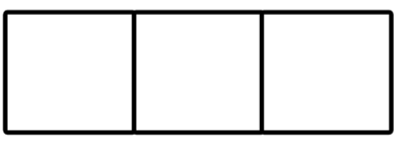  Can the children read these captions?  a hug and a kiss  go to the log hut | Adult write these words on a piece of paper 1 at a time.  Children will have a go at segmenting and blending with actions.  but big back bet  bad bag bed bud  beg bug bun bus  Ben bat bit  and / or  play this game online on Phonics Play  Buried Treasure phase 2  + b  Children could have a go at writing these words as the adult segments and blends them.  but big back bet  bad bag bed bud  beg bug bun bus  Ben bat bit  Use the phase 2 sound mat to help  Use a phoneme frame if you need to  Can the children read these captions?  pack a pen in the bag  a bat and a bug | Adult segment and blend these words one at a time.  Children try to write each word on a piece of paper.  Use the phase 2 sound mat to help  of if fit fun  fig fog fan fat  Children could use the phoneme frame to write the words on if they need to.  Children could have a go at writing these words as the adult segments and blends them.  of if fit fun  fig fog fan fat  Use the phase 2 sound mat to help  Use a phoneme frame if you need to  Can the children read these captions?  a cat and a big fat rat  a big fin | Adult say some / all of these words 1 at a time.  Children try to write each word on a piece of paper.  Use the phase 2 sound mat to help  off puff huff  cuff  Children could use the phoneme frame to write the words on if they need to.  and / or  play this game online on Phonics Play  Buried Treasure phase 2  +f/ff  Children could have a go at writing these words as the adult segments and blends them.  off puff huff  cuff  Use the phase 2 sound mat to help  Use a phoneme frame if you need to  Can the children read these captions?  to huff and puff  get off the mat | Adult  Show the children the phase 2 tricky words.  See below.  Use an online timer /egg timer  How many tricky words can the child read in a minute?  Can you beat last weeks score?

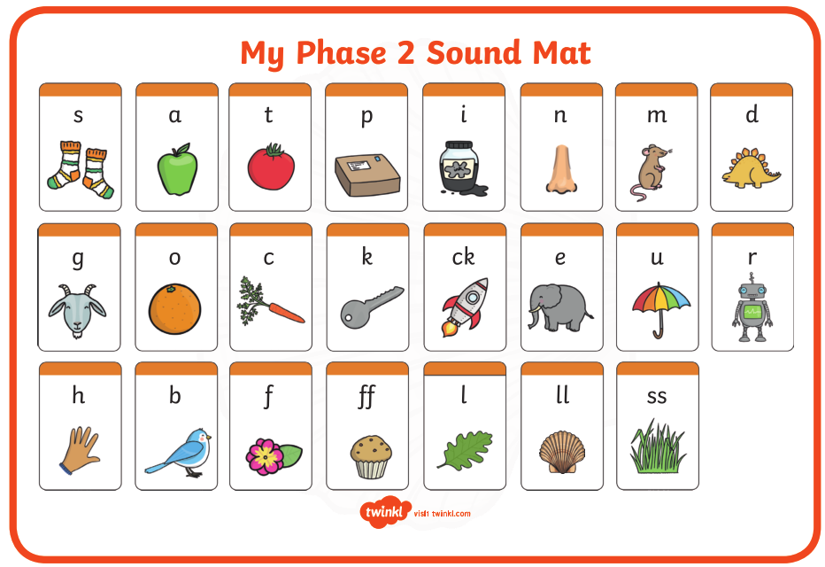

Pre phase 2 words

in | it | is
on | up | of
am | as | us

Phase 2 tricky words

I | no | the
into | go | to
and

Phoneme frames

