Monday | Tuesday | Wednesday | Thursday | Friday
Phonics Focus- l | Phonics Focus- ll | Phonics Focus- ss | Phonics Focus- segmenting and blending and  reading captions using phase 2 sounds | Tricky Words
Children - Say the phase 2 sounds that we have learnt in school.  Adult - You can point to them in random order or in the order on the sound mat.  See and use sound mat below  Children – read the phase 2 tricky words and the pre phase 2 words  Adult –show the children a word at a time. Remember the tricky words are sight words and you cannot segment and blend them.  See and use the word lists below | Children - Say the phase 2 sounds that we have learnt in school.  Adult - You can point to them in random order or in the order on the sound mat.  See and use sound mat below  Children – read the phase 2 tricky words and the pre phase 2 words  Adult –show the children a word at a time. Remember the tricky words are sight words and you cannot segment and blend them.  See and use the word lists below | Children - Say the phase 2 sounds that we have learnt in school.  Adult - You can point to them in random order or in the order on the sound mat.  See and use sound mat below  Children – read the phase 2 tricky words and the pre phase 2 words  Adult –show the children a word at a time. Remember the tricky words are sight words and you cannot segment and blend them.  See and use the word lists below | Children - Say the phase 2 sounds that we have learnt in school.  Adult - You can point to them in random order or in the order on the sound mat.  See and use sound mat below  Children – read the phase 2 tricky words and the pre phase 2 words  Adult –show the children a word at a time. Remember the tricky words are sight words and you cannot segment and blend them.  See and use the word lists below | Play the tricky word song-phase 2  Google  Phase 2 tricky word song or use this  https://www.bing.com/search?q=tricky+words+song+phase+2&form=EDNTHT&mkt=en-gb&httpsmsn=1&msnews=1&plvar=0&refig=40eadad2dbc34571a3ab30ad92f94c13&sp=5&qs=SC&pq=tricky+words+sou&sk=PRES1SC3AS1&sc=8-16&cvid=40eadad2dbc34571a3ab30ad92f94c13&cc=GB&setlang=en-US  Children – read the phase 2 tricky words and the pre phase 2 words  Adult –show the children a word at a time. Remember the tricky words are sight words and you cannot segment and blend them.
Watch the video Mr Thorne does phonics sound ‘l’.  Google  Mr Thorne does phonics episode l | Watch the video Mr Thorne does phonics sound ‘ll’.  Google  Mr Thorne does phonics episode ll  and or watch  https://www.twinkl.co.uk/resource/t-l-53374-phase-two-phonemes-set-5-ll-video | Watch the video Mr Thorne does phonics sound ‘ss’.  Google  Mr Thorne does phonics episode ss  and or watch  https://www.twinkl.co.uk/resource/t-l-53375-phase-two-phonemes-set-5-ss-video | Play this game online using  Phonics play  Phase 2  Interactive resources  Make a match  h b f l  ff ll ss | Play the game  Tricky Words Phase 2 –  Play game on Phonics Play  Tricky Word Trucks
Write the l sound on a piece of paper / in the air.  Collect some items beginning with l.  Children - Segment and blend these words below  Adult - write these words on a piece of paper the children can add sound buttons and segment and blend them.  lap let leg lot lit log lip lad  lick lid | Write the ll sound on a piece of paper / in the air.  Collect some items with the ll sound in them.  Children - Segment and blend these words  Adult - write these words on a piece of paper the children can add sound buttons and segment and blend them.  bell fill doll tell  sell Bill Nell dull  bull  Children could find some of these items as the adult segments the word. | Write the ss sound on a piece of paper / in the air.  Collect some items with the ss sound in them.  Children - Segment and blend these words  Adult - write these words on a piece of paper the children can add sound buttons and segment and blend them.  less hiss mass mess boss fuss pass Tess ass | Adult  Using the phase 2 sound mat – see below  Read out the sounds  Child  Write the sounds as the adult says them. | Play Tricky word Bingo  Adult  Write all of the phase 2 tricky words on a piece of paper. Say a word one at a time. Children will cross off the word when you say it.
Adult say some / all of these words 1 at a time.  Segment and blend with actions.  lap let leg lot lit log lip lad  lick lid  When you have said 1 word – ask the child to segment it and write it. Use the phase 2 sound mat to help  Use the actions we use in school when segmenting.  Repeat with the other words.  Children could use the phoneme frame (below) to write the words on if they need to.  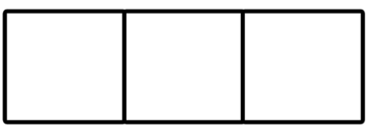  Can the children read these captions?  a big lad  a red lip | Adult write these words on a piece of paper 1 at a time.  Children will have a go at segmenting and blending with actions.  bell fill doll tell  sell Bill Nell dull  bull  and / or  play this game online on Phonics Play  Buried Treasure phase 2  + l / ll  Children could have a go at writing these words as the adult segments and blends them.  bell fill doll tell  sell Bill Nell dull  bull  Use the phase 2 sound mat to help  Use a phoneme frame if you need to  Can the children read these captions?  a big bull  to the top of the hill | Adult segment and blend these words one at a time.  Children try to write each word on a piece of paper.  Use the phase 2 sound mat to help  less hiss mass mess boss fuss pass Tess ass  Children could use the phoneme frame to write the words on if they need to.  and / or  play this game online on Phonics Play  Buried Treasure phase 2  +ss  Children could have a go at writing these words as the adult segments and blends them.  less hiss mass mess boss fuss pass Tess ass  Use the phase 2 sound mat to help  Use a phoneme frame if you need to  Can the children read these captions?  a big mess  a big boss | Adult  Say a phase 2 CVC word.  e.g.lap  You can segment the and use the actions we use in school.  Then segment it with the child with actions.  Child  Write the CVC words.  Use the phoneme frame if you ned to.  Here is a list of words that you could use.  get cap gap  dog cog duck  rag hug back  adult  Write these captions on a piece of paper  a hot hob  no lid on the pan  child  Read the captions segment and blend with actions to help. | Adult  Show the children the phase 2 tricky words.  See below.  Use an online timer /egg timer  How many tricky words can the child read in a minute?  Can you beat last weeks score?

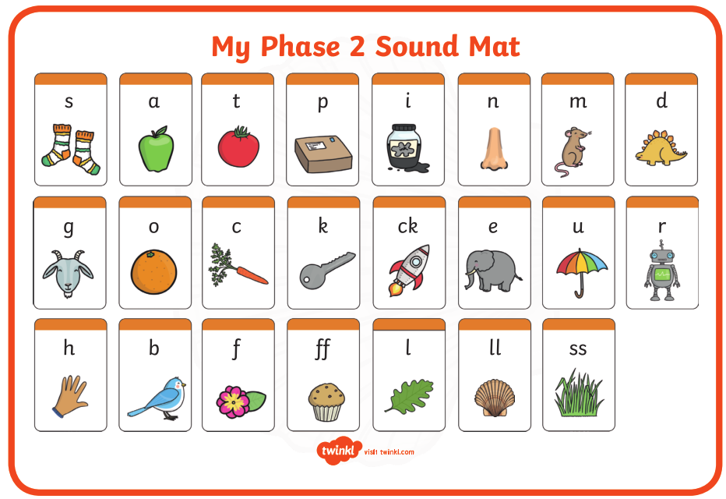

Pre phase 2 words

in | it | is
on | up | of
am | as | us

Phase 2 tricky words

I | no | the
into | go | to
and

Phoneme frames

