Monday | Tuesday | Wednesday | Thursday | Friday
Phonics Focus- UR | Phonics Focus- OW | Phonics Focus- OI | Phonics Focus- EAR | Tricky Words
Phonics play https://www.phonicsplay.co.uk  Recap sounds- Flash Card Speed Trial-Phase 2/3 | Phonics play https://www.phonicsplay.co.uk  Recap sounds- Flash Card Speed Trial-Phase 2/3 | Phonics play https://www.phonicsplay.co.uk  Recap sounds- Flash Card Speed Trial-Phase 2/3 | Phonics play https://www.phonicsplay.co.uk  Recap sounds- Flash Card Speed Trial-Phase 2/3 | Play the tricky word songs  https://www.youtube.com/watch?v=TvMyssfAUx0  https://www.youtube.com/watch?v=ri4u0TjAZ38
Search ‘Geraldine the Giraffe learns the UR/ sound’ on YouTube  Diagraph – 2 letters 1 sound | Search ‘Geraldine the Giraffe learns the /OW/ sound’ on YouTube  Diagraph – 2 letters 1 sound | Search ‘Geraldine the Giraffe learns the /OI/ sound’ on YouTube  Diagraph – 2 letters 1 sound | Search ‘Geraldine the Giraffe learns the /EAR/ sound’ on YouTube  Trigraph – 3 letters 1 sound | Tricky Words Phase 2/3 –  Play game on Phonics Play  Tricky Word Trucks
Have a go at writing some words that have the UR sound e.g.  Burn, surf, turf, burst, curl, church, turnip.  Now choose a word and write a sentence e.g.  The surf can curl. | Have a go at writing some words that have the OW sound e.g.  Cow, brown, owl, crown, town, clown, flower, shower,  Now choose a word and write a sentence e.g.  The clown has a crown. | Write the words-  Coin, soil, foil, coil, oil, spoil  Get an adult to stick them up around the room and run to the words  Now choose a word and write a sentence e.g.  The coin is in the foil. | Write the words on some paper.  Ear, fear, spear, hear, near.  Cut them up and get the children to put them back together.  Now choose a word and write a sentence e.g.  I can hear. | Matching pairs Write some of tricky words on paper (duplicate).  Put them face down on the table and play the matching pair game.
Play the UR game on Education City- Free Trial | Play the OW game on Education City- Free Trial | Play the OI game on Education City- Free Trial | Play the EAR game on Education City- Free Trial | Play the tricky word game on Education City- Free Trial

Access to Education City.
Type Education City into Google.
Click on find content by subject
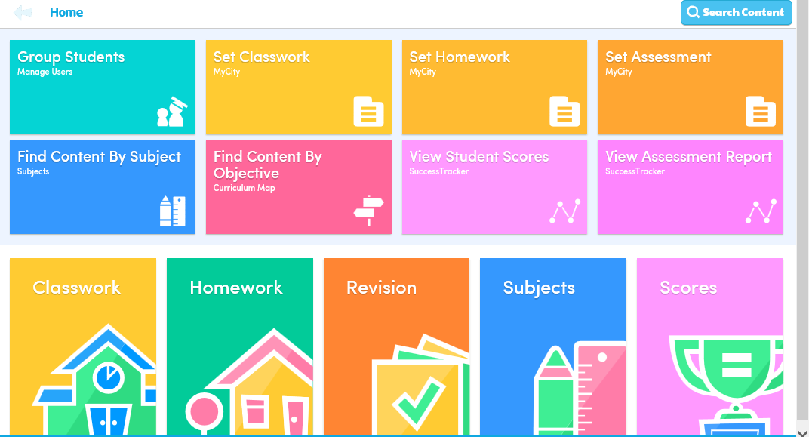
Click on English
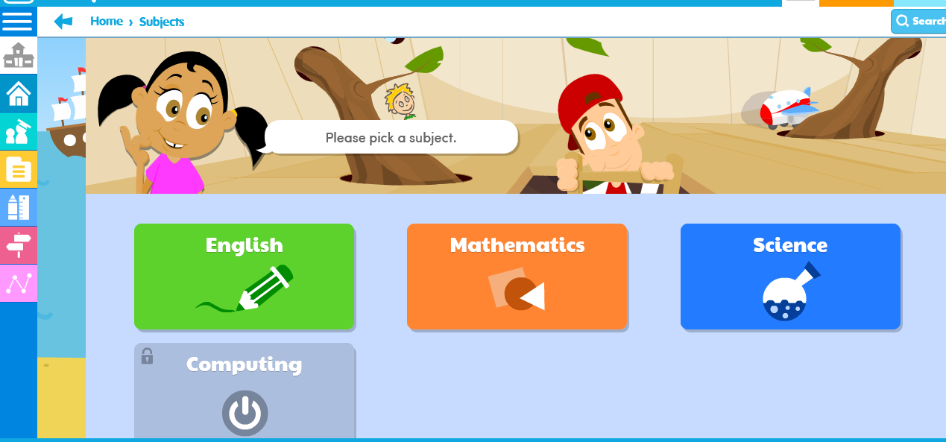
Click on EYFS
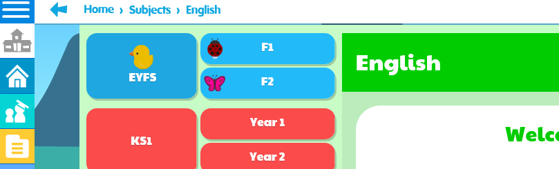

Click on Letters and Sounds

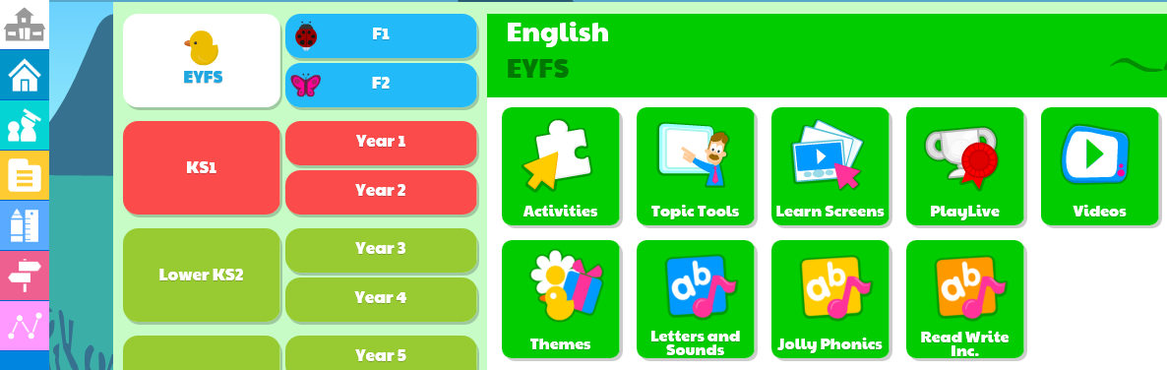
Click on Phase 2 or 3 (depending on which group your child is working in) then click on the sound you child is working on.


