Monday | Tuesday | Wednesday | Thursday | Friday
Phonics Focus- OA | Phonics Focus- OO | Phonics Focus- AR | Phonics Focus- OR | Tricky Words
Phonics play https://www.phonicsplay.co.uk  Recap sounds- Flash Card Speed Trial-Phase 2/3 | Phonics play https://www.phonicsplay.co.uk  Recap sounds- Flash Card Speed Trial-Phase 2/3 | Phonics play https://www.phonicsplay.co.uk  Recap sounds- Flash Card Speed Trial-Phase 2/3 | Phonics play https://www.phonicsplay.co.uk  Recap sounds- Flash Card Speed Trial-Phase 2/3 | Play the tricky word songs  https://www.youtube.com/watch?v=TvMyssfAUx0  https://www.youtube.com/watch?v=ri4u0TjAZ38
Search ‘Geraldine the Giraffe learns the /OA/ sound’ on YouTube  Diagraph – 2 letters 1 sound | Search ‘Geraldine the Giraffe learns the /OO/ sound’ on YouTube  Diagraph – 2 letters 1 sound | Search ‘Geraldine the Giraffe learns the /AR/ sound’ on YouTube  Diagraph – 2 letters 1 sound | Search ‘Geraldine the Giraffe learns the /OR/ sound’ on YouTube  Diagraph – 2 letters 1 sound | Tricky Words Phase 2/3 –  Play game on Phonics Play  Tricky Word Trucks
Have a go at writing some words that have the OA sound e.g.  Road, toad, boat, coat, goat moat  Now choose a word and write a sentence e.g.  The goat has a coat | Have a go at writing some words that have the OO sound e.g.  Moon, spoon, food, roof,  Now choose a word and write a sentence e.g.  The spoon is on the moon. | Write the words-  Star, car, park, march, card, jar  Get an adult to stick them up around the room and run to the words  Now choose a word and write a sentence e.g.  The star is in a jar. | Write the words on some paper.  Fork, pork, storm, torch, born, corn  Cut them up and get the children to put them back together.  Now choose a word and write a sentence e.g.  The fork is in the corn. | Matching pairs Write some of tricky words on paper (duplicate).  Put them face down on the table and play the matching pair game.
Play the OA game on Education City- Free Trial | Play the OO game on Education City- Free Trial | Play the AR game on Education City- Free Trial | Play the OR game on Education City- Free Trial | Play the tricky word game on Education City- Free Trial

Access to Education City.
Type Education City into Google.
Click on find content by subject
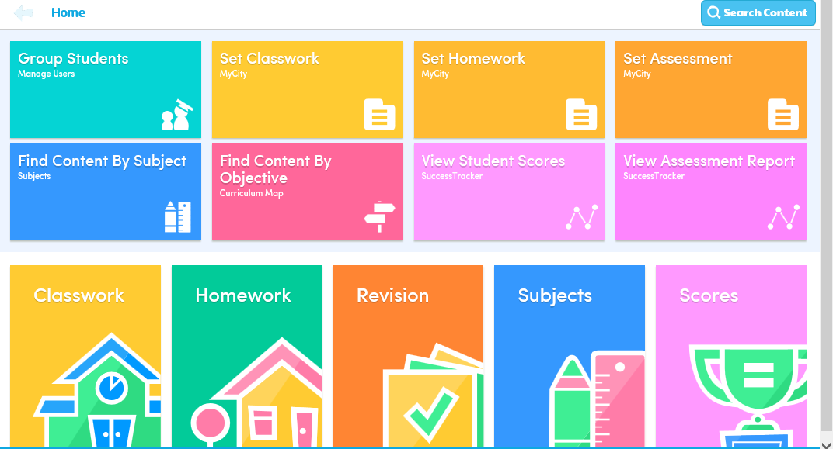
Click on English
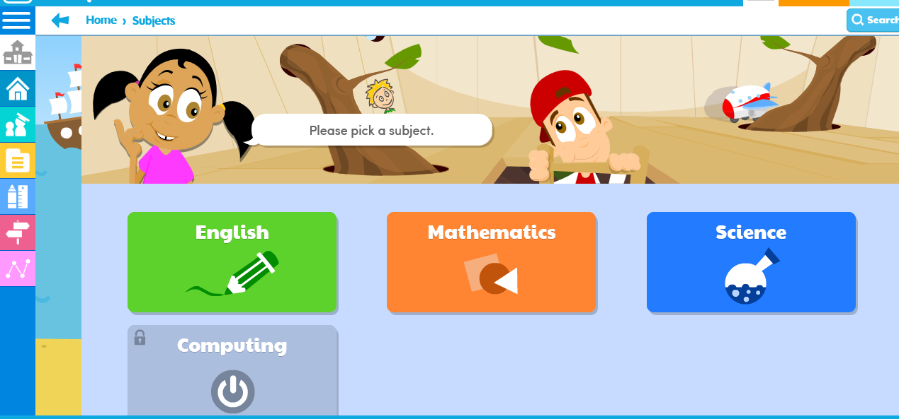
Click on EYFS
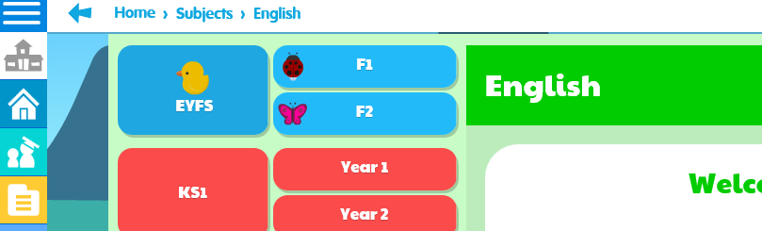

Click on Letters and Sounds

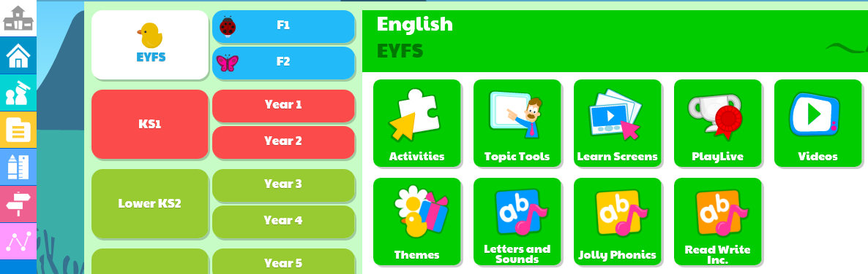
Click on Phase 2 or 3 (depending on which group your child is working in) then click on the sound you child is working on.


