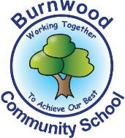
Reception Home Learning Pack – Monday 18th May 2020
Topic - Minibeasts
Literacy
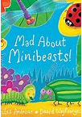
Reading:
This week our story focus is… Mad About Minibeasts
To read the story follow this link:
https://www.youtube.com/watch?v=SW-7MgHEZOE
Writing:
- Write a list of minibeasts you think you may find at the bottom of your garden.
- Go on a minibeast hunt in your garden! Draw and label all the minibeasts you find.
- Write a few sentences describing what the minibeasts looked like, how many legs they had etc
- Practise writing your name.
Reading
Please follow this link, it has lots of reading books that your child recieves from school.
https://www.oxfordowl.co.uk/for-home/find-a-book/library-page?view=image&query=&type=book&age_group=&level=book+band+1%3A+pink&level_select=book+band+1%3A+pink&book_type=&series=#
Maths
Focus of the week- counting,recognising, ordering and writing numbers to 20. Addition and subtraction.
You can dance, jump, whisper or shout your numbers to 20.
Using the worksheets below try to answer the questions or even make up your own. You may want to challenge yourselves and do bigger numbers!
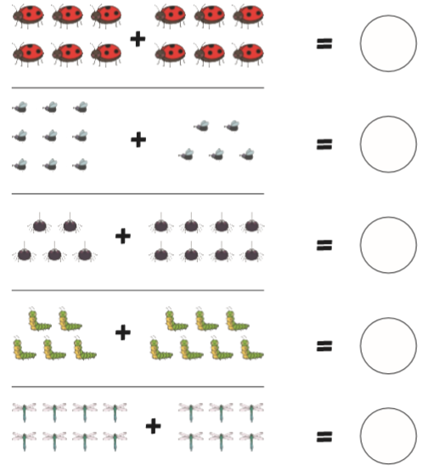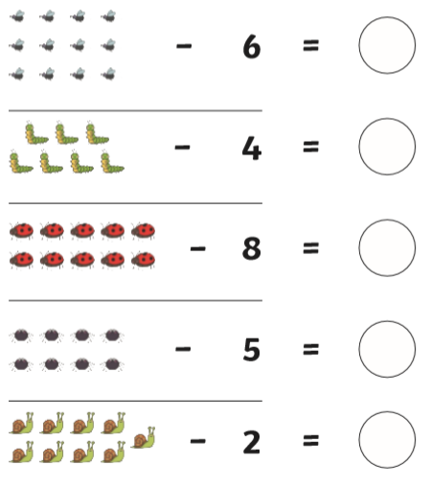

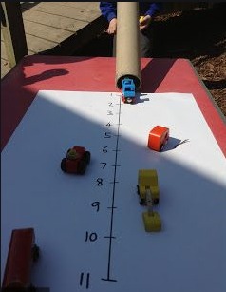
Go outside and find a flat path. Draw lines on the floor using tape or chalk and number them. Jump and mark where you land. Get people in your household to join in too! Talk about who jumped the shortest, longest or furthest distance.

If its raining you can do this inside, using a piece of paper draw a line and number it (as shown in the picture). Use an empty toilet roll holder and roll objects down to see how far they can travel. Lower and raise the toilet roll holder to see if this makes the objects travel longer or shorter.
Topic
Let’s get creative!  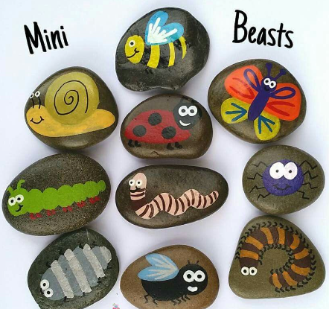  When you have painted your minibeast rocks, wait for them to dry and then put glue over them so they last longer. | Let’s get cooking!  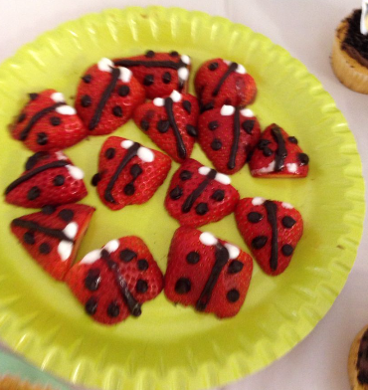  Using fruit you have in the house, see if you can make your very own minibeast snack. These ladybirds are made from strawberries!
PE: Please also try to enjoy some daily exercise (remember Joe Wicks is doing PE videos every morning!). There is also something called Jumpstart Jonny https://www.youtube.com/watch?v=-1Pz_R4aaDo
Also guided mediation and Cosmic Kids Yoga is a great way to have some quiet time.
https://www.youtube.com/watch?v=DWOHcGF1Tmc

https://www.youtube.com/watch?v=xlg052EKMtk

We miss you very much and hope to see you very soon!
Please share your home learning on our school Facebook page.
Miss Zahoor, Miss Wedgwood and Mrs Treasure.

