Monday | Tuesday | Wednesday | Thursday | Friday
Bank Holiday | Phonics Focus- CH | Phonics Focus- SH | Phonics Focus- TH | Tricky Words
Bank Holiday | Phonics play https://www.phonicsplay.co.uk  Recap sounds- Flash Card Speed Trial-Phase 2/3 | Phonics play https://www.phonicsplay.co.uk  Recap sounds- Flash Card Speed Trial-Phase 2/3 | Phonics play https://www.phonicsplay.co.uk  Recap sounds- Flash Card Speed Trial-Phase 2/3 | Play the tricky word songs  https://www.youtube.com/watch?v=TvMyssfAUx0  https://www.youtube.com/watch?v=ri4u0TjAZ38
Bank Holiday | Search ‘Geraldine the Giraffe learns the /CH/ sound’ on YouTube  Diagraph – 2 letters 1 sound- You find this diagraph at the end of a word | Search ‘Geraldine the Giraffe learns the /SH/ sound’ on YouTube  Diagraph – 2 letters 1 sound | Search ‘Geraldine the Giraffe learns the /TH/ sound’ on YouTube  Diagraph – 2 letters 1 sound | Tricky Words Phase 2/3 –  Play game on Phonics Play  Tricky Word Trucks
Bank Holiday | Have a go at writing some words that have the CH sound e.g.  Chip, chop, rich, chick, chin, chill | Write the words-  Shop, ship, shed, rush, hush, shush mush mash, bash, flash  Get an adult to stick them up around the room and run to the words | Write the words  Thick, thin, path, bath, moth, cloth on some paper.  Cut them up and get the children to put them back together. | Matching pairs Write some of tricky words on paper (duplicate).  Put them face down on the table and play the matching pair game.
Bank Holiday | Play the CH game on Education City- Free Trial  https://go.educationcity.com/content/index/34615/0/1/1/null/null/true/false/null/24//0 | Play the SH game on Education City- Free Trial  https://go.educationcity.com/content/index/34661/0/1/1/null/null/true/false/null/24//0 | Play the TH game on Education City- Free Trial  https://go.educationcity.com/content/index/34647/0/1/1/null/null/true/false/null/24//0 | Play the tricky word game on Education City- Free Trial  https://go.educationcity.com/content/index/34735/0/1/1/null/null/true/false/null/24//0

Access to Education City.
Type Education City into Google.
Click on find content by subject
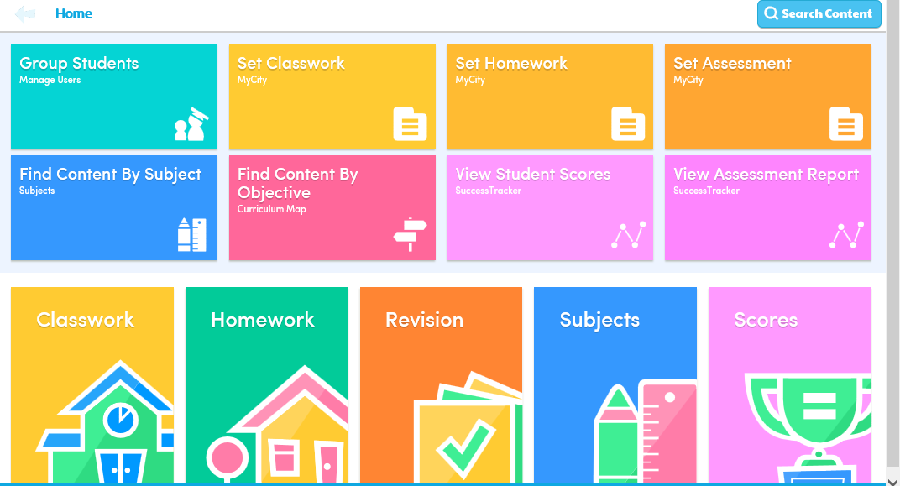
Click on English
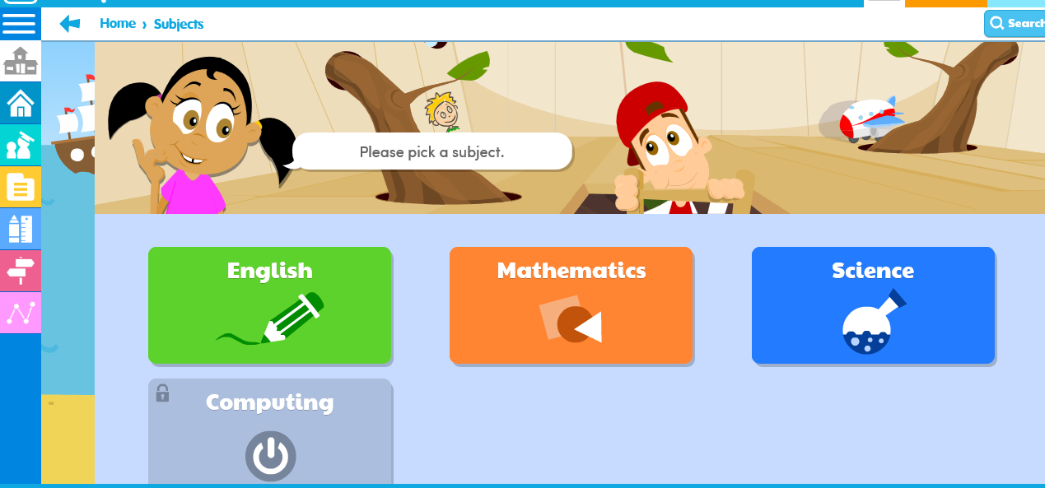
Click on EYFS
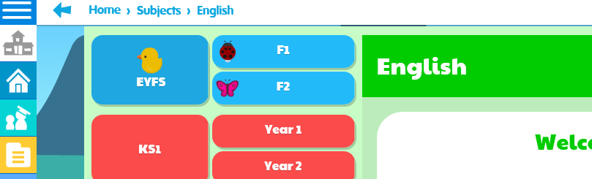

Click on Letters and Sounds

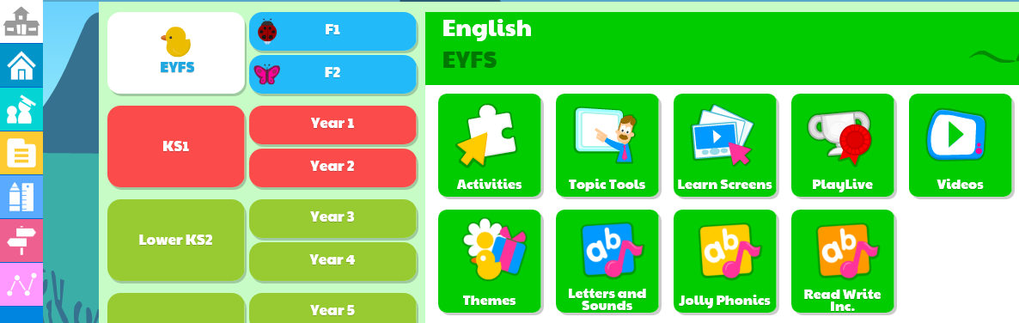
Click on Phase 2 or 3 (depending on which group your child is working in) then click on the sound you child is working on.


