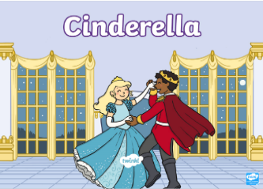

Literacy – Monday 27th April
Read the story Cinderella. If you don’t have this book at home you can access it, for free here:
https://www.twinkl.co.uk/resource/t-t-5223-cinderella-story-powerpoint
Answer these questions about the story – Cinderella. You could write the answers or say them verbally in a sentence (use the story and the pictures to help).
1. What colour is Cinderella’s hair?

2. How many ugly sisters did Cinderella have?

3. What colour was the fairy godmother’s dress?

4. Who did Cinderella marry?

Maths Homework – Monday
Count the pictures and write the answers in the circles. You can use the number line to help you to write the numbers.
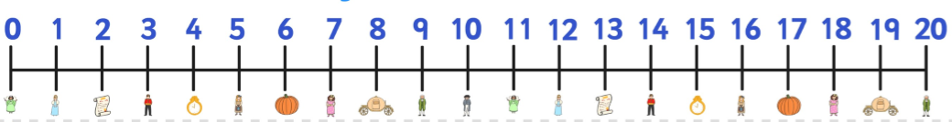

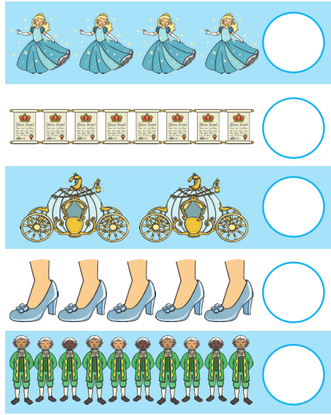

Literacy Homework – Tuesday
Write a word / caption or a sentence about each of the pictures.
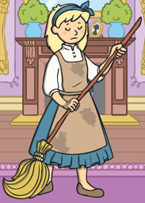
___________________________________________________________________________________________________________________
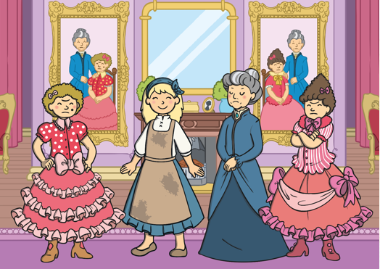
___________________________________________________________________________________________________________________
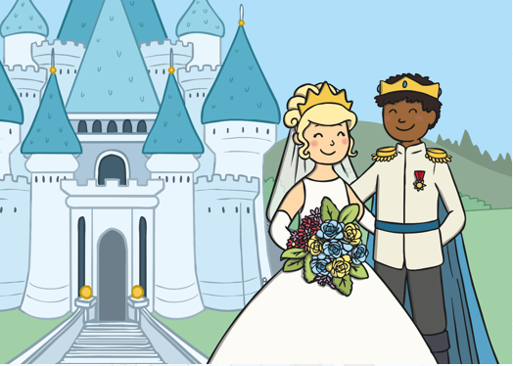
___________________________________________________________________________________________________________________

Maths Homework- Tuesday
Count the two groups and write the answer in the circle.

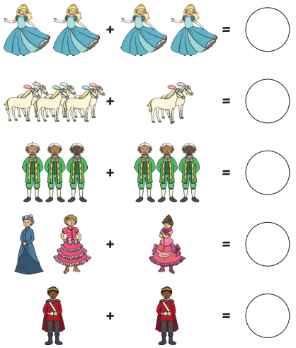
Literacy Homework – Wednesday
Read the story Hansel and Gretel. If you don’t have this book at home you can access it, for free here:
https://www.twinkl.co.uk/resource/t-t-10621-hansel-and-gretel-story-powerpoint

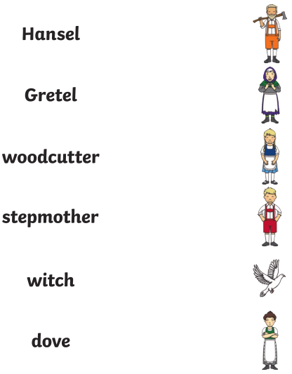

Maths Homework – Wednesday
Fill in the missing numbers on the path.

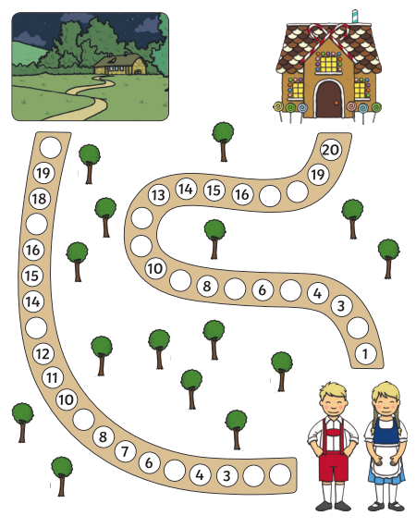

Literacy Homework – Thursday
Using the pictures, write a word, caption or a sentence.
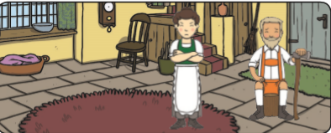

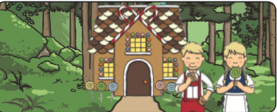

Maths Homework – Thursday
Use the number shapes to work out the answers to each subtraction question.

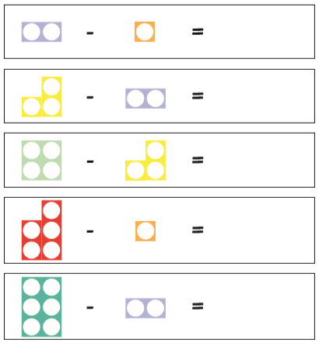

Literacy homework – Friday
Read and copy the tricky words the caterpillars are saying onto the leaves to help them turn into a butterfly.

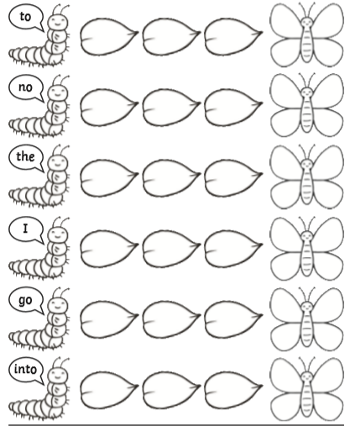
Maths Homework – Friday
2D shape colouring
Say the names of the 2D shapes and their properties and colouring them using the key.


