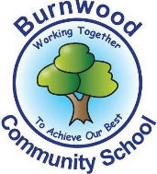
Reception Home Learning Pack – Monday 11th May 2020
Literacy – Once upon a time

Literacy
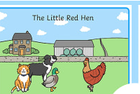
Reading:
This week our story focus is… The Little Red Hen
To read the story follow this link:
https://www.twinkl.co.uk/resource/t-t-11090-the-little-red-hen-story-powerpoint
Writing:
- Write a list of the animals that live on the farm.
- Draw and label your own farm.
- Write some instructions on how to make some bread.
- Write a few sentences using your phonics to explain why you liked this story.
- Practise writing your name.
Reading
Please follow this link, it has lots of reading books that your child recieves from school.
https://www.oxfordowl.co.uk/for-home/find-a-book/library-page?view=image&query=&type=book&age_group=&level=book+band+1%3A+pink&level_select=book+band+1%3A+pink&book_type=&series=#
Maths
Focus of the week- counting,recognising, ordering and writing numbers to 20. One more and one less.
You can hop, clap whisper or shout your numbers to 20.
Fill in the one more and one less than activities or create your own
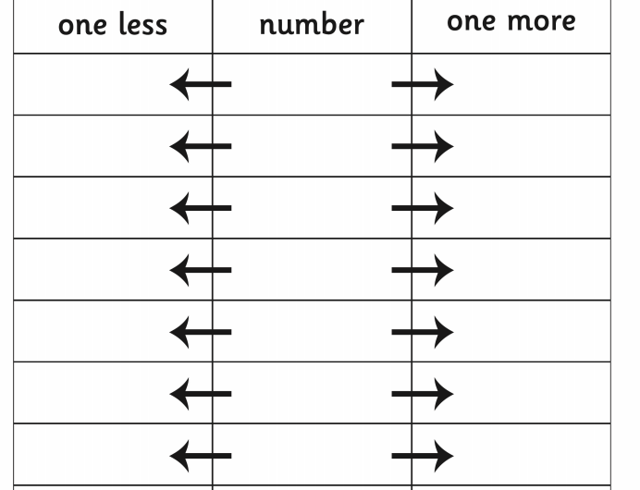
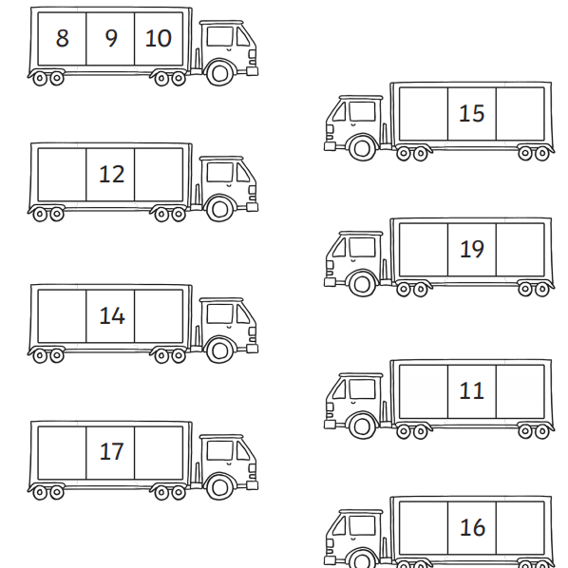

Set up a toy shop using your toys, you could even make price tags. Ask your parents or carers to take the role of the shop keeper and provide some coins. Use the coins to make the correct amounts. You could even set up an icecream palour!
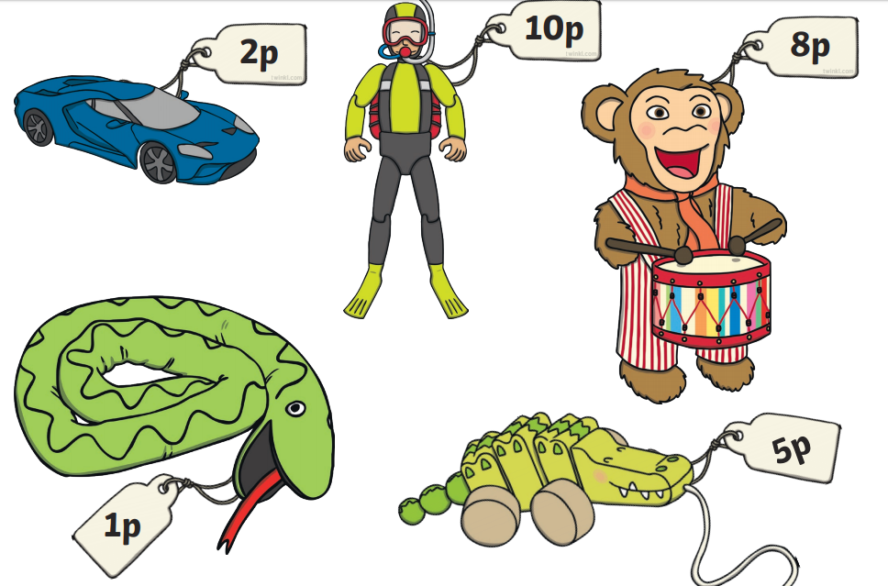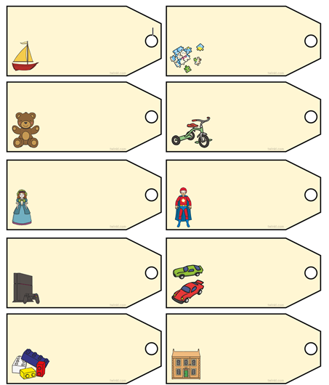
Topic
Let’s get creative!  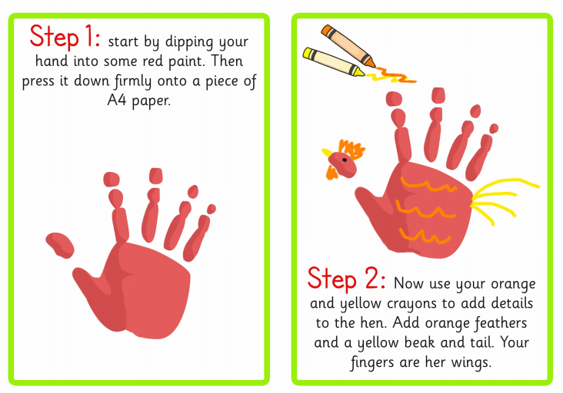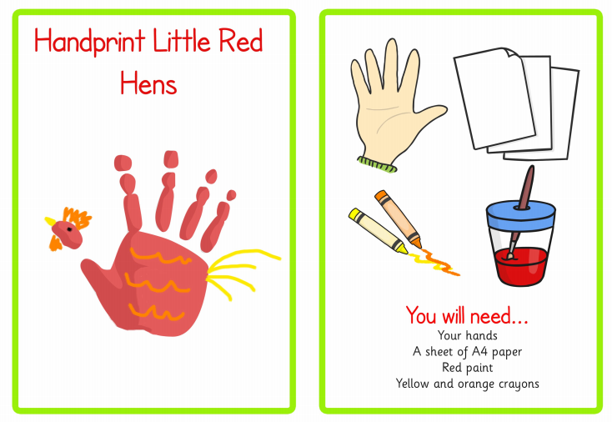 | Let’s get cooking!  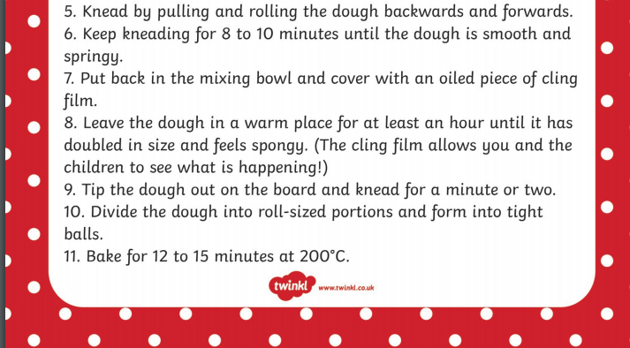  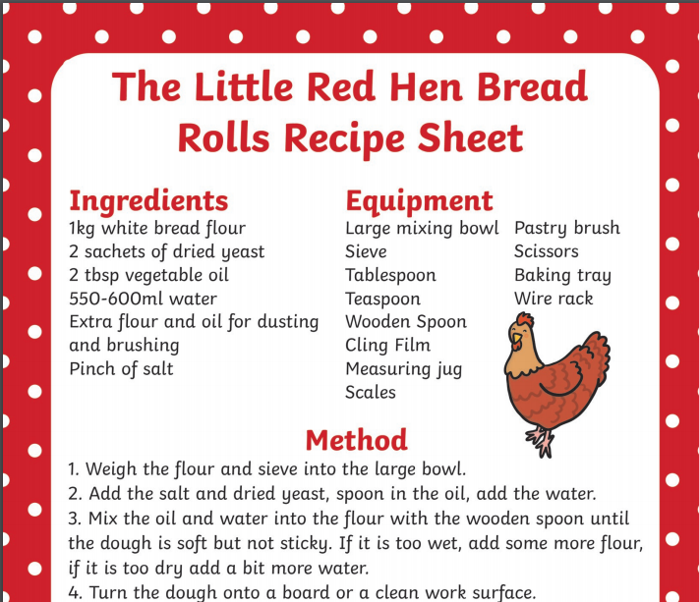
PE: Please also try to enjoy some daily exercise (remember Joe Wicks is doing PE videos every morning!).
Also guided mediation and Cosmic Kids Yoga is a great way to have some quiet time.
https://www.youtube.com/watch?v=DWOHcGF1Tmc

https://www.youtube.com/watch?v=xlg052EKMtk

We miss you very much and hope to see you very soon!
Please keep an eye out, we will be ringing you soon.
Miss Zahoor, Miss Wedgwood and Mrs Treasure.

