Monday | Tuesday | Wednesday | Thursday | Friday
Phonics Focus- EAR | Phonics Focus- AIR | Phonics Focus-URE | Phonics Focus- ER | Tricky Words
Phonics play https://www.phonicsplay.co.uk  Recap sounds- Flash Card Speed Trial-Phase 2/3 | Phonics play https://www.phonicsplay.co.uk  Recap sounds- Flash Card Speed Trial-Phase 2/3 | Phonics play https://www.phonicsplay.co.uk  Recap sounds- Flash Card Speed Trial-Phase 2/3 | Phonics play https://www.phonicsplay.co.uk  Recap sounds- Flash Card Speed Trial-Phase 2/3 | Play the tricky word songs  https://www.youtube.com/watch?v=TvMyssfAUx0  https://www.youtube.com/watch?v=ri4u0TjAZ38
Search ‘Geraldine the Giraffe learns the /EAR/ sound’ on YouTube  Trigraph – 3 letters 1 sound | Search ‘Geraldine the Giraffe learns the /AIR/ sound’ on YouTube  Trigraph – 3 letters 1 sound | Search ‘Geraldine the Giraffe learns the /URE/ sound’ on YouTube  Trigraph – 3 letters 1 sound | Search ‘Geraldine the Giraffe learns the /ER/ sound’ on YouTube  Diagraph – 2 letters 1 sound | Tricky Words Phase 2/3 –  Play game on Phonics Play  Tricky Word Trucks
Write the words on some paper.  Ear, fear, spear, hear, near.  Cut them up and get the children to put them back together.  Now choose a word and write a sentence e.g.  My beard is brown, | Have a go at writing some words that have the AIR sound e.g.  Stairs, hair, chair, lair, fair, pair, air  Now choose a word and write a sentence e.g.  I can sit on my chair. | Write the words-  Pure, cure, lure  Get an adult to stick them up around the room and run to the words  Now choose a word and write a sentence e.g.  The silver is pure. | Write the words-  River, summer, rubber, mixer, burger, winter  Get an adult to stick them up around the room and run to the words  Now choose a word and write a sentence e.g.  The river is cool. | Matching pairs Write some of tricky words on paper (duplicate).  Put them face down on the table and play the matching pair game.
Play the EAR game on Education City- Free Trial | Play the AIR game on Education City- Free Trial | Play the URE game on Education City- Free Trial | Play the ER game on Education City- Free Trial | Play the tricky word game on Education City- Free Trial

Access to Education City.
Type Education City into Google.
Click on find content by subject
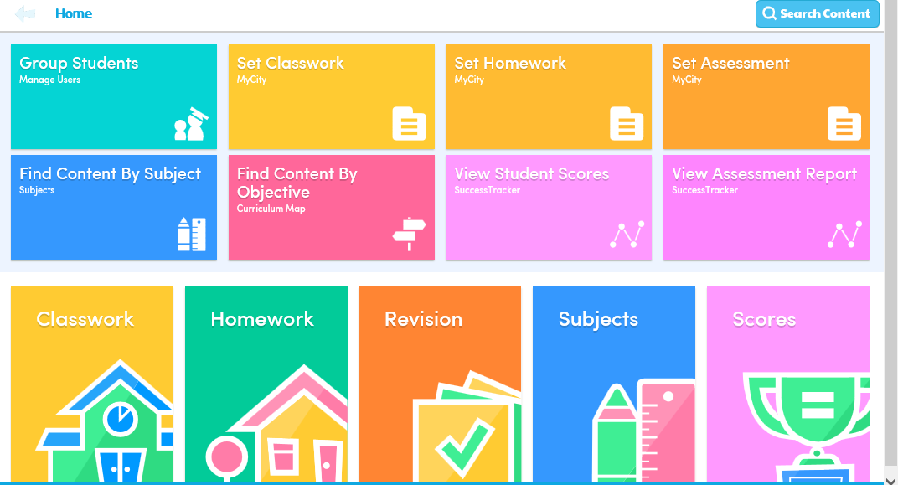
Click on English
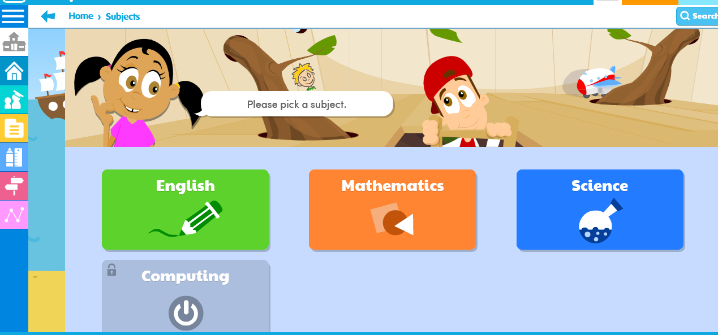
Click on EYFS
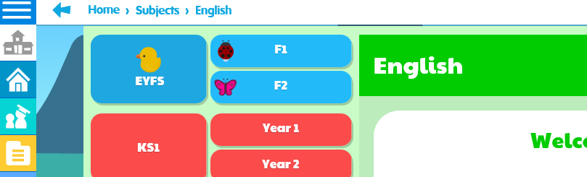

Click on Letters and Sounds

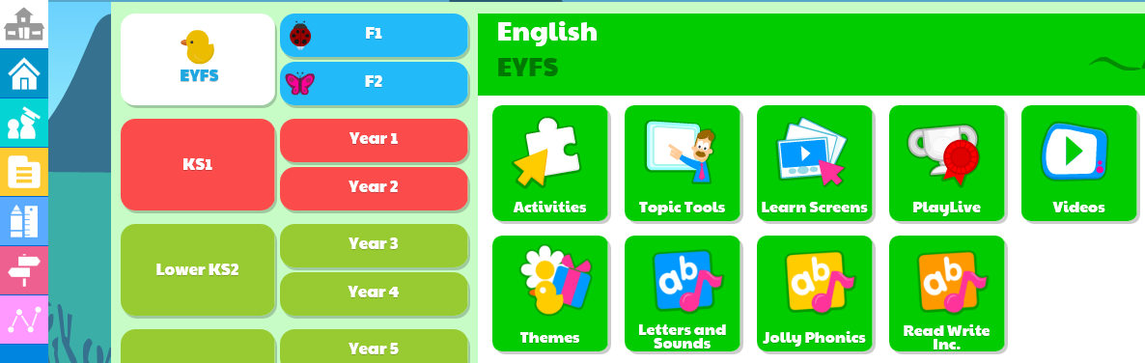
Click on Phase 2 or 3 (depending on which group your child is working in) then click on the sound you child is working on.


