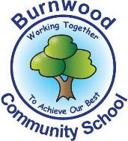
Reception Home Learning Pack – Monday 1st June 2020
Topic – Under the Sea
Literacy
Reading:
This week our story focus is… Sharing a Shell
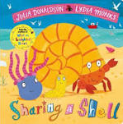
To read the story follow this link:
https://www.youtube.com/watch?v=VpJumAZx1t8
Can you answer these questions about the story or by looking at the pictures?
- What colour is the gull?
- Where is the story set?
- What sea creatures can you see in the book?

Reading
Please follow this link, it has lots of reading books that your child recieves from school.
https://www.oxfordowl.co.uk/for-home/find-a-book/library-page?view=image&query=&type=book&age_group=&level=book+band+1%3A+pink&level_select=book+band+1%3A+pink&book_type=&series=#

Writing:
- Write a list of the sea creatures that are in the book
- Choose one of the characters in the story. Draw a picture of it and write a few CVC words or sentences about it to describe it. E.g how many legs, eyes, colour of its shell etc.
- Write about the story using the frame below to help.

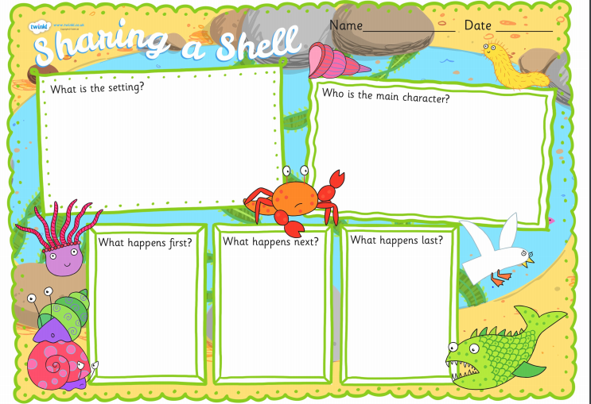

Ycan download it using this link
https://content.twinkl.co.uk/resource/ff/8a/T-T-12728-Sharing-a-Shell-Book-Review-Writing-Frame.pdf?__token__=exp=1590841888~acl=%2Fresource%2Fff%2F8a%2FT-T-12728-Sharing-a-Shell-Book-Review-Writing-Frame.pdf%2A~hmac=7725ad47a73fe5e6e13ca53a5b77a953bb9605b8fb824a0daf75fff8360e7e15
- Practise writing your full name (first and last names).

Maths
Number
Focus of the week- counting,recognising, ordering and writing numbers to 20. Addition and subtraction.
You can dance, jump, whisper or shout your numbers to 20.
Using the worksheets below try to answer the questions or even make up your own. You may want to challenge yourselves and do bigger numbers!
Complete the addition sums.
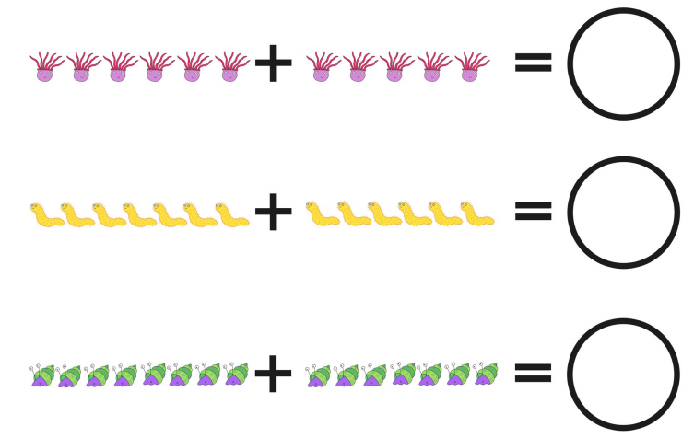
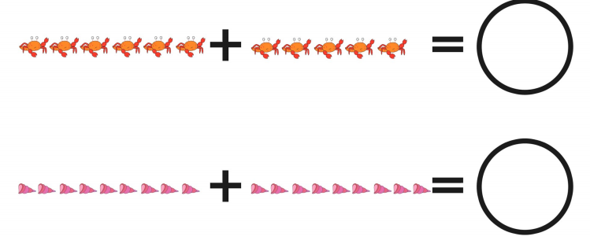
Shape, Space and Measure
Order the shells from smallest to largest.

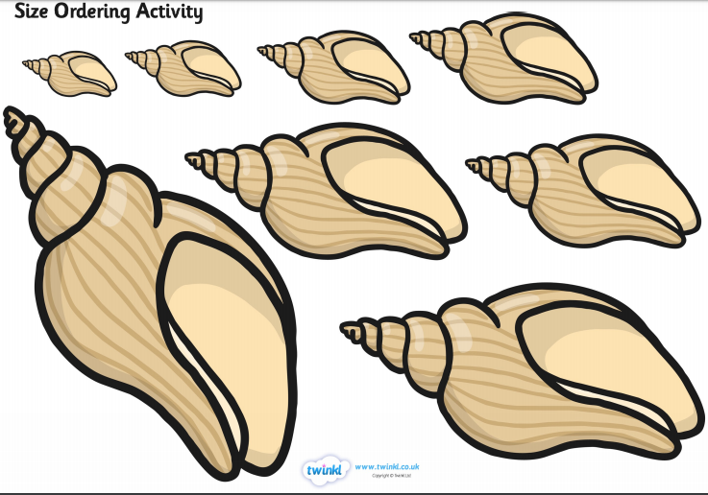

You can oder 3 or more of all them if you wish. Here is a miknk to the webpage that you can download.
https://content.twinkl.co.uk/resource/62/c2/T-T-5519-Under-The-Sea-Shell-Size-Ordering.pdf?__token__=exp=1590842930~acl=%2Fresource%2F62%2Fc2%2FT-T-5519-Under-The-Sea-Shell-Size-Ordering.pdf%2A~hmac=bd4ef6f1ed7b7a65fd1a5faef7aa80e510c1fec2aa36e12e9dbc82e49e00cfa8

If you cannot access this you can find 3 objects in your house and order them from smallest to largest.
You could use toys, books etc.

Topic
Let’s get creative!  Make a crab using a paper plate  Use the link to read the instructions https://simplytodaylife.com/paper-plate-ocean-crab-craft/  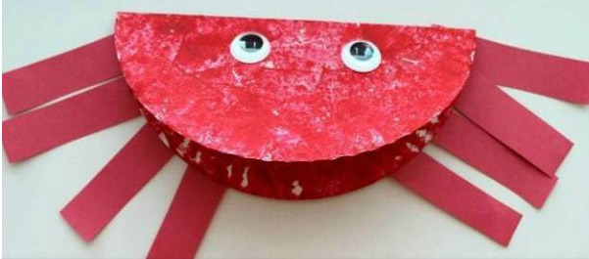 | Let’s get cooking!  Make a sandwich that looks like a crab  Try making your own sandwich in the shape of a crab. Use the link below to help.  https://www.pinterest.co.uk/pin/469218854913200884/  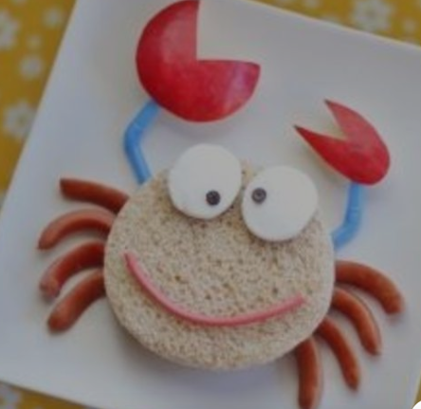
PE: Please also try to enjoy some daily exercise (remember Joe Wicks is doing PE videos every morning!). There is also something called Jumpstart Jonny https://www.youtube.com/watch?v=-1Pz_R4aaDo
Also guided mediation and Cosmic Kids Yoga is a great way to have some quiet time.
https://www.youtube.com/watch?v=DWOHcGF1Tmc

https://www.youtube.com/watch?v=xlg052EKMtk

We miss you very much and hope to see you very soon!
Please share your home learning on our school Facebook page.
Miss Zahoor, Miss Wedgwood and Mrs Treasure.

