Hello everyone,
I hope you are all keeping safe and well. As school has now opened to children within reception, we are going to be starting a new phase of phonics in line with it being taught in school.

This will also mean new tricky words to learn, but we will continue to practise the tricky words we have already learnt. If there are any questions or queries please feel free to contact the school office or school Facebook page and any message will be passed on for us to help you.

Your child(ren) may struggle, this is normal! Contact us if you need any help or support with this. I will be giving links to the same two games per week with details on how to access them and swapping them each week to give the children chance to get used to them. The initial video may also be repeated, this is so that your child gets used to the pronunciation of the consonant blends being taught.

Miss Wedgwood

Monday | Tuesday | Wednesday | Thursday | Friday
Phonics focus – st | Phonics focus – nd | Phonics focus – mp | Phonics focus – nt | Phonics focus – tricky words
Recap sounds - Phonics Bloom  https://www.phonicsbloom.com/uk/game/flash-cards-time-trial?phase=3 | Recap sounds - Phonics Bloom  https://www.phonicsbloom.com/uk/game/flash-cards-time-trial?phase=3 | Recap sounds - Phonics Bloom  https://www.phonicsbloom.com/uk/game/flash-cards-time-trial?phase=3 | Recap sounds - Phonics Bloom  https://www.phonicsbloom.com/uk/game/flash-cards-time-trial?phase=3 | https://www.youtube.com/watch?v=3NOzgR1ANc4
Https://www.youtube.com/watch?v=mPtYpqEwEHo | https://www.youtube.com/watch?v=k-1rmuOxGE8&list=PLr8_5HYa7f2I0OEnEYzDtFAQa-TzztD1X | https://www.youtube.com/watch?v=k-1rmuOxGE8&list=PLr8_5HYa7f2I0OEnEYzDtFAQa-TzztD1X | https://www.youtube.com/watch?v=k-1rmuOxGE8&list=PLr8_5HYa7f2I0OEnEYzDtFAQa-TzztD1X | Get your child to write each of the tricky words as they appear on the screen.
Have a go at writing each of these words:  Stem, stool, stairs, stick, stop.  Have a go at writing this sentence: The nest is next to the star.  Remember; capital letters, finger spaces and a full stop. | Once you have watched the video and your child has wrote all the words; sand, bend, fund (check they are spelt correctly) you can use these to put around the room. And then get your child to run to them once you have said them.  Have a go at writing this sentence: I want to stand next to the band. | Get your child to write the words on a piece of paper, put them on the floor and segment each of the words. Get your child to splat them using a fly swat/spatula or wooden spoon.  Have a go at writing this sentence: A chimp can stand. | Have a go at writing these words; tent, lent, sent, trent, bent. Put them next to a cushion, get your child to say them out loud as they stand on the cushion next to the word.  Have a go at writing this sentence: But I burnt the toast. | Write another set of the tricky words and lie both sets face down. Play the matching pairs game and see who finds all the matching tricky words first.
Play the game ‘Make a Match’ on Phonics Play  https://www.phonicsplay.co.uk/member-only/MatchingPh4.html | Play the game; ‘Buried Treasure’ on Phonics Play  https://www.phonicsplay.co.uk/member-only/BuriedTreasure2.html | Play the game ‘Make a Match’ on Phonics Play  https://www.phonicsplay.co.uk/member-only/MatchingPh4.html | Play the game; ‘Buried Treasure’ on Phonics Play  https://www.phonicsplay.co.uk/member-only/BuriedTreasure2.html | https://www.phonicsplay.co.uk/member-only/TrainYourBrainPh4.html

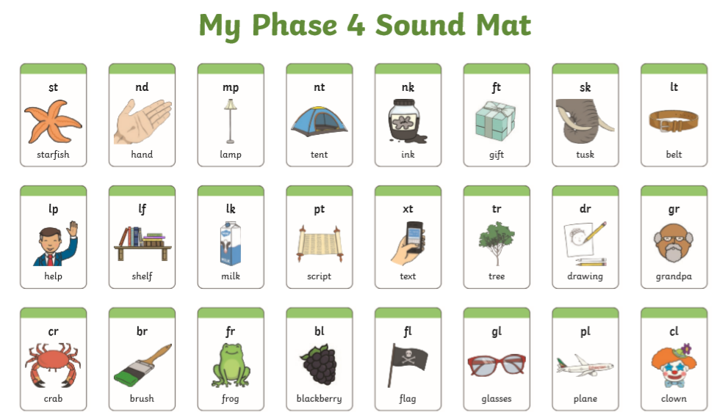

Tuesday and Thursday’s game
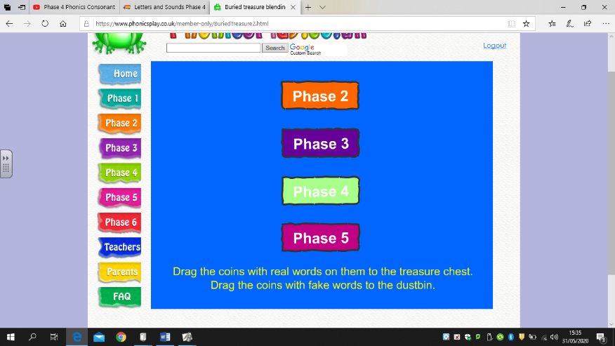
Click phase 4

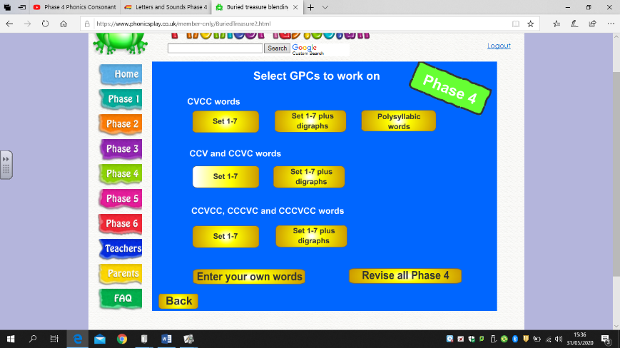
And then under CCV and CCVC words click: Set 1-7

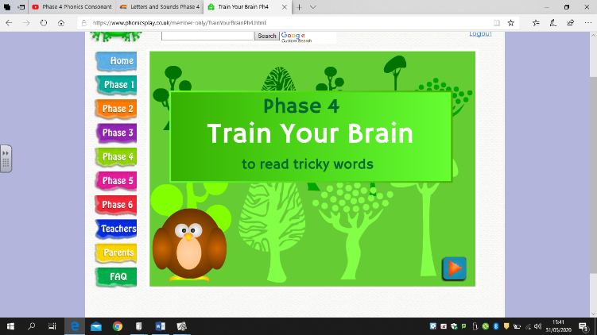
Friday’s game
Click the arrow in the bottom right corner

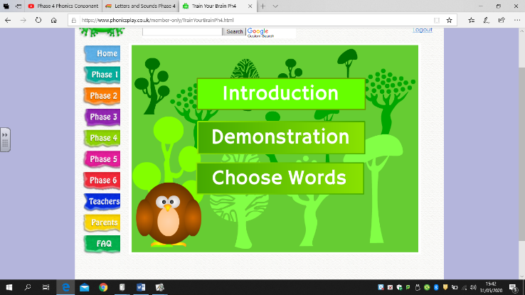

And then click introduction. This will talk you through it.

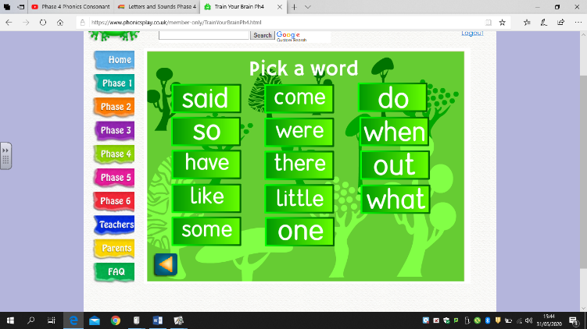
Once you have listened to the introduction you need so click on the tricky words you want to practise.

