Hello everyone,
I hope you are all well and enjoying your home learning!

When children start Phase Four of the phonics programme, they will know a grapheme for each of the 42 phonemes. They will also be able to blend phonemes to read CVC (consonant-vowel-consonant) words and segment in order to spell them. Children will also have begun reading straightforward two-syllable words and simple captions, as well as reading and spelling tricky words.

The main aim of this phase is to consolidate the children's knowledge and to help them learn to read and spell words which have adjacent consonants, such as: trap, string and milk.

Miss Wedgwood

Monday | Tuesday | Wednesday | Thursday | Friday
Phonics focus – lp | Phonics focus – lf | Phonics focus – lk | Phonics focus – pt | Phonics focus – tricky words
Recap sounds  https://www.phonicsplay.co.uk/member-only/Flashcards.html  phase 2 and 3. | Recap sounds  https://www.phonicsplay.co.uk/member-only/Flashcards.html | Recap sounds  https://www.phonicsplay.co.uk/member-only/Flashcards.html | Recap sounds  https://www.phonicsplay.co.uk/member-only/Flashcards.html | https://www.youtube.com/watch?v=3NOzgR1ANc4
Please watch this video on youtube:  https://www.youtube.com/watch?v=7_c8RCjU8_g | Please watch this video on youtube:  https://www.youtube.com/watch?v=k-1rmuOxGE8 | Please watch this video on youtube:  https://www.youtube.com/watch?v=k-1rmuOxGE8 | Please watch this video on youtube, skip it to 3:50:  https://www.youtube.com/watch?v=y8wcpHpfOKY&t=458s | Get your child to write each of the tricky words as they appear on the screen.
Have a go at writing these words; ink, blink, think, stink  Have a go at writing this sentence: A drip from the tap drops in the sink.  Remember; capital letters, finger spaces and a full stop. | Have a go at writing these words; left, gift, lift.  Have a go at writing this sentence: I left a gift on the step. | Have a go at writing these words; tusk, mask, ask, task  Have a go at writing this sentence:  The plump skunk stinks. | Have a go at writing these words; belt, felt, melt, adult  Have a go at writing this sentence: The flag twisted on the steep hill.
Play the game ’Picnic on Pluto’ on Phonics Play.  https://www.phonicsplay.co.uk/member-only/PicnicOnPluto.html | Play ‘Rocket Rescue’ on Phonics Play.  https://www.phonicsplay.co.uk/member-only/Ph4RocketRescue.html | Play the game ’Picnic on Pluto’ on Phonics Play.  https://www.phonicsplay.co.uk/member-only/PicnicOnPluto.html | Play ‘Rocket Rescue’ on Phonics Play.  https://www.phonicsplay.co.uk/member-only/Ph4RocketRescue.html

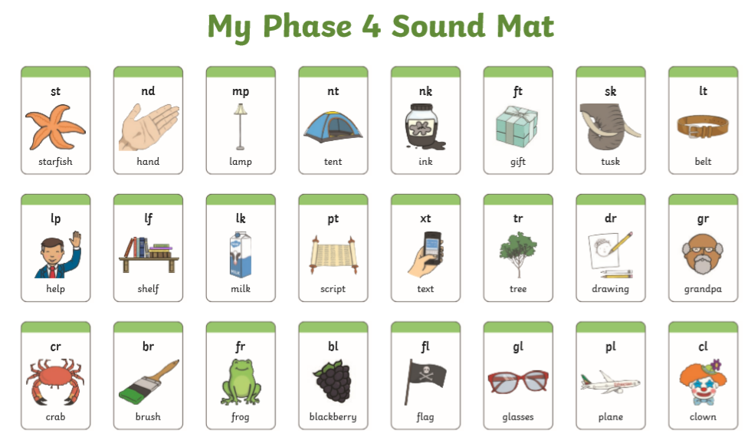

Weekly recap of sounds
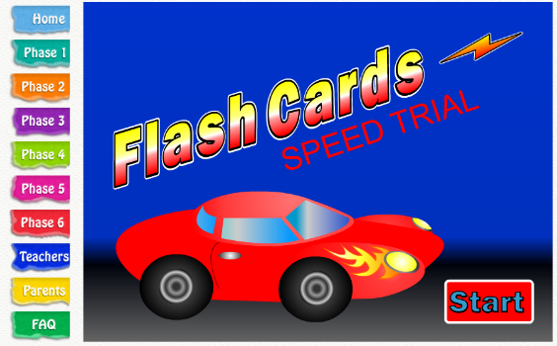
Click start

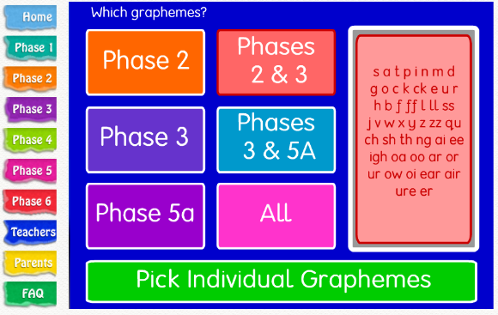

Click phases2 and 3

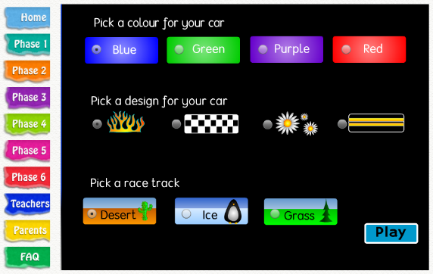
Your child can choose their own settings for their car

Monday and Wednesday’s Game
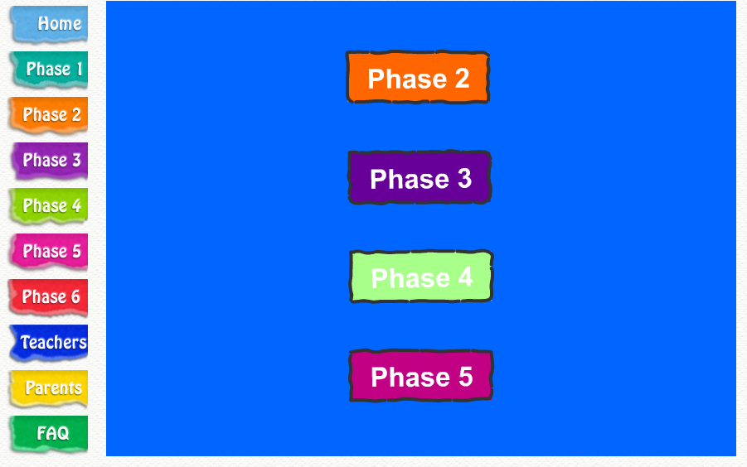
Click Phase 4

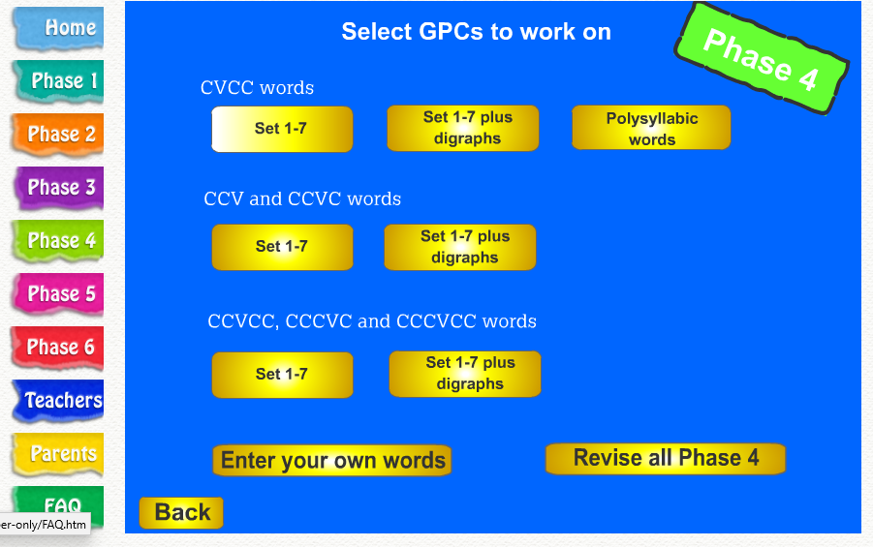
Under CVCC words
Click set 1-7 plus digraphs

Friday’s game
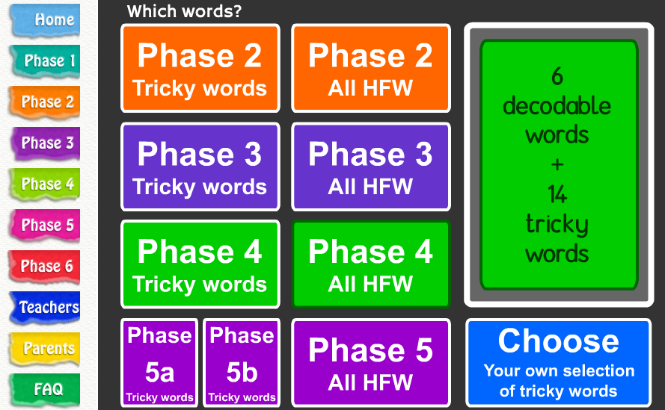
Click Phase 4
All HFW

