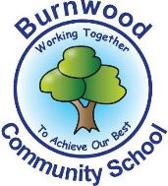
Reception Home Learning Pack – Monday 8th June 2020
Topic – Under the Sea
Literacy
Reading:
This week our story focus is… The snail and the whale
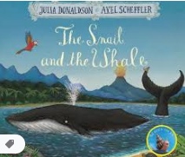
To read the story follow this link:
https://www.youtube.com/watch?v=x887mPO9X9c
To watch the video follow this think
https://www.bbc.co.uk/iplayer/episode/m000cslw/the-snail-and-the-whale
Can you answer these questions about the story or by looking at the pictures?
- Who are the main characters in the story?
- Where is the story set?
- Can you find words that rhyme in the story?
- Who helped to rescue the whale when it was stuck on the sand?

Reading
Please follow this link, it has lots of reading books that your child recieves from school.
https://www.oxfordowl.co.uk/for-home/find-a-book/library-page?view=image&query=&type=book&age_group=&level=book+band+1%3A+pink&level_select=book+band+1%3A+pink&book_type=&series=#

Writing:
- Choose a picture from the look. Look at it and discuss what is in thet picture / what is happening with an adult
- Write an intial sounds / CVC words and sentences or captions about the picture.
- Practise writing your full name (first and last names).

Maths
Number
Starter activities
- Count forwards and backwards to 1-10 – use this video link
https://www.bbc.co.uk/bitesize/topics/zhsspg8/articles/zfqcbdm
- Count forwards and backwards to 20 – use the link
https://www.bbc.co.uk/bitesize/topics/zhsspg8/articles/zm83f4j
- Write numbers 1-20 on pieces of paper. Place them face down on a table. Choose 1and say the number.
- Chooose a number that is on a piece of paper, (between 1 – 200 say it and then do the number of jumps, claps or hops that is on the paper.
- Write numbers that an adults says to youbetween 1 – 20.
- Count in 2s - 2 times table- follow the link - https://www.bbc.co.uk/teach/supermovers/ks1-maths-the-2-times-table-with-bridget-the-lioness/zrrx92p

Main activities –
This week our maths focus is – subtraction – (taking away)
- Watch this powerpoint on twinkl about subtraction – follow the link
https://www.twinkl.co.uk/resource/t-n-1288-under-the-sea-themed-subtraction-powerpoint

- Complete these tasks with an adult. Cross out the amount you are taking away or use the number lint to count backwards.

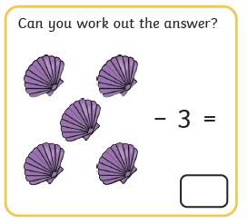

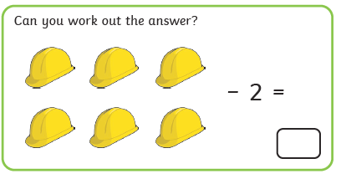
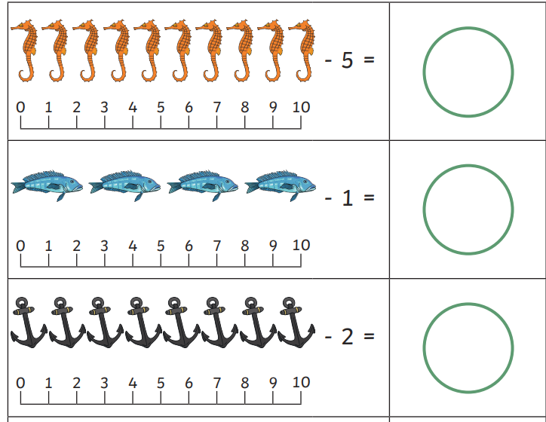

Try to solve these subtraction word problems.
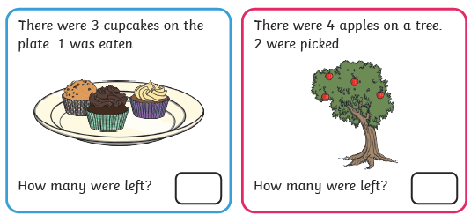
Shape, Space and Measure
- Make a bridge using 3d shapes that you can find around the home.
- you could use tins, packets food,boxes etc.

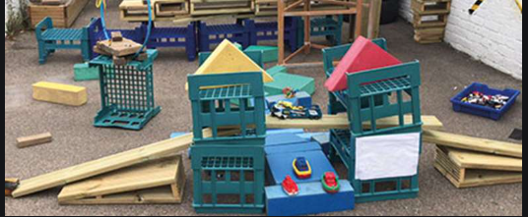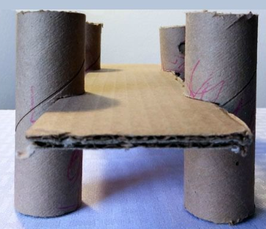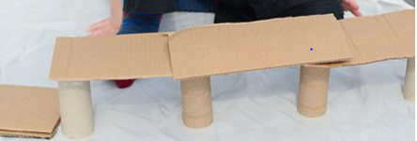

Topic
Let’s get creative!

- Draw or paint a picture of a whale.
- Make a whale using a paper plate

Here are some ideas to help you

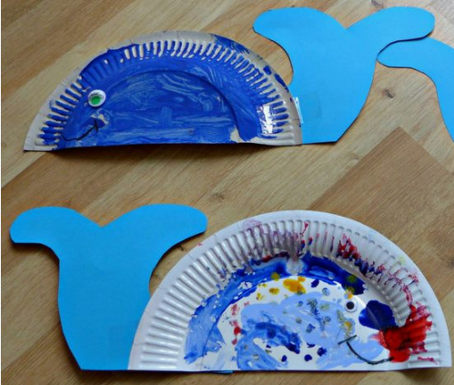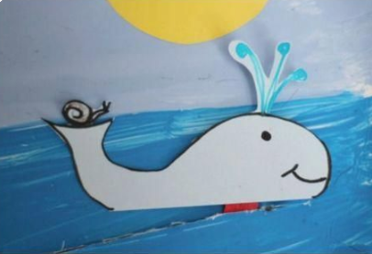

All about whales

- Watch this video about whales
- Talk about what you have learnt about them with an adult.

PE: Please also try to enjoy some daily exercise (remember Joe Wicks is doing PE videos every morning!). There is also something called Jumpstart Jonny https://www.youtube.com/watch?v=-1Pz_R4aaDo
Also guided mediation and Cosmic Kids Yoga is a great way to have some quiet time.
https://www.youtube.com/watch?v=DWOHcGF1Tmc

https://www.youtube.com/watch?v=xlg052EKMtk

We miss you very much and hope to see you very soon!
Please share your home learning on our school Facebook page.
Miss Zahoor, Miss Wedgwood and Mrs Treasure.

