Hello everyone,
I hope you are all well and enjoying your home learning!

When children start Phase Four of the phonics programme, they will know a grapheme for each of the 42 phonemes. They will also be able to blend phonemes to read CVC (consonant-vowel-consonant) words and segment in order to spell them. Children will also have begun reading straightforward two-syllable words and simple captions, as well as reading and spelling tricky words.

The main aim of this phase is to consolidate the children's knowledge and to help them learn to read and spell words which have adjacent consonants, such as: trap, string and milk.

Miss Wedgwood

Monday | Tuesday | Wednesday | Thursday | Friday
Phonics focus – nk | Phonics focus – ft | Phonics focus – sk | Phonics focus – lt | Phonics focus – tricky words
Recap sounds  https://www.ictgames.com/phonicsPop/index.html  Select the sounds: ee, er, ur | Recap sounds  https://www.ictgames.com/phonicsPop/index.html  Select the sounds: ir, ue, ew | Recap sounds  https://www.ictgames.com/phonicsPop/index.html  Select the sounds: oo, oo, au. | Recap sounds  https://www.ictgames.com/phonicsPop/index.html  Select the sounds: or, igh, ai | https://www.youtube.com/watch?v=3NOzgR1ANc4
Please watch this video on youtube:  https://www.youtube.com/watch?v=7_c8RCjU8_g | Please watch this video on youtube:  https://www.youtube.com/watch?v=k-1rmuOxGE8 | Please watch this video on youtube:  https://www.youtube.com/watch?v=k-1rmuOxGE8 | Please watch this video on youtube, skip it to 3:50:  https://www.youtube.com/watch?v=y8wcpHpfOKY&t=458s | Get your child to write each of the tricky words as they appear on the screen.
Have a go at writing these words; ink, blink, think, stink  Have a go at writing this sentence: A drip from the tap drops in the sink.  Remember; capital letters, finger spaces and a full stop. | Have a go at writing these words; left, gift, lift.  Have a go at writing this sentence: I left a gift on the step. | Have a go at writing these words; tusk, mask, ask, task  Have a go at writing this sentence:  The plump skunk stinks. | Have a go at writing these words; belt, felt, melt, adult  Have a go at writing this sentence: The flag twisted on the steep hill. | Using the words your child wrote play a game of bingo. Say the words and get your child you cross them out once you have said them.
Play the game ‘Dragons Den’ on Phonics Play  https://www.phonicsplay.co.uk/member-only/DragonsDen.html | Play ‘Space Race’ on Phonics Play.  https://www.phonicsplay.co.uk/member-only/SpaceRacePhase4.html | Play the game ‘Dragons Den’ on Phonics Play  https://www.phonicsplay.co.uk/member-only/DragonsDen.html | Play ‘Space Race’ on Phonics Play.  https://www.phonicsplay.co.uk/member-only/SpaceRacePhase4.html | https://www.phonicsplay.co.uk/member-only/TrainYourBrainPh4.html  Focus on: said, come, do, so, were.

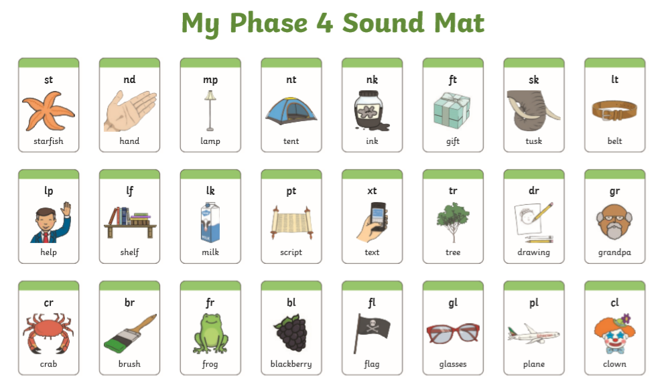

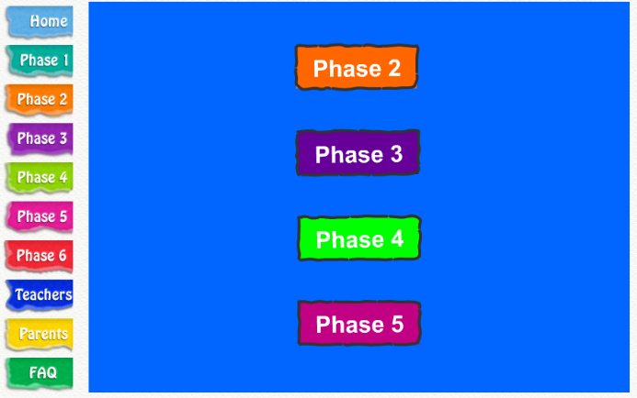
Monday and Wednesday’s Game
Click Phase 4

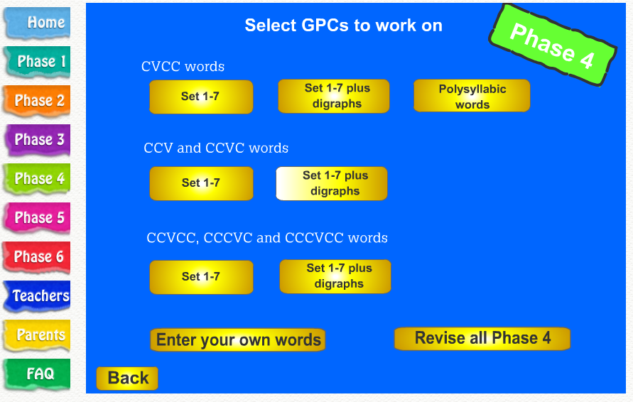
Under CCV and CCVC words
Click set 1-7 plus digraphs

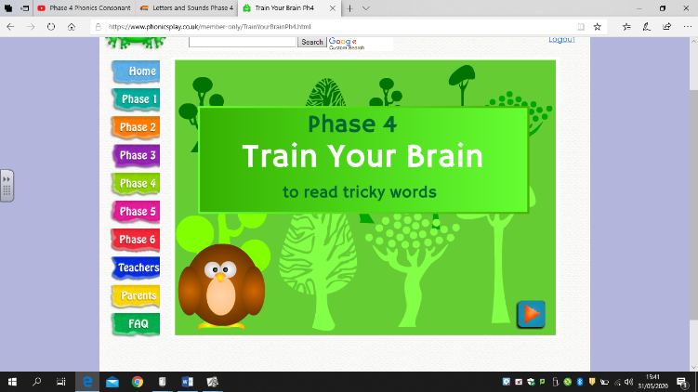
Friday’s game
Click the arrow in the bottom right corner

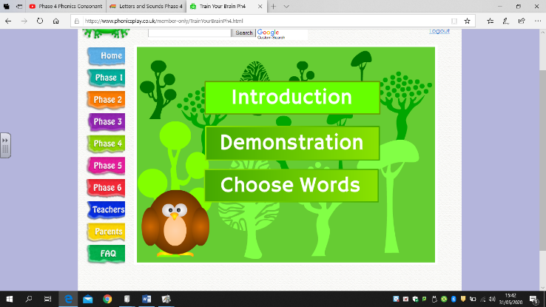

And then click introduction. This will talk you through it.

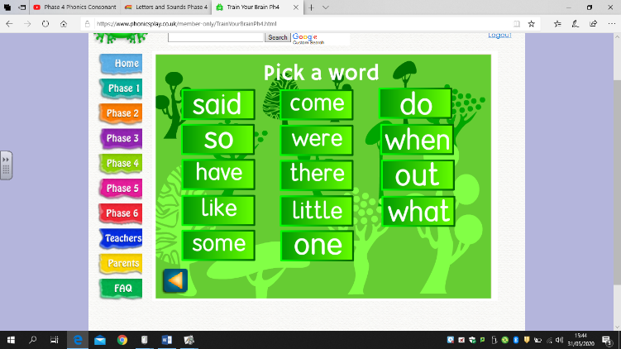
Once you have listened to the introduction you need so click on the tricky words you want to practise.

