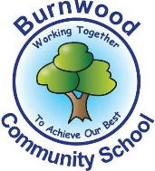
Reception Home Learning Pack – Monday 15th June 2020
Topic – Let’s Set Sail
Literacy
Reading:
This week our story focus is… The Rainbow Fish
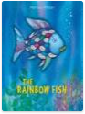
To read / listen to the story follow this link:
https://www.youtube.com/watch?v=QFORvXhub28
To watch the video follow this think
https://www.youtube.com/watch?v=ifXlc0QI2kY
Can you answer these questions about the story or by looking at the pictures?
- Who is the main characters in the story?
- What was special about Rainbow Fish?
- Where is the story set?
- Who did Rainbow fish find in the cave?
- Was Rainbow Fish happy at the end of the story? Why?

Reading
Please follow this link, it has lots of reading books that your child recieves from school.
https://www.oxfordowl.co.uk/for-home/find-a-book/library-page?view=image&query=&type=book&age_group=&level=book+band+1%3A+pink&level_select=book+band+1%3A+pink&book_type=&series=#

Writing:
- Choose a picture from the book. With an adult, look at it and discuss what is in the picture / what is happening ?
- Write intial sounds / CVC words and sentences or captions about the picture.
You can use this word bank to help
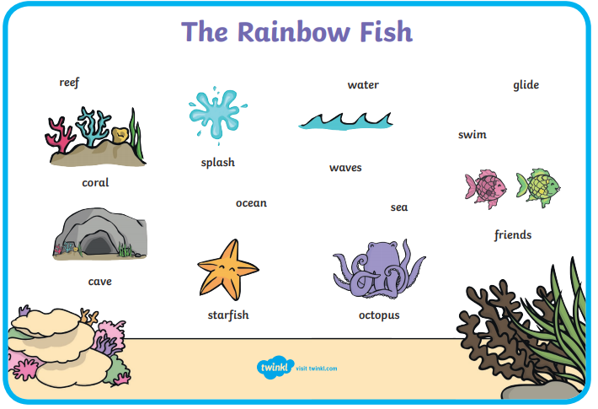
- Write a wish list. (Write a list of things that you would like if you could have anything you wanted.
- Practise writing your full name (first and last names).

Maths
Number
Starter activities
- Count forwards and backwards to 1-10 – use this video link
https://www.bbc.co.uk/bitesize/topics/zhsspg8/articles/zfqcbdm
- Count forwards and backwards to 20 – use the link
https://www.bbc.co.uk/bitesize/topics/zhsspg8/articles/zm83f4j
- Write numbers 1-20 on pieces of paper. Place them face down on a table. Choose 1and say the number.
- Chooose a number that is on a piece of paper, (between 1 – 20 say it and then do the number of jumps, claps or hops that is on the paper.
- Write numbers that an adults says to youbetween 1 – 20.
- Count in 2s - 2 times table- follow the link - https://www.bbc.co.uk/teach/supermovers/ks1-maths-the-2-times-table-with-bridget-the-lioness/zrrx92p

Main activities –
This week our maths focus is – doubling – e.g. -1 + 1 / 2 + 2 etc
- Watch / sing this song about doubling – follow the link
https://www.youtube.com/watch?v=e-KTHfrFit0
- Watch this powerpoint on twinkl about subtraction – follow the link
https://www.twinkl.co.uk/resource/doubling-machine-powerpoint-t-n-2548584

- Complete these tasks with an adult.

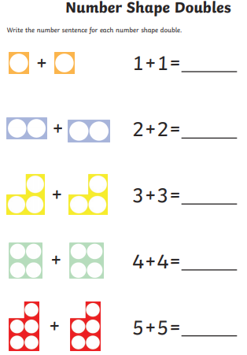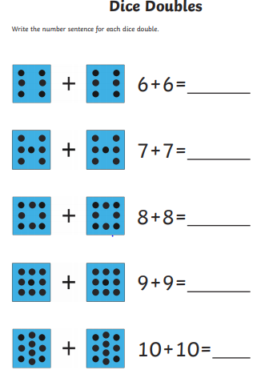
Try to solve these doubling word problems.

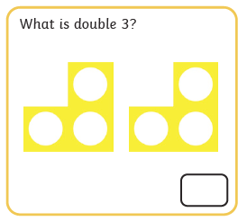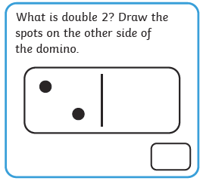

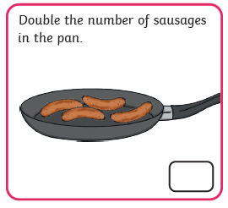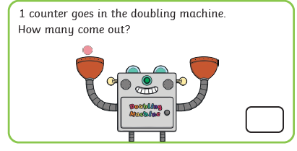

Shape, Space and Measure
This week our focus is - Money
- Watch this song about money / coins. follow this link
https://www.youtube.com/watch?v=dFzAU3u06Ps
- Watch and listen to this story about aboy who goes to the shop. – follow this link
https://www.youtube.com/watch?v=o-d5n3ltpwg
Activities
- Get these coins – 1p 2p 5p 10p 20p
Tell an adult what the coins are.
Which coinis is worth the most money?
Which coin is worth the least money?
- Play this game about find amounts of money up to 10p onTwinkl
https://www.twinkl.co.uk/resource/t-n-930-money-matching-powerpoint-activity-up-to-10p
- Create your own shop at home. Collect some of your toys / objects and label them with amounts of money -1p 2p 5p 10p 20p
One person be the shopkeeper and another person will be the customer.
Choose one thing at a time to buy and choose the crrect coin.
Topic
Let’s get creative!

- Create your own Rainbow Fish

Here are some ideas to help you

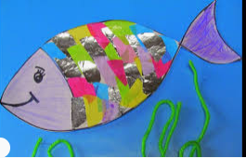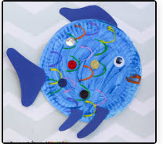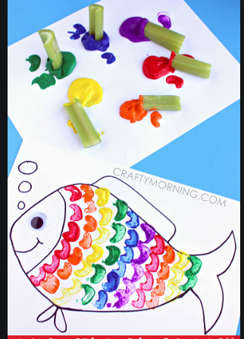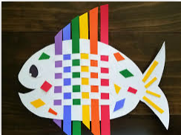
Under the sea
- Watch this video about under the sea. https://www.youtube.com/watch?v=tSzqojYlAyI
- Talk about what you have learnt /seen with an adult.

PSHE
This week we are learning about our bodies.
Starter
Sing the song head shoulders Knees and toes. Use this link
https://www.bbc.co.uk/iplayer/episode/p06r1xvv/sing-with-cbeebies-series-1-5-heads-shoulders-knees-toes

Activities
- Talk about the different parts of your body with an adult and what they are used for. E.g.- eyes allow us to see.
- Get a large piece of paper and get a member of your family to lie own on it and draw around them. Draw on the face.
- Label parts of the body.
(If you cannot do this get a doll or use the resources below)

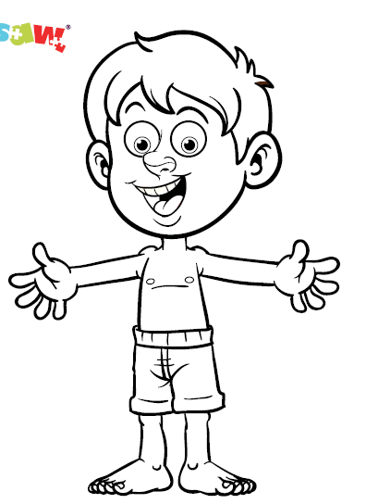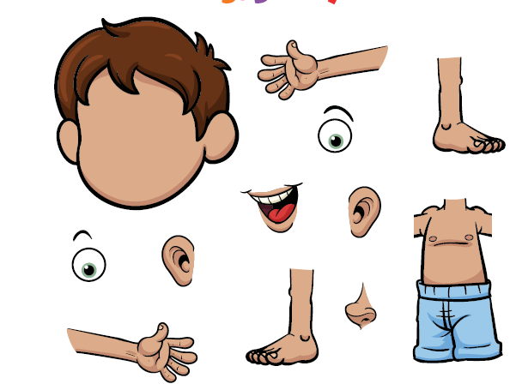

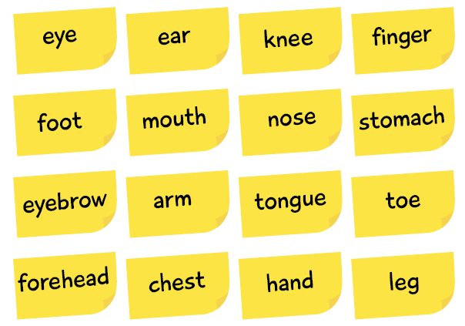

PE: Please also try to enjoy some daily exercise (remember Joe Wicks is doing PE videos every morning!). There is also something called Jumpstart Jonny https://www.youtube.com/watch?v=-1Pz_R4aaDo

Also guided mediation and Cosmic Kids Yoga is a great way to have some quiet time.
https://www.youtube.com/watch?v=DWOHcGF1Tmc
https://www.youtube.com/watch?v=xlg052EKMtk

We miss you very much and hope to see you very soon!
Please share your home learning on our school Facebook page.
Miss Zahoor, Miss Wedgwood and Mrs Treasure.

