Monday | Tuesday | Wednesday | Thursday | Friday
Phonics Focus- Y | Phonics Focus- Z | Phonics Focus- ZZ | Phonics Focus- QU | Tricky Words
Phonics play https://www.phonicsplay.co.  uk  Recap sounds- Flash Card Speed Trial-Phase 2/3 | Phonics play https://www.phonicsplay.co.uk  Recap sounds- Flash Card Speed Trial-Phase 2/3 | Phonics play https://www.phonicsplay.co.uk  Recap sounds- Flash Card Speed Trial-Phase 2/3 | Phonics play https://www.phonicsplay.co.uk  Recap sounds- Flash Card Speed Trial-Phase 2/3 | Play the tricky word songs  https://www.youtube.com/watch?v=TvMyssfAUx0  https://www.youtube.com/watch?v=ri4u0TjAZ38
Search ‘Geraldine the Giraffe learns the /Y/ sound’ on YouTube | Search ‘Geraldine the Giraffe learns the /Z/ sound’ on YouTube | Search ‘Geraldine the Giraffe learns the /ZZ/ sound’ on YouTube  Diagraph – 2 letters 1 sound- You find this diagraph at the end of a word | Search ‘Geraldine the Giraffe learns the /QU/ sound’ on YouTube  Diagraph – 2 letters 1 sound | Tricky Words Phase 2/3 –  Play game on Phonics Play  Tricky Word Trucks
Have a go at writing the words-  Yak, yap, yes, yet and yum. Get an adult to stick them up around the room and run to the words. | Have a go at writing some words that have the Z sound e.g.  Zip, zap and zigzag. | Have a go at writing the words-  Fizz, buzz, fuzz and jazz.  Get an adult to stick them up around the room and run to the words | Write the words  Quack, quilt, quick and Queen on some paper.  Cut them up and get the children to put them back together. | Matching pairs Write some of tricky words on paper (duplicate).  Put them face down on the table and play the matching pair game.
Play –Make a match on phonics play.  https://www.phonicsplay.co.uk/member-only/MatchingPh3Wk12.html | Play the z game on Education City- Free Trial  https://go.educationcity.com/content/index/34604/0/1/1/null/null/true/false/null/24//0 | Play – Grab a giggling grapheme  on phonics play.  https://www.phonicsplay.co.uk/member-only/GrabAGigglingGrapheme.html | Play the QU game on Education City- Free Trial  https://go.educationcity.com/content/index/34613/0/1/1/null/null/true/false/null/24//0 | Play the tricky word game on Education City- Free Trial  https://go.educationcity.com/content/index/34735/0/1/1/null/null/true/false/null/24//0
Access to Education City.
Type Education City into Google.
Click on find content by subject
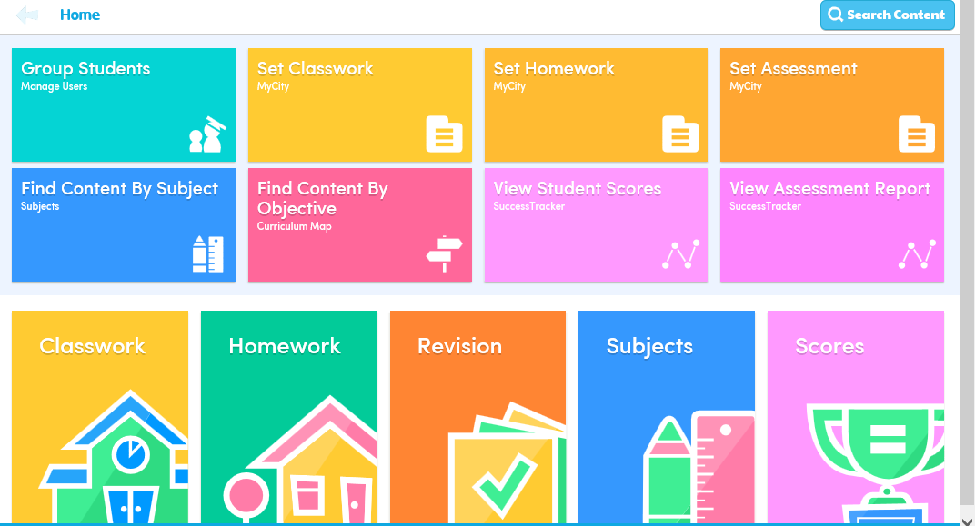
Click on English
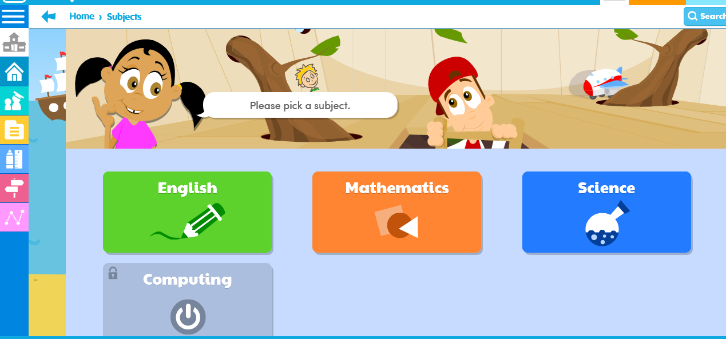
Click on EYFS
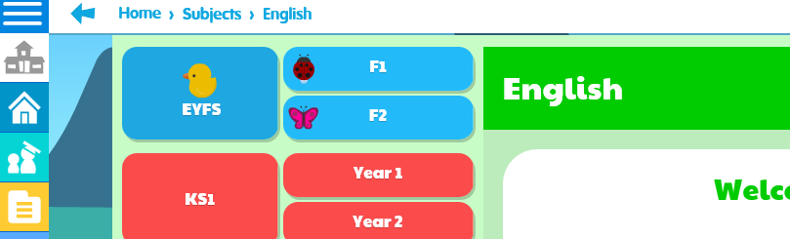

Click on Letters and Sounds

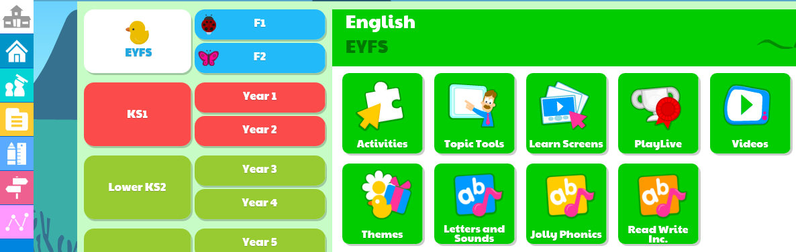
Click on Phase 2 or 3 (depending on which group your child is working in) then click on the sound you child is working on.


