Monday | Tuesday | Wednesday | Thursday | Friday
Segmenting blending phase 2 sounds | Segmenting blending phase 2 sounds | Segmenting blending phase 2 sounds | Segmenting blending phase 2 sounds | Segmenting blending phase 2 sounds
Phonics play https://www.phonicsplay.co.uk  Recap sounds- Flash Card Speed Trial-Phase 2 | Read the sounds on the board, pre teach phase 2 words and the phase 2 tricky words  See below | Phonics play https://www.phonicsplay.co.uk  Recap sounds- Flash Card Speed Trial-Phase 2 | Adult read the sounds on the phase 2 sound board or the tricky words one at a time.  Child – write the sound or the word as it is said. | Read the tricky words  See below
Phonics play – phase 2  Buried Treasure  Set 1 (satp) plus set 2 | Phonics play – phase 2  Buried Treasure  Set 1 and 2 plus set 3 | Phonics play – phase 2  Buried Treasure  Set 1 - 3 plus set 4 | Phonics play – phase 2  Buried Treasure  Set 1 - 5 plus set 5 | Tricky Words Phase 2 – Phonics Play – Phase 2  Play - Tricky Word Trucks
Look at the picture. Write an initial sound, CVC word and /or sentence about the picture.  Use the tricky and the pre teach words.  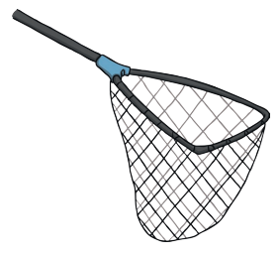 | Look at the picture. Write an initial sound, CVC word and /or sentence about the picture. Use the tricky and the pre teach words.  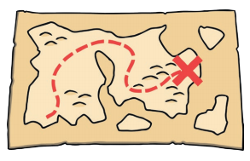 | Look at the picture. Write an initial sound, CVC word and /or sentence about the picture. Use the tricky and the pre teach words.   | Look at the picture. Write an initial sound, CVC word and /or sentence about the picture. Use the tricky and the pre teach words.   | Matching pairs Write some of tricky words on paper (duplicate).  Put them face down on the table and play the matching pair game.
Read this caption   | Read this caption   | Read this caption  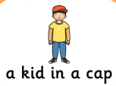 | Read this caption  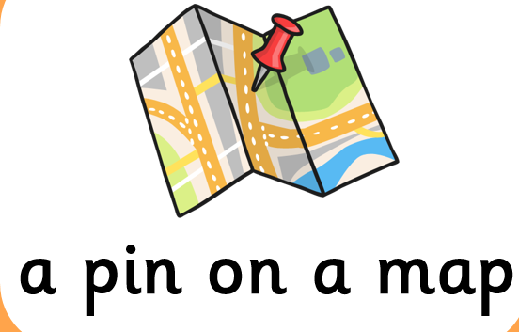 | Use an online timer. How many tricky words can you read in a minute?

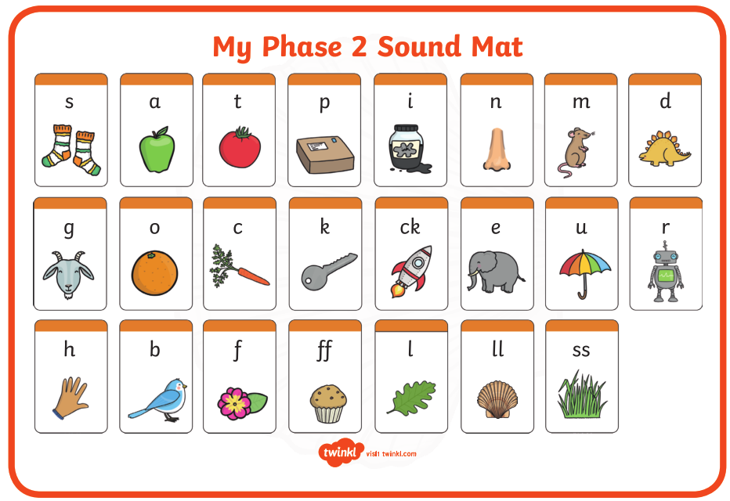

Pre phase 2 words

in | it | is
on | up | of
am | as | us

Phase 2 tricky words

I | no | the
into | go | to
and

Phoneme frames



