Monday | Tuesday | Wednesday | Thursday | Friday
Segmenting blending phase 2 sounds | Segmenting blending phase 2 sounds | Segmenting blending phase 2 sounds | Segmenting blending phase 2 sounds | Segmenting blending phase 2 sounds
Phonics play https://www.phonicsplay.co.uk  Recap sounds- Flash Card Speed Trial-Phase 2 | Read the sounds on the board, pre teach phase 2 words and the phase 2 tricky words  See below | Phonics play https://www.phonicsplay.co.uk  Recap sounds- Flash Card Speed Trial-Phase 2 | Adult read the sounds on the phase 2 sound board or the tricky words one at a time.  Child – write the sound or the word as it is said. | Read the tricky words and the pre teach words  See below
Phonics play – Picnic on Pluto- phase 2 set 1-3 plus set 4 +ck  https://www.phonicsplay.co.uk/resources/phase/2/picnic-on-pluto | Phonics play – Picnic on Pluto- phase 2 set 1-3 plus set 4 +b  https://www.phonicsplay.co.uk/resources/phase/2/picnic-on-pluto | Phonics play – Make a match phase 2 week 4  https://www.phonicsplay.co.uk/resources/phase/2 | Phonics play – Make a match phase 2 week 5 all phase 2  https://www.phonicsplay.co.uk/resources/phase/2/grab-a-giggling-grapheme | Phonics Play phase 2 Tricky word tucks  https://www.phonicsplay.co.uk/resources/phase/2/tricky-word-trucks
Look at the picture. Write an initial sound, CVC word and /or sentence about the picture.  Use the tricky and the pre teach words.  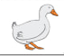 | Look at the picture. Write an initial sound, CVC word and /or sentence about the picture. Use the tricky and the pre teach words.  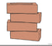 | Look at the picture. Write an initial sound, CVC word and /or sentence about the picture. Use the tricky and the pre teach words.  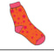 | Look at the picture. Write an initial sound, CVC word and /or sentence about the picture. Use the tricky and the pre teach words.  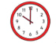 | Matching pairs Write some of tricky words on paper (duplicate).  Put them face down on the table and play the matching pair game.  Then  Write the tricky words as an adults says them to you?  How many did you get correct?
Read this caption    Write the caption when an adult has dictated it to you. | Read this caption  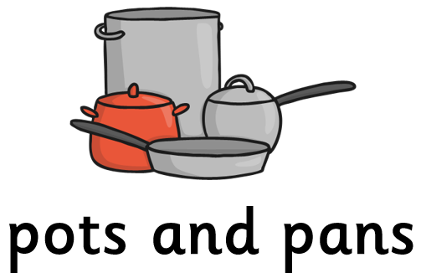  Write the caption when an adult has dictated it to you. | Read this caption    Write the caption when an adult has dictated it to you. | Read this caption  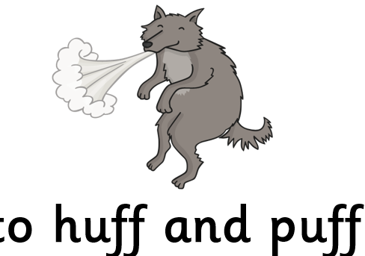  Write the caption when an adult has dictated it to you. | Phonics Play phase 2 Tricky word tucks – all HFW  https://www.phonicsplay.co.uk/resources/phase/2/tricky-word-trucks

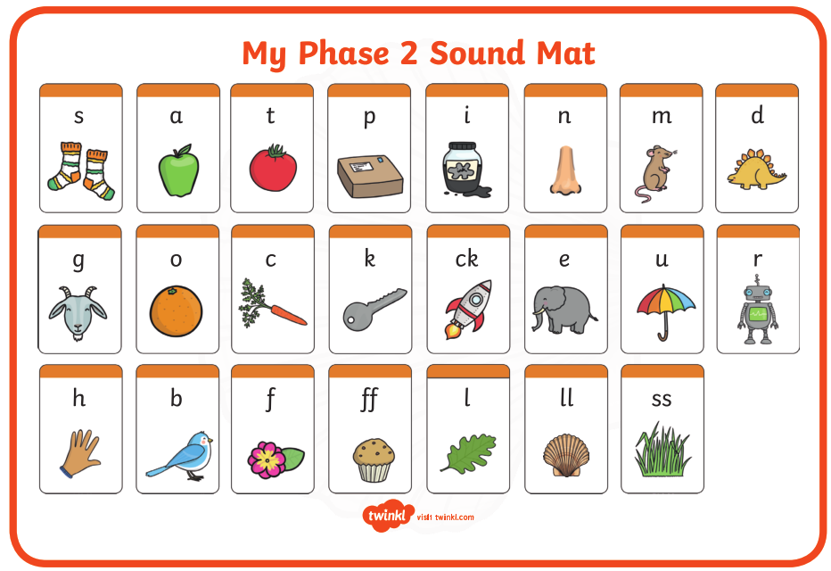

Pre phase 2 words

in | it | is
on | up | of
am | as | us

Phase 2 tricky words

I | no | the
into | go | to
and

Phoneme frames



