Hello everyone,
I hope you are all keeping safe and well. Please feel free to share your learning on the Burnwood Facebook Page or by emailing the school office .

Miss Wedgwood

Monday | Tuesday | Wednesday | Thursday | Friday
Phonics focus – xt | Phonics focus – dr | Phonics focus – gr | Phonics focus – tr | Phonics focus – tricky words
Recap sounds - Phonics Bloom  https://www.phonicsplay.co.uk/member-only/Flashcards.html  phase 2 and 3. | Recap sounds - Phonics Bloom  https://www.phonicsplay.co.uk/member-only/Flashcards.html  phase 2 and 3. | Recap sounds - Phonics Bloom  https://www.phonicsplay.co.uk/member-only/Flashcards.html  phase 2 and 3. | Recap sounds - Phonics Bloom  https://www.phonicsplay.co.uk/member-only/Flashcards.html  phase 2 and 3. | https://www.youtube.com/watch?v=3NOzgR1ANc4
https://www.youtube.com/watch?v=Ye8mH0Vw-_U | https://www.youtube.com/watch?v=Ye8mH0Vw-_U up to 6:01 | https://www.youtube.com/watch?v=Ye8mH0Vw-_U up to 6:50 | https://www.youtube.com/watch?v=Ye8mH0Vw-_U 7:37 – 8:30 | Get your child to write each of the tricky words as they appear on the screen.
Have a go at writing each of these words: next, text, context, pretext.  Have a go at writing this sentence: I stood next to my mum when she sent a text.  Remember; capital letters, finger spaces and a full stop. | Have a go at writing each of these words: drink, drain, drip, children.  Have a go at writing this sentence: I had a drink and put it back. | Have a go at writing each of these words: green, great, group, grip.  Have a go at writing this sentence: Gran planted the tree next to the bench. | Have a go at writing each of these words: tree, treat, trust, tripod.  Have a go at writing this sentence:  Trisha took a book off the shelf. | Write another set of the tricky words and lie both sets face down. Play the matching pairs game and see who finds all the matching tricky words first.
Play the game ‘Make a Match’ on Phonics Play  https://www.phonicsplay.co.uk/member-only/MatchingPh4.html | Play the game; ‘Buried Treasure’ on Phonics Play  https://www.phonicsplay.co.uk/member-only/BuriedTreasure2.html | Play the game ‘Make a Match’ on Phonics Play  https://www.phonicsplay.co.uk/member-only/MatchingPh4.html | Play the game; ‘Buried Treasure’ on Phonics Play  https://www.phonicsplay.co.uk/member-only/BuriedTreasure2.html | https://www.phonicsplay.co.uk/member-only/TrainYourBrainPh4.html

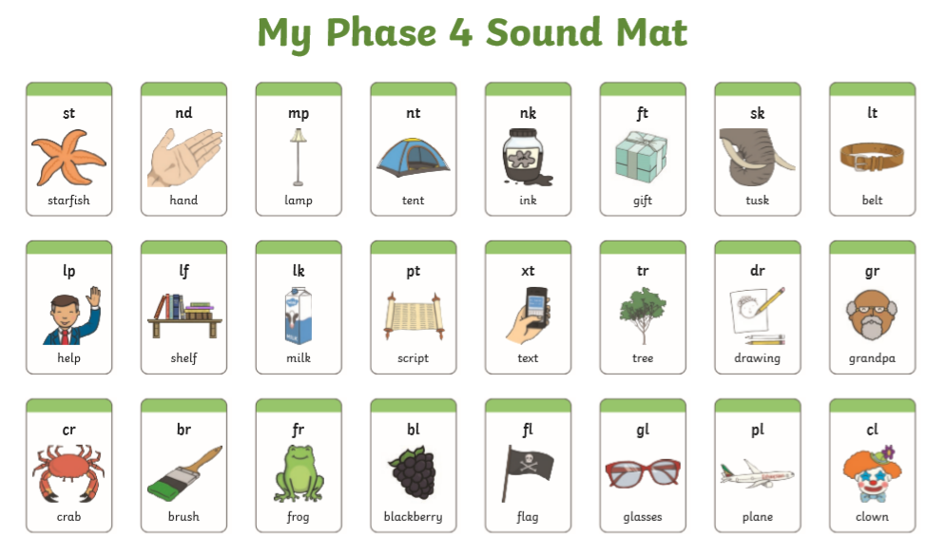

Tuesday and Thursday’s game
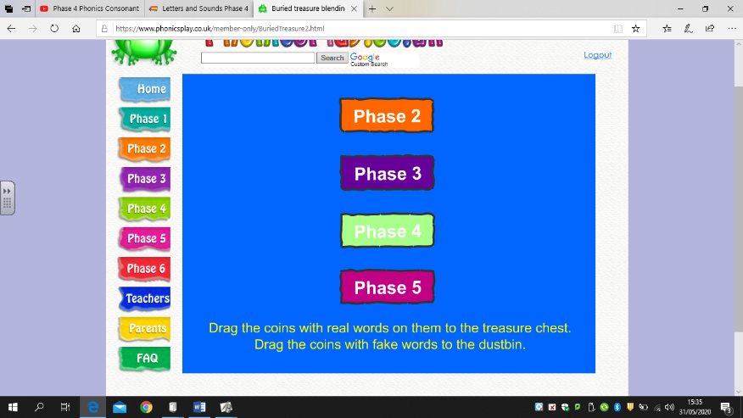
Click phase 4

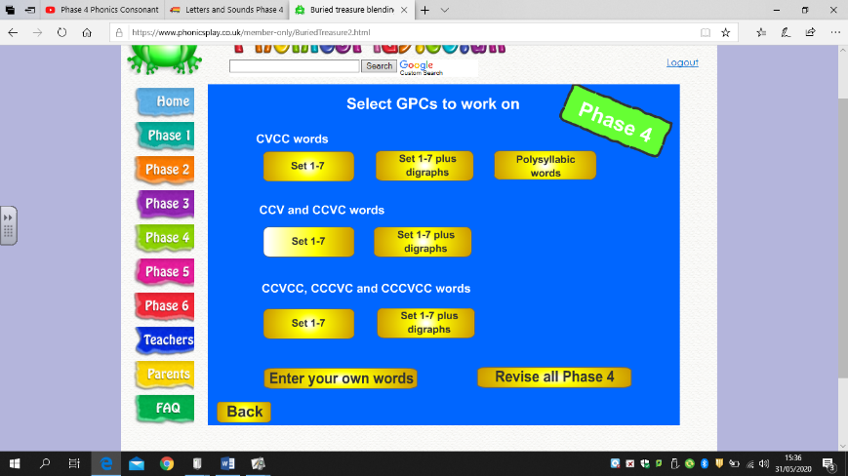
And then under CCVCC, CCCVC and CCCVCC words
Click Set 1-7 plus digraphs.

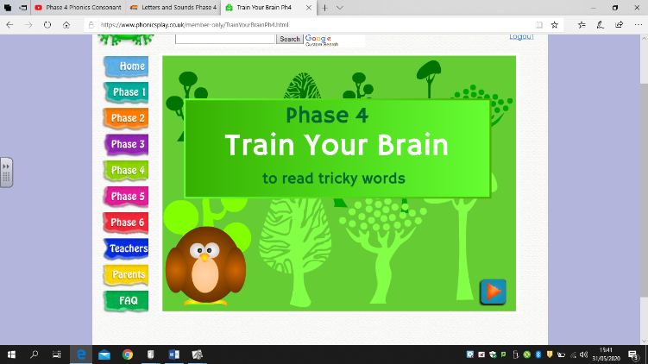
Friday’s game
Click the arrow in the bottom right corner

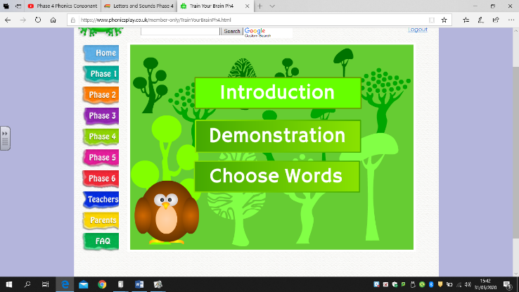

And then click introduction. This will talk you through it.

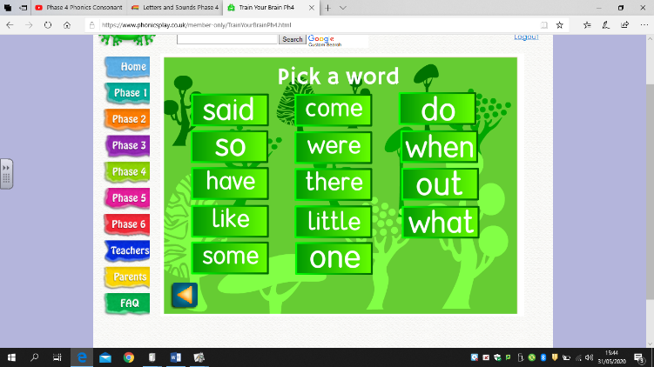
Once you have listened to the introduction you need so click on the tricky words you want to practise.

