Monday | Tuesday | Wednesday | Thursday | Friday
Phonics Focus- OO | Phonics Focus- AR | Phonics Focus- OR | Phonics Focus- UR | Tricky Words
Phonics play https://www.phonicsplay.co.uk  Recap sounds- Flash Card Speed Trial-Phase 2/3 | Phonics play https://www.phonicsplay.co.uk  Recap sounds- Flash Card Speed Trial-Phase 2/3 | Phonics play https://www.phonicsplay.co.uk  Recap sounds- Flash Card Speed Trial-Phase 2/3 | Phonics play https://www.phonicsplay.co.uk  Recap sounds- Flash Card Speed Trial-Phase 2 /3 | Play the tricky word songs  https://www.youtube.com/watch?v=TvMyssfAUx0  https://www.youtube.com/watch?v=ri4u0TjAZ38
Search ‘Geraldine the Giraffe learns the /OO/ sound’ on YouTube | Search ‘Geraldine the Giraffe learns the /AR/ sound’ on YouTube | Search ‘Geraldine the Giraffe learns the /OR/ sound’ on YouTube | Search ‘Geraldine the Giraffe learns the /UR/ sound’ on YouTube | Tricky Words Phase 2/3 –  Play game on Phonics Play  Tricky Word Trucks
Look at the picture and write a sentence about the picture.   | Look at the picture and write a sentence about the picture.  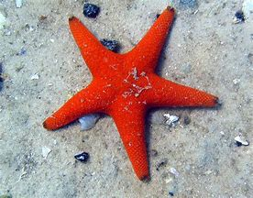 | Look at the picture and write a sentence about the picture.   | Look at the picture and write a sentence about the picture.   | Matching pairs Write some of tricky words on paper (duplicate).  Put them face down on the table and play the matching pair game.
Play the OO game on Education City- Free Trial | Play the AR game on Education City- Free Trial | Play the OR game on Education City- Free Trial | Play the UR game on Education City- Free Trial | Use an online timer. How many tricky words can you read in a minute?
Access to Education City.
Type Education City into Google.
Click on find content by subject
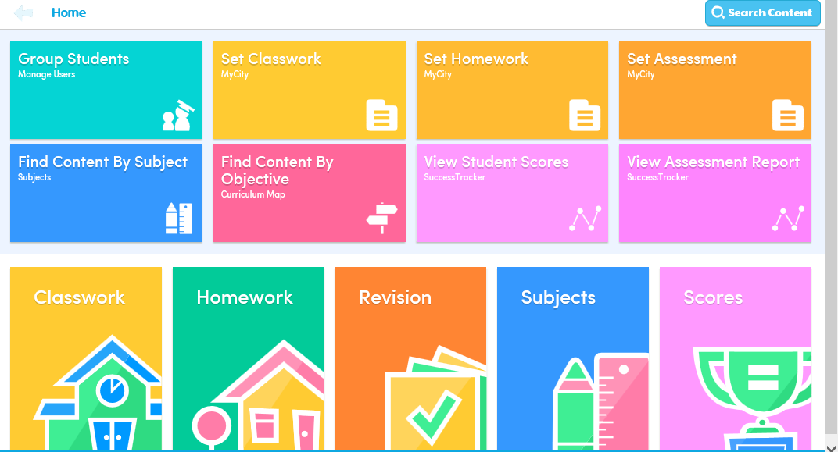
Click on English
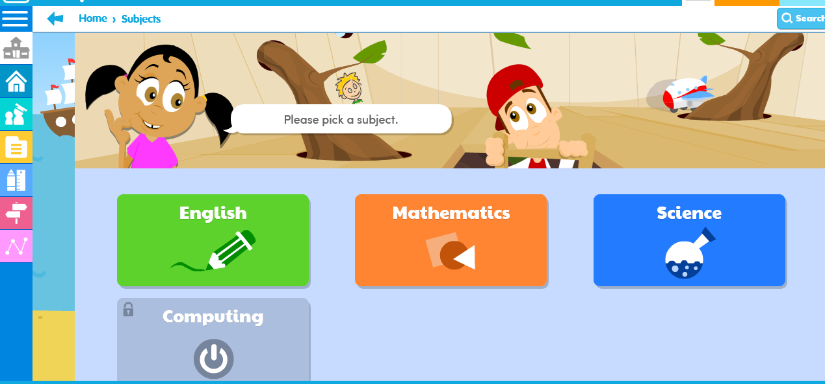
Click on EYFS
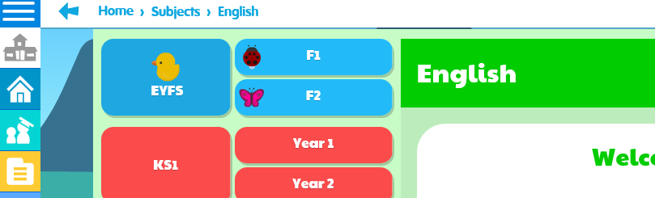

Click on Letters and Sounds

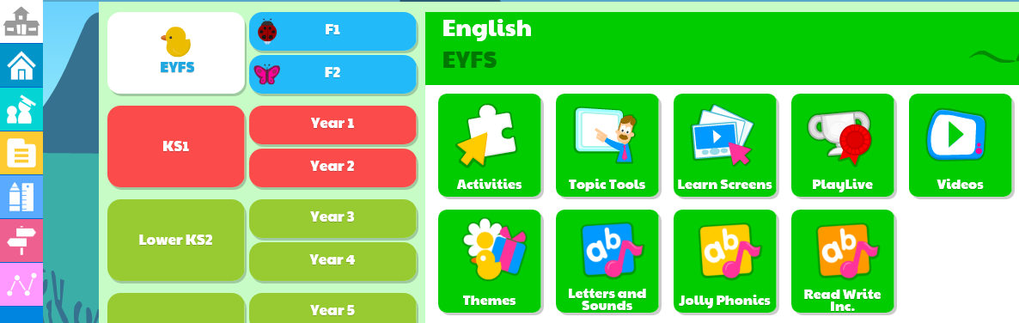
Click on Phase 2 or 3 (depending on which group your child is working in) then click on the sound you child is working on.


