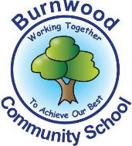
Reception Home Learning Pack – Monday 22nd June 2020
Topic – Under the Sea
Literacy
Reading:
This week our story focus is… Shark in the Park
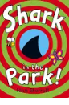
To read / listen to the story follow this link:
https://www.youtube.com/watch?v=Ketu-SWDyD0
To do an extra short task follow this think
https://www.youtube.com/watch?v=Ketu-SWDyD0&t=291s
Can you answer these questions about the story or by looking at the pictures?
- Who is the main character in the story?
- What was Timothy Pope using?
- What objects did Timothy Pope see through his telescope?
- Where is the story set?
- Which words rhyme in the story?
- Was there a shark in the park? What was the object that Timothy Pope thought was a shark?

Reading
Please follow this link, it has lots of reading books that your child recieves from school.
https://www.oxfordowl.co.uk/for-home/find-a-book/library-page?view=image&query=&type=book&age_group=&level=book+band+1%3A+pink&level_select=book+band+1%3A+pink&book_type=&series=#

Writing:
- Choose a picture from the look. With an adult, look at it and discuss what is in the picture / what is happening ?
- Write intial sounds / CVC words and sentences or captions about the picture.
You can use this word bank to help
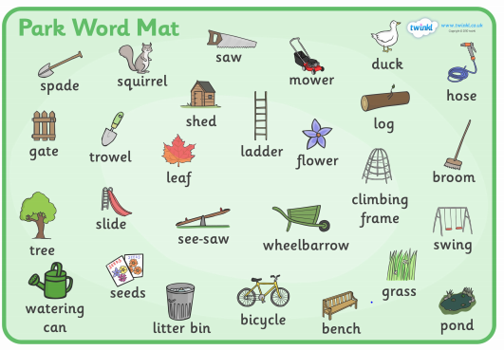
- Draw a picture of your favouite character / animal in the story. Write intial sounds / CVC words and sentences or captions about the picture.
- Practise writing your full name (first and last names).
Maths
Number
Starter activities
- Count forwards and backwards to 1-10 – use this video link
https://www.bbc.co.uk/bitesize/topics/zhsspg8/articles/zfqcbdm
- Count forwards and backwards to 20 – use the link
https://www.bbc.co.uk/bitesize/topics/zhsspg8/articles/zm83f4j
- Write numbers 1-20 on pieces of paper. Place them face down on a table. Choose 1 and say the number.
- Chooose a number that is on a piece of paper, (between 1 – 20 say it and then do the number of jumps, claps or hops that is on the paper.
- Write numbers that an adults says to youbetween 1 – 20.
- Count in 2s - 2 times table- follow the link - https://www.bbc.co.uk/teach/supermovers/ks1-maths-the-2-times-table-with-bridget-the-lioness/zrrx92p

Main activities –
This week our maths focus is – missing numbers / ordering numbers to 20 Watch this Numberblocks video about number sequences– follow the link
https://www.youtube.com/watch?v=dBKyiYq5k98

- Complete these tasks with an adult.
- Write numbers 1-5, 1-10 and / or 1-20 on pieces of paper, muddle them up and put them in order.
- Write the missing numbers
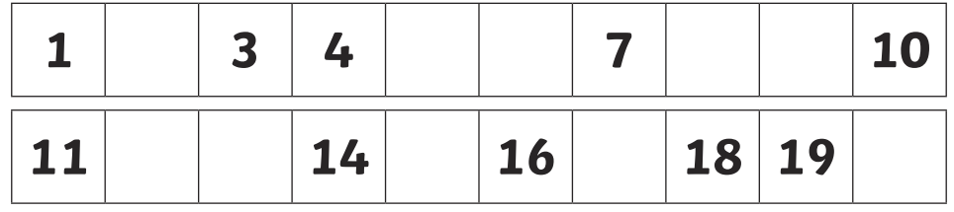

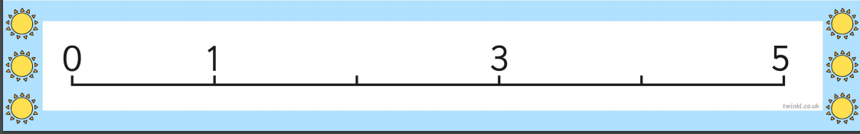
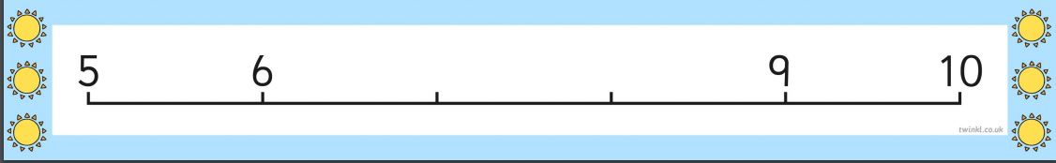
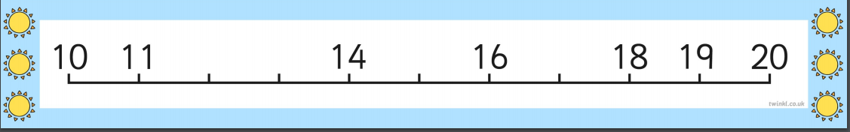

Try to solve these counting word problems.

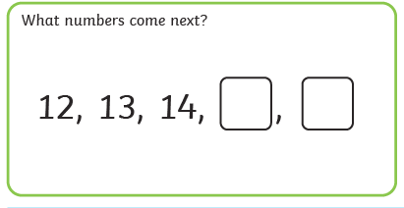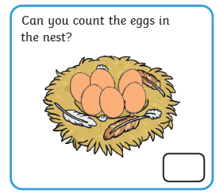

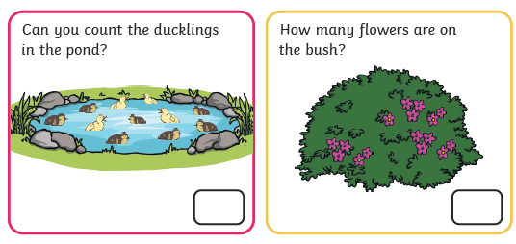

- What number comes before 5?
- What number comes after 8?
- Mrs Treasure says the missing number is 8. Is she correct? Explan your answer to an adult. (How do you know what the missing number is?)
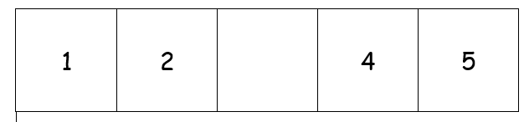
Shape, Space and Measure
This week our focus is - Patterns
- Watch this song about pattrens - follow this link
https://www.youtube.com/watch?v=MBjjxSx45-Q
- Watch and discuss this power point about patterns - follow this link
https://www.twinkl.co.uk/resource/curly-caterpillars-repeating-pattern-powerpoint-t-m-31772

Activities
- Complete these repeating patterns
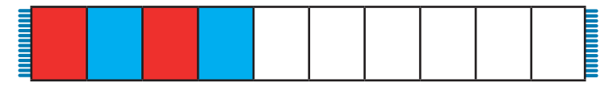

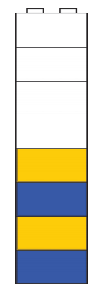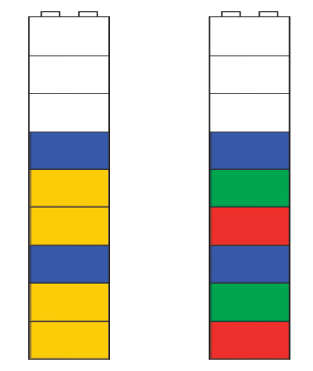

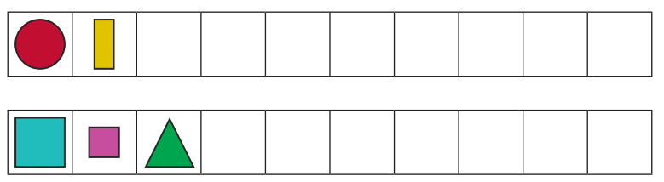

- Complete these word problems about patterns
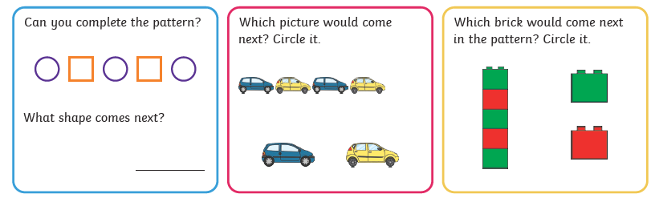

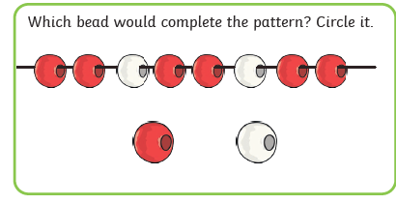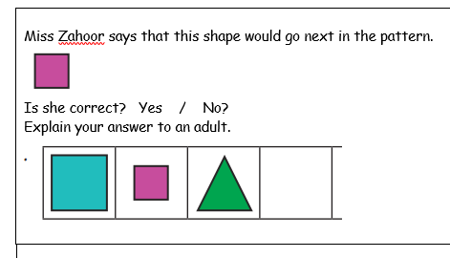
Topic
Materials – natural – man made
There are many different types of materials. Can you name any of them?
Look at this power point. Discuss the different types of materials – follow the link
https://www.twinkl.co.uk/resource/t-t-12069-yoruba-benin-west-african-creation-story-editable-bookmarks
- Collect objects that are made using the materials power point or name objects that are made using these materials.
- Some objects are natural and others are manmade. Watch this power point about natural and manmade materials – follow this link
https://www.twinkl.co.uk/resource/t-t-7849-natural-and-manmade-materials-powerpoint

- Complete this task sorting objects that are natural or manmade. You can collect items from around your home or outside to sort or use these pictures. Use this link to download the task
https://content.twinkl.co.uk/resource/2d/1b/t-t-7727-natural-or-man-made-materials-sorting-activity_ver_3.pdf?__token__=exp=1591962419~acl=%2Fresource%2F2d%2F1b%2Ft-t-7727-natural-or-man-made-materials-sorting-activity_ver_3.pdf%2A~hmac=7d93bd94aa12d8a31d54ef9e56f18739f38057765e1fd80a9258d30e5f370352

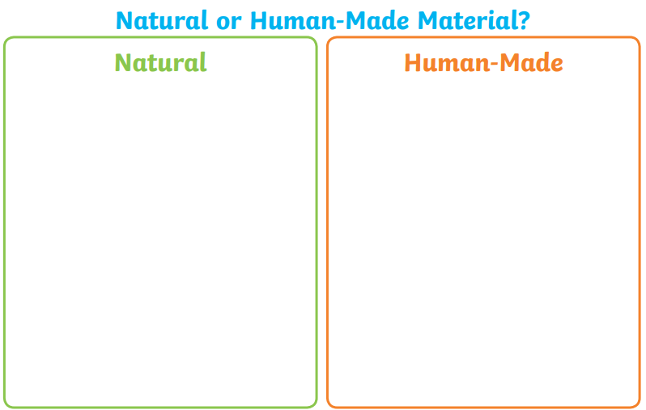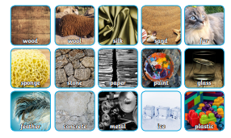

PSHE
This week we are learning about Respecting my body / keeping it healthy
Starter
What types of things do we do / need to do to keep our bodies healthy
Watch this video –follow the link –
https://www.youtube.com/watch?v=UxnEuj1c0sw
You could also read this power point – follow the link –
https://www.twinkl.co.uk/resource/t-tp-5249-all-about-me-looking-after-yourself-powerpoint
Activities
- Collect different types of fruit / vegetables and taste them. Discuss what they taste like, if you liked them or not and why.
- Go outside and do some exercise. E.g. running, skipping etc. What happens y=to your body when you exercise?
- Role play having a picnic outside.
- Collect different types of foods. Sort them into heathy foods and less heathy foods.
You can use this link and use the pictures - https://www.twinkl.co.uk/resource/au-t-100-australia---healthy-and-unhealthy-sorting-activity

PE: Please also try to enjoy some daily exercise (remember Joe Wicks is doing PE videos every morning!). There is also something called Jumpstart Jonny https://www.youtube.com/watch?v=-1Pz_R4aaDo

Also guided mediation and Cosmic Kids Yoga is a great way to have some quiet time.
https://www.youtube.com/watch?v=DWOHcGF1Tmc
https://www.youtube.com/watch?v=xlg052EKMtk

We miss you very much and hope to see you very soon!
Please share your home learning on our school Facebook page.
Miss Zahoor, Miss Wedgwood and Mrs Treasure.

