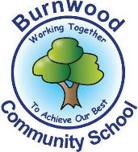
Reception Home Learning Pack – Monday 29th June 2020
Topic – Under the Sea
Phonics
- Miss Zahoor’s phonics group revise phase 3
- Miss Wedgewood’s phonics group revise phases 3and 4
- Mrs Treasure’s phonics group revise phase 2

Literacy
Reading:
This week our story focus is… Ten Little Pirates
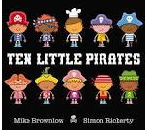
To read / listen to the story follow this link:
https://www.youtube.com/watch?v=GiLySC_emj0
Can you answer these questions about the story or by looking at the pictures?
- Who are the main characters in the story?
- What were the ten little pirates looking for?
- What colour was the sail on the ship?
- Where is the story set?
- What was on the flag?
- On the last pages of the story, what were the pirates cooking?
Reading
Please follow this link, it has lots of reading books that your child recieves from school.
https://www.oxfordowl.co.uk/for-home/find-a-book/library-page?view=image&query=&type=book&age_group=&level=book+band+1%3A+pink&level_select=book+band+1%3A+pink&book_type=&series=#
Writing:
- Look at the last 2 pictures in the look. With an adult, look at it and discuss what is in the picture / what is happening ?
- Write intial sounds / CVC words and sentences or captions about a picture in the book.
- Create a wanted poster for a pirate. Draw a pirate and write about him / her. Here is an example and a word bank
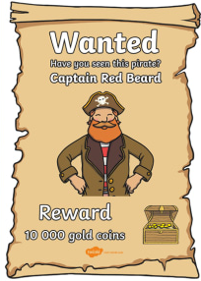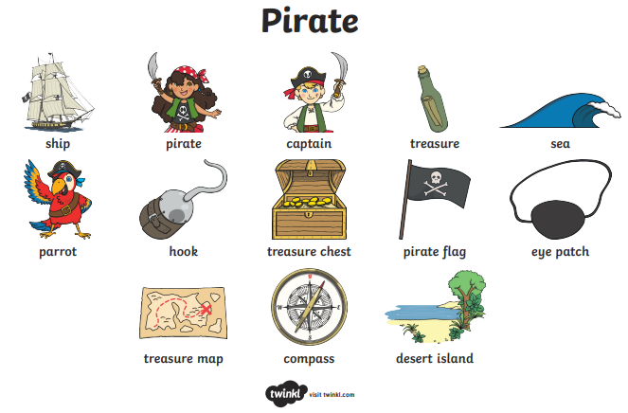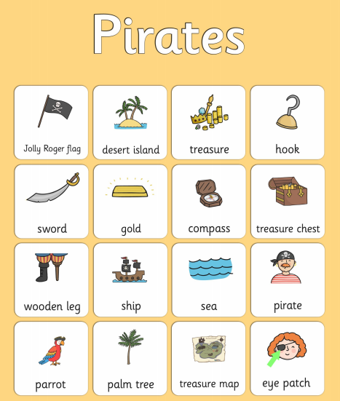
Follow this link if you would like to use this template.
https://content.twinkl.co.uk/resource/b9/69/t-t-102-create-your-own-pirate-wanted-display-poster_ver_1.pdf?__token__=exp=1592560910~acl=%2Fresource%2Fb9%2F69%2Ft-t-102-create-your-own-pirate-wanted-display-poster_ver_1.pdf%2A~hmac=04cc6084bb148cedfea12645f01f6be37a3720b0ed3bd911cd7e5e7ad0016b2d
- Practise writing your full name (first and last names).

Maths
Number
Starter activities
- Count forwards and backwards to 1-10 – use this video link
https://www.bbc.co.uk/bitesize/topics/zhsspg8/articles/zfqcbdm
- Count forwards and backwards to 20 – use the link
https://www.bbc.co.uk/bitesize/topics/zhsspg8/articles/zm83f4j
- Write numbers 1-20 on pieces of paper. Place them face down on a table. Choose 1 and say the number.
- Chooose a number that is on a piece of paper, (between 1 – 20 say it and then do the number of jumps, claps or hops that is on the paper.
- Write numbers that an adults says to youbetween 1 – 20.
- Count in 2s - 2 times table- follow the link - https://www.bbc.co.uk/teach/supermovers/ks1-maths-the-2-times-table-with-bridget-the-lioness/zrrx92p

Main activities –
This week our maths focus is – Number bonds
Watch this video about what Number bonds are / how teach – follow the link
https://www.youtube.com/watch?v=D1hwopQLeCU
- Complete these tasks with an adult.
Practical tasks
- Get 5,10 or 20 objects and explore ways of making these amounts like in the video
e.g. how many ways can you make 5 with your objects – 5 and 0 / 1 and 4 etc
written tasks
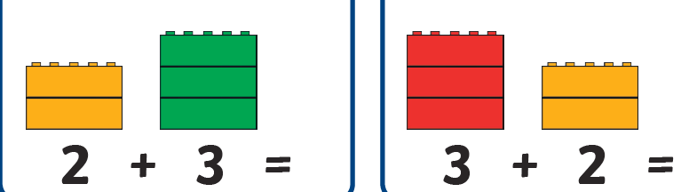

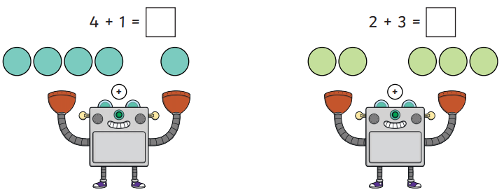

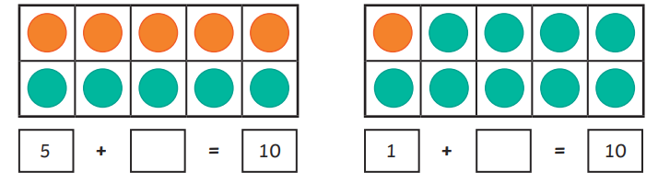

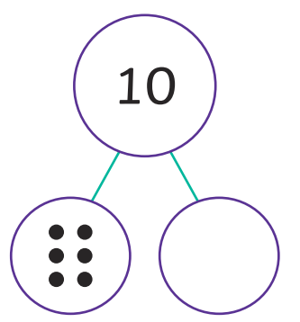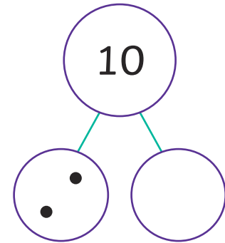

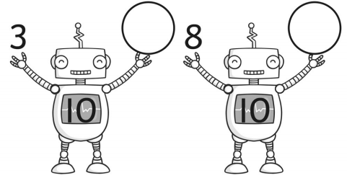

Try to solve these number bonds problems.
For each of the pictures write ALL of the number bond addition sentences e.g. 5 + 0 = 5.
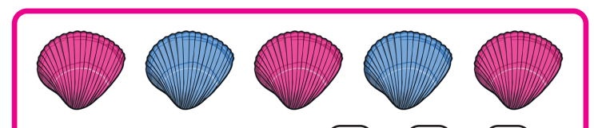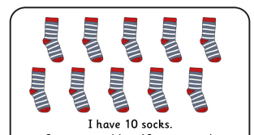
I have 5 shell
Complete these number bond word problems

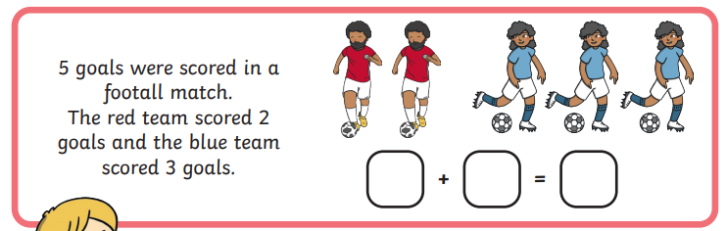

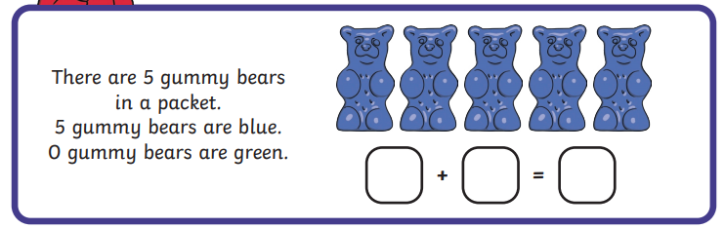
Shape, Space and Measure
This week our focus is – weight – (comapring / ordering)
- Watch this video about weight
https://www.youtube.com/watch?v=ybEU-6U7s8k
- Read and discussthe activities in this Power Point - follow this link
https://www.twinkl.co.uk/resource/au-n-565-lighter-or-heavier-powerpoint

Activities
Complete these activities about weight
- Collect 2 or3 items and place them in order from lightest to heaviest. Talk to an adult about it. Is the biggest object always the heaviest?
- Tick the picture that is the heaviest. Here is the link to download the sheet.
https://content.twinkl.co.uk/resource/09/ca/tp-n-81-heavy-or-light-activity-sheet_ver_1.pdf?__token__=exp=1592566919~acl=%2Fresource%2F09%2Fca%2Ftp-n-81-heavy-or-light-activity-sheet_ver_1.pdf%2A~hmac=e78a68feda5d58da4a5238e74f9253a5967236a2c18fea429e00caf351face0b

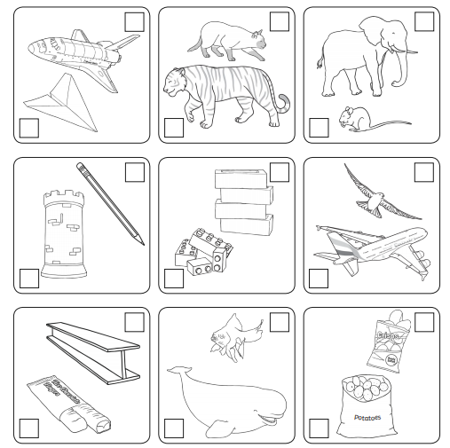
- Cut out all or some of the items and order them from lightest to heaviest. Chose 3 at a time to order
Here is the link to the activity
https://content.twinkl.co.uk/resource/23/bb/au-n-567-lightest-to-heaviest-activity-sheet_ver_2.pdf?__token__=exp=1592566558~acl=%2Fresource%2F23%2Fbb%2Fau-n-567-lightest-to-heaviest-activity-sheet_ver_2.pdf%2A~hmac=bbeec1072921310477cfb546799f140eacc2493f9c81df5620f50a58228b8bfd

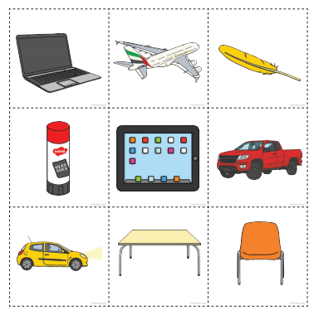

- Complete this probem about weight. Talk to an adult about your reasons.

Mrs Teasure says that the feather is heavier thanthe glue stick. Is she correct. Explain why.

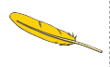

Topic
This week we are learning about pirates and making a pirate hat.
Activities
- Read this power point with an adult about pirates
https://www.twinkl.co.uk/resource/t-tp-1314-all-about-pirates-powerpoint
- Listen to this song about pirates.
https://www.youtube.com/watch?v=_qAngsMJD3I
- Make a pirate hat.
Here are links to a template / instructions and a picture.
Making hats – follow the links below
https://www.twinkl.co.uk/resource/us-t-t-16878-paper-pirate-hat-activity

https://content.twinkl.co.uk/resource/8d/87/es-t-t-2548201-how-to-make-a-pirate-hat-instruction-activity-sheet-english-spanish.pdf?__token__=exp=1592568534~acl=%2Fresource%2F8d%2F87%2Fes-t-t-2548201-how-to-make-a-pirate-hat-instruction-activity-sheet-english-spanish.pdf%2A~hmac=f590376dfb1dfd11b3c99f03aae9514b8de289ff8c09d8041cd1eb65277dccbe

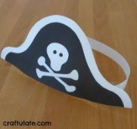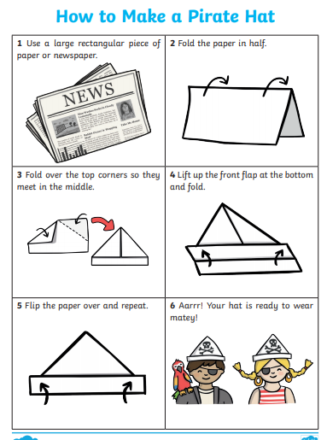

PSHE
This week we are learning about Growing up
Starters

- Listen to the song – growing up – follow the link
https://www.youtube.com/watch?v=F5DVGXBosIA
- Read this power point with an adult about growing up
https://www.twinkl.co.uk/resource/cfe-g-015-hwb1-50a-growing-up-powerpoint

- Look at the pictures below. With an adult discuss who is in the picture.
Answer these questions.
- Who is the youngest person? How do you know
- Who is the oldest person? How do you know?
- How old do you think the boy is? Why?

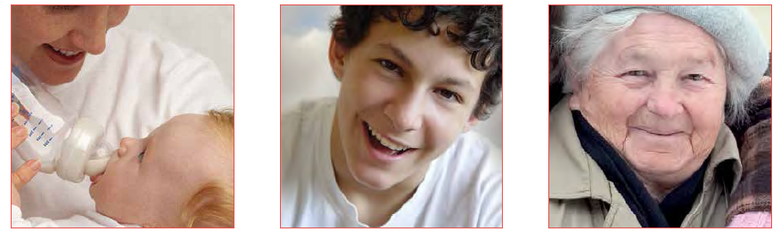
Activities
- Collect pictures of you or a member of your family at different ages.
- Place them in order from youngest to oldest.
- Talk about how you or they have changed over the years.
- Draw a picture of yourself now and when you were a baby.
- Write a sentence about what you were like when you were a baby and now.

PE: Please also try to enjoy some daily exercise (remember Joe Wicks is doing PE videos every morning!). There is also something called Jumpstart Jonny https://www.youtube.com/watch?v=-1Pz_R4aaDo

Also guided mediation and Cosmic Kids Yoga is a great way to have some quiet time.
https://www.youtube.com/watch?v=DWOHcGF1Tmc
https://www.youtube.com/watch?v=xlg052EKMtk

We miss you very much and hope to see you very soon!
Please share your home learning on our school Facebook page.
Miss Zahoor, Miss Wedgwood and Mrs Treasure.

