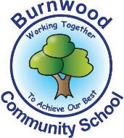
Reception Home Learning Pack – Monday 6th July 2020
Topic – Under the Sea
Phonics
- Miss Zahoor’s phonics group revise phase 3
- Miss Wedgewood’s phonics group revise phases 3 and 4
- Mrs Treasure’s phonics group revise phase 2
Literacy
Reading:
This week our story focus is… The Pirate Cruncher
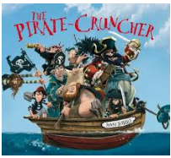
To read / listen to the story follow this link:
https://www.youtube.com/watch?v=0rJ6PBPa45M
Can you answer these questions about the story or by looking at the pictures?
- Who are the main characters in the story?
- What were the ten little pirates looking for?
- What colour was the sail on the ship?
- Where is the story set?
- What was on the flag?
- On the last pages of the story, what were the pirates cooking?
Reading
Please follow this link, it has lots of reading books that your child recieves from school.
https://www.oxfordowl.co.uk/for-home/find-a-book/library-page?view=image&query=&type=book&age_group=&level=book+band+1%3A+pink&level_select=book+band+1%3A+pink&book_type=&series=#
Writing:
- Look at a picture in the look with an adult and discuss what is in the picture / what is happening ?
- Write initial sounds / CVC words and or sentences about each of the pirate pictures. (Pirate Writing Activity) Here is a link to the sheets.
https://content.twinkl.co.uk/resource/22/50/t-e-2550030-pirates-early-writing-activities_ver_3.pdf?__token__=exp=1592570825~acl=%2Fresource%2F22%2F50%2Ft-e-2550030-pirates-early-writing-activities_ver_3.pdf%2A~hmac=fa4311be6f1bf50441858833f25e30f6c17f7669fd91a62deb2f888090b5bf27

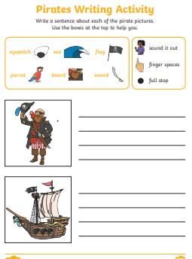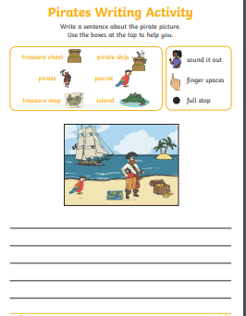

use the word mats to help
.

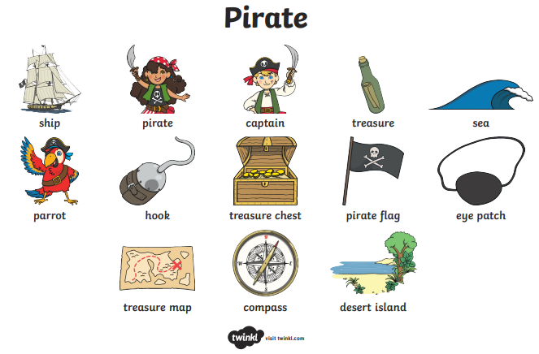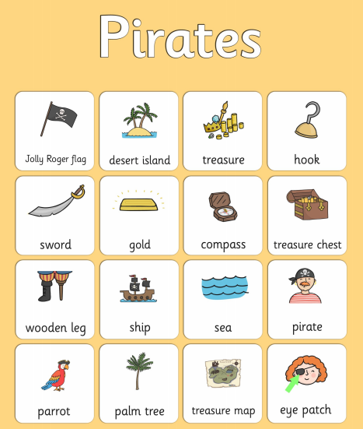
- Draw a picture of a ship and write initial sounnds / CVC words and or sentences about it
- Practise writing your full name (first and last names).

Maths
Number
Starter activities
- Count forwards and backwards to 1-10 – use this video link
https://www.bbc.co.uk/bitesize/topics/zhsspg8/articles/zfqcbdm
- Count forwards and backwards to 20 – use the link
https://www.bbc.co.uk/bitesize/topics/zhsspg8/articles/zm83f4j
- Write numbers 1-20 on pieces of paper. Place them face down on a table. Choose 1 and say the number.
- Chooose a number that is on a piece of paper, (between 1 – 20 say it and then do the number of jumps, claps or hops that is on the paper.
- Write numbers that an adults says to youbetween 1 – 20.
- Count in 2s - 2 times table- follow the link - https://www.bbc.co.uk/teach/supermovers/ks1-maths-the-2-times-table-with-bridget-the-lioness/zrrx92p

Main activities –
This week our maths focus is – Sharing
Watch this episode of Number blocks series 4 episode 18 – about sharing follow the link
https://www.bbc.co.uk/iplayer/episode/m0006xcw/numberblocks-series-4-the-lair-of-shares
- Watch this video about sharing – follow the link
https://www.youtube.com/watch?v=KTFJ9gjfAXg

Complete these tasks with an adult.
Practical tasks
- Get 4 objects – share them between 2. How many are in each group?
- Get 10 objects – share them between 2. How many are in each group?
- Get 9 objects – share them between 3. How many are in each group?
- Get 12 objects – share them between 4. How many are in each group?
- Complete this cut and stick sharing activity – follow the link
https://content.twinkl.co.uk/resource/4b/52/T-T-277020-Sharing-Food-Lunch-Boxes-Cut-and-Stick-Activity.pdf?__token__=exp=1592574162~acl=%2Fresource%2F4b%2F52%2FT-T-277020-Sharing-Food-Lunch-Boxes-Cut-and-Stick-Activity.pdf%2A~hmac=4f3ae4731d3a4fa89a51f047231c1e2a3df792f3bef65cef0cf6a296e52e8d63

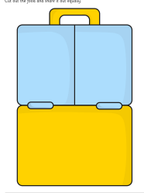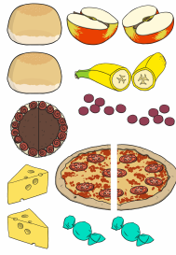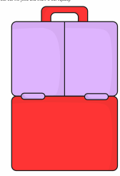

Written tasks - sharing
Sharing Bananas
Here is the link - https://content.twinkl.co.uk/resource/a2/88/CfE-N-021A-Sharing-Bananas-Activity-Sheet-Colour.pdf?__token__=exp=1592576325~acl=%2Fresource%2Fa2%2F88%2FCfE-N-021A-Sharing-Bananas-Activity-Sheet-Colour.pdf%2A~hmac=2b94e2cc392de8070e8956be56ed9a4d566f1a0d9fbef07bbef2cb3e9e7d9a34
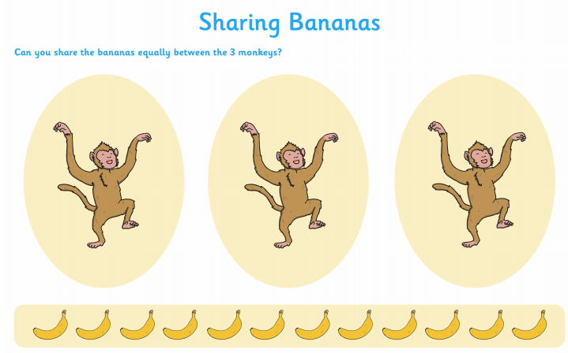

- Feeding the Mini beasts – follow the link
https://content.twinkl.co.uk/resource/60/0c/t-tp-691-feeding-the-minibeasts-activity-sheet_ver_1.pdf?__token__=exp=1592576486~acl=%2Fresource%2F60%2F0c%2Ft-tp-691-feeding-the-minibeasts-activity-sheet_ver_1.pdf%2A~hmac=7cd3b36e0b15f9feb55742dd581b04e11a8b071925f1ec6657d50d1a02e5d14b

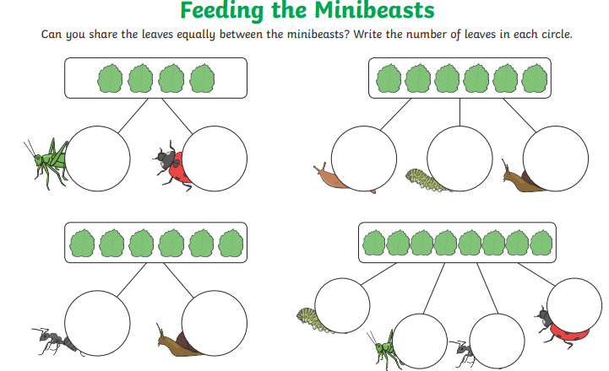

Complete these sharing word problems.
- Sharing money (1ps) – follow the link – you could do these practically
https://content.twinkl.co.uk/resource/e9/47/t-n-2546257-pocket-money-at-the-beach-sharing-activity-sheets.pdf?__token__=exp=1592576060~acl=%2Fresource%2Fe9%2F47%2Ft-n-2546257-pocket-money-at-the-beach-sharing-activity-sheets.pdf%2A~hmac=d79876e77a137055637f1e2cf01085fec8146c92486bf4c19e33ad7ec94e824b
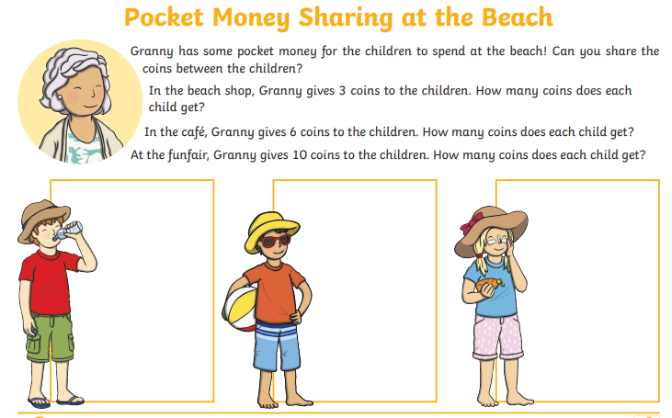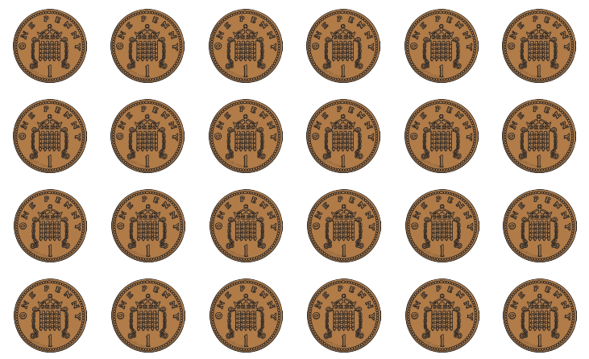

- Complete these sharing reasoning problem solving questions- discuss them with an adult
- Use the power point to complete these to help explain how to find the answers.
Here is the link
https://www.twinkl.co.uk/resource/sharing-max-the-monkeys-bananas-problem-solving-and-reasoning-powerpoint-t-n-7669

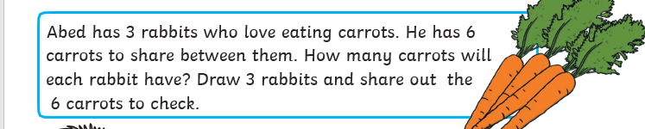

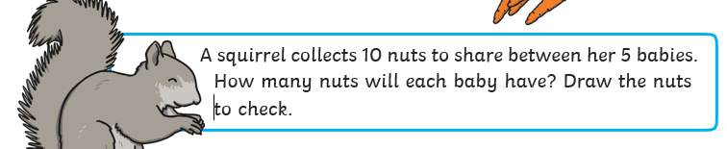

Shape, Space and Measure
This week our focus is – capacity – (comapring / ordering)
- Watch these videos about capacity
https://www.youtube.com/watch?v=HL3O2l2lFGs

Activities
Complete these activities about capacity
- Get 3 containers and water. Fill one full, one half full and leave one empty.
- Order your containers from full to empty
- Complete this worksheet about capacity. Work with an adult and explain your answers. E.g. Explain why you think an object holds the most / least.
Here is the link
https://content.twinkl.co.uk/resource/8e/14/t-n-2545119-how-much-does-it-hold-activity-sheet.pdf?__token__=exp=1592578568~acl=%2Fresource%2F8e%2F14%2Ft-n-2545119-how-much-does-it-hold-activity-sheet.pdf%2A~hmac=92d1ae5016401e1c4c3c1be06c33c80da177cf1af0af296d866d24386e9752ce

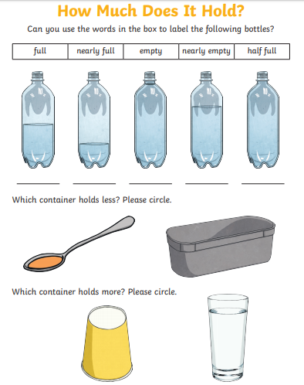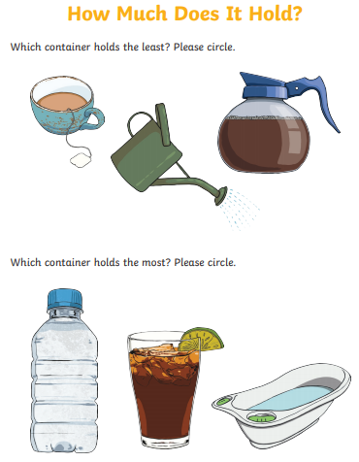

Topic
This week we are learning about floating and sinking.

- Watch this video about floating and sinking
https://www.youtube.com/watch?v=s2DTW0EMigk
- Activities
- 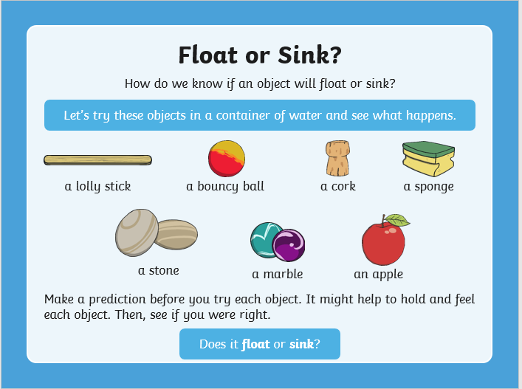
- Get a bowl of water and see which of these object sink or float.
- Place them under these headings – float sink
- Discuss why the objects sink or float.
- Complete this sheet about floating and sinking. Make a prediction (guess) before to see if it does float or sink.
Here is the link - https://content.twinkl.co.uk/resource/5a/da/t-t-5448-float-or-sink-activity-sheet-.pdf?__token__=exp=1592579381~acl=%2Fresource%2F5a%2Fda%2Ft-t-5448-float-or-sink-activity-sheet-.pdf%2A~hmac=f2c868a2383ca733157bf3032dd05b885971e48eef93a210ee252fffe026b37d

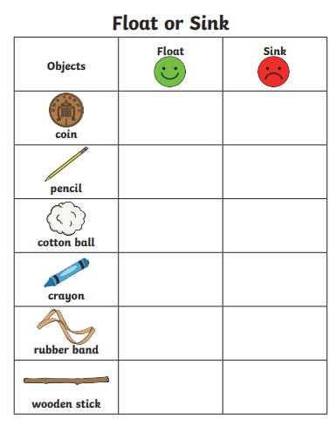

PSHE
This week we are learning about changes

There are lots of different changes. We go through lots of different changes in our lives.
At the moment things are different.
Activities
- Talk to an adult about what you have enjoyed about being at home during this time that you have not been in school.
- Draw a picture of it

PE: Please also try to enjoy some daily exercise (remember Joe Wicks is doing PE videos every morning!). There is also something called Jumpstart Jonny https://www.youtube.com/watch?v=-1Pz_R4aaDo

Also guided mediation and Cosmic Kids Yoga is a great way to have some quiet time.
https://www.youtube.com/watch?v=DWOHcGF1Tmc
https://www.youtube.com/watch?v=xlg052EKMtk

We miss you very much and hope to see you very soon!
Please share your home learning on our school Facebook page.
Miss Zahoor, Miss Wedgwood and Mrs Treasure.

