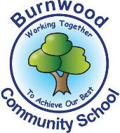
Reception Home Learning Pack – Monday 13th July 2020
Topic – Under the Sea
Phonics
- Miss Zahoor’s phonics group revise phase 3
- Miss Wedgewood’s phonics group revise phases 3 and 4
- Mrs Treasure’s phonics group revise phase 2
Literacy
Reading:
This week our story focus is… Barry The Fish With Fingers

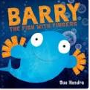

To read / listen to the story follow this link:
https://www.youtube.com/watch?v=Jn1FBkrHNKg

Can you answer these questions about the story or by looking at the pictures?

- Who are the main characters in the story?
- What did Barry have that fish do not normally have?
- What things could Barry do with his fingers?
- Why was Pufffy the fish sad?
- What landed on the sea bet?
- Why were Barry and Puffy friends at the end of the story?
Reading
Please follow this link, it has lots of reading books that your child recieves from school.
https://www.oxfordowl.co.uk/for-home/find-a-book/library-page?view=image&query=&type=book&age_group=&level=book+band+1%3A+pink&level_select=book+band+1%3A+pink&book_type=&series=#

Writing:

Writing tasks

- Look at a picture in the look with an adult and discuss what is in the picture / what is happening ?
- Find a picture that you like in the story. Write sentences about what is happening in the picture, write CVC words of objects that are in the picture or initial sounds of things that are in the picture.
- Draw a picture of an object or character that are in the story. Write sentences, CVCwords or initial sounds about it.
- Re-write the main events of the story. Use the pictures in the book to help.
- Wrute about creatures that live in the sea. Here are some writing formats and word bankstohelp to help. Follow the links
- Writing formats -https://www.twinkl.co.uk/resource/t-t-5512-under-the-sea-description-writing-template
- Word banks - https://www.twinkl.co.uk/resource/t-t-10998-under-the-sea-scene-word-mat

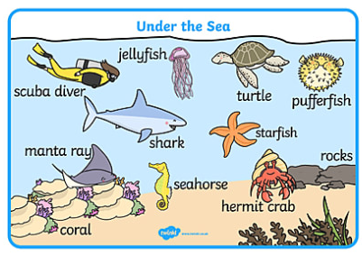

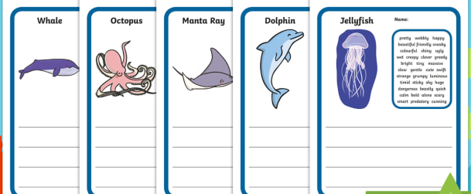

Maths
Number
Starter activities
- Count forwards and backwards to 1-10 – use this video link
https://www.bbc.co.uk/bitesize/topics/zhsspg8/articles/zfqcbdm
- Count forwards and backwards to 20 – use the link
https://www.bbc.co.uk/bitesize/topics/zhsspg8/articles/zm83f4j
- Write numbers 1-20 on pieces of paper. Place them face down on a table. Choose 1 and say the number.
- Chooose a number that is on a piece of paper, (between 1 – 20 say it and then do the number of jumps, claps or hops that is on the paper.
- Write numbers that an adults says to youbetween 1 – 20.
- Count in 2s - 2 times table- follow the link - https://www.bbc.co.uk/teach/supermovers/ks1-maths-the-2-times-table-with-bridget-the-lioness/zrrx92p

Main activities –
This week our maths focus is – halving

- Watch this video about halving
https://www.youtube.com/watch?v=eBWTP84lcUI&t=16s

- Watch this video which shows you what halving is and how to can do it practically - https://www.youtube.com/watch?v=FH0j4tUSrOg

- Read this halving numbers power point
https://www.twinkl.co.uk/resource/ui2-m-59-halving-numbers-powerpoint

Complete these tasks with an adult.
Practical tasks

- Get 2, 4,6, 8, 10, 12, 14, 16, 18 0r 20 objects such toys, coins, etc and place them into 2 equal groups by sharing them.
- How many objects are in each group?
- Does each groups have an equal amount of objects?

Written tasks -

- Complete this having ladybirds task – here is the link
https://content.twinkl.co.uk/resource/73/e4/t-c-254628-differentiated-halving-to-20-ladybird-activity-sheets.pdf?__token__=exp=1593775850~acl=%2Fresource%2F73%2Fe4%2Ft-c-254628-differentiated-halving-to-20-ladybird-activity-sheets.pdf%2A~hmac=292cc2f81b0e9d249c9575c1197d675b3f1f899c3c31960c2c830334610bc7ea

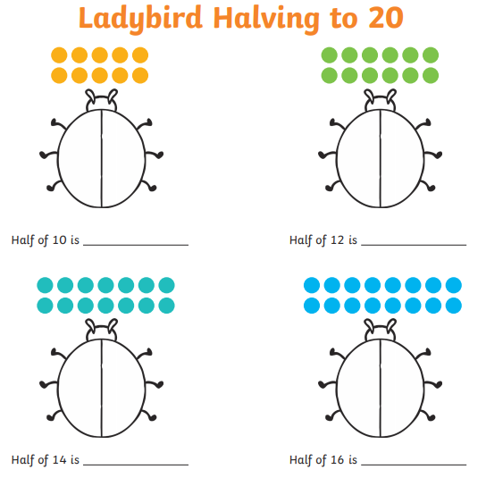

- Complete these having cut out tasks – follow the link
https://content.twinkl.co.uk/resource/4e/e0/t-n-7553-what-is-half-halving-activity-cutouts-english.pdf?__token__=exp=1593776011~acl=%2Fresource%2F4e%2Fe0%2Ft-n-7553-what-is-half-halving-activity-cutouts-english.pdf%2A~hmac=24e074e97e993bddf967c9403c2b497b89d87215f18f5597c536d56f5bef598d

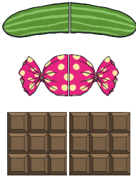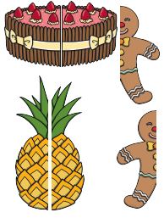
Complete these halving word problems.

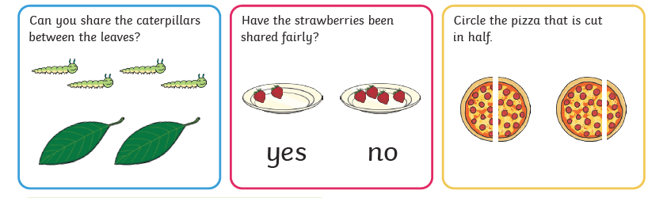
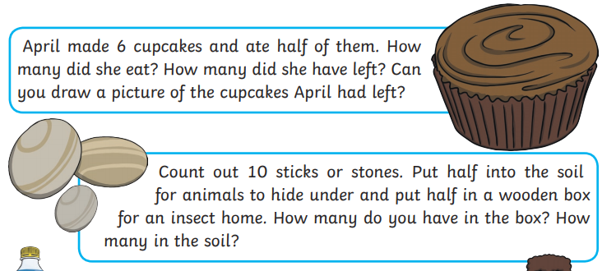

Shape, Space and Measure
This week our focus is – length

- Watch these videos about - follow the length
https://www.bbc.co.uk/bitesize/articles/zbwc92p

Activities
Complete these activities about – length

- Go outside and see who can jump the furthest from the same point.

- Collect objects that are different lengths and order 2 or 3 of them and say which is the longest and which is the shortest.

- Complete this activity –measuring length – follow the link
https://www.twinkl.co.uk/resource/eyfs-maths-mastery-home-learning-challenge-length-t-m-32029

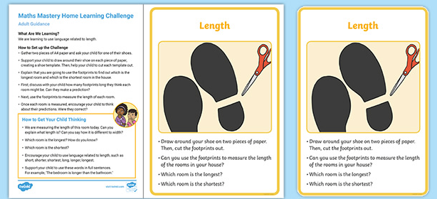

- Complete these word problems about length

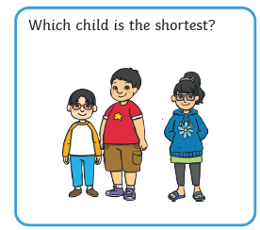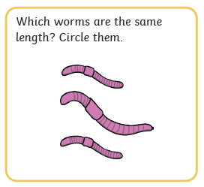

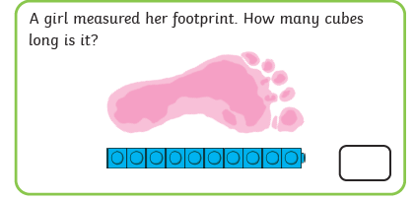

Topic
This week we are learning about under the sea and waterproof materials

- Watch this video clip to see lots of animals that live in the sea.- follow the link
https://www.youtube.com/watch?v=hXtrIy95V80
- Follow the link to play a game about what you can see and hear under the sea –
https://www.bbc.co.uk/teach/school-radio/listen-and-play-under-the-sea/zm6xwty

- Watch this video about waterproof materials
- https://www.youtube.com/watch?v=4nd42ISTOJI
- Activities
- Get a bowl of water and different objects that are made of different materials e.g. cotton, metal, denim, cotton wool, paper towel, etc and predict (guess) if you think it be waterproof or not. Get a jug with water in it and pour water onto it and observe if it lets water through it or not.
- Make a list of the items that are waterproof and not waterproof.

- Art / Craft
- Complete an under the sea plate.
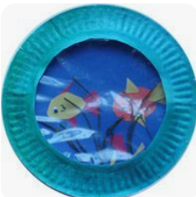
PSHE
This week we are learning about our talents

Talents are things that we are good at. Using the book Barry the Fish with Fingers talk to an adult and discuss the following things below.

- Puffy, the puffer fish, can blow the best bubbles. Think about your talents... what are you good at doing? What are your friends' talents?
- Look at the expressions on the faces of the characters in the story. How are they feeling? How do you know?
- Puffy gets upset when everyone wants to play with Barry. What could he do to make himself feel better? How could the other fish cheer him up?
- Puffy explains that he was a 'grumpy spoilsport'. What is a spoilsport?
Task
Draw a picture of yourself doing something that you are talented / good at.

PE: Please also try to enjoy some daily exercise (remember Joe Wicks is doing PE videos every morning!). There is also something called Jumpstart Jonny https://www.youtube.com/watch?v=-1Pz_R4aaDo

Also guided mediation and Cosmic Kids Yoga is a great way to have some quiet time.
https://www.youtube.com/watch?v=DWOHcGF1Tmc
https://www.youtube.com/watch?v=xlg052EKMtk

We miss you very much and hope to see you very soon!
Please share your home learning on our school Facebook page.
Miss Zahoor, Miss Wedgwood and Mrs Treasure.

