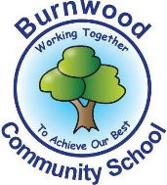
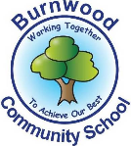
Year 6 Home Learning 20.04.2020
Theme: Ancient Greeks

Maths |  | English
White Rose Hub will be releasing daily learning to keep your brains engaged with maths. Check out their website below.  https://whiterosemaths.com/homelearning/year-6/ *If you feel that your child cannot access the work as it is too difficult, please feel free to have a look at the work for the week from other year groups on the White Rose website.  Times Tables Rockstars  Don’t forget to keep practicing your x table knowledge!  Addition  We have attached a sheet below for you to have a go at. |  | Using the picture can you complete the activities below:  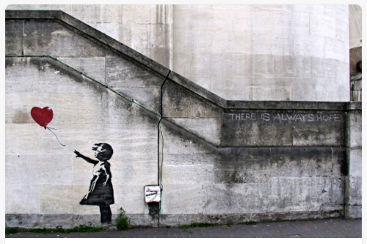  Task 1- Sick sentences!  These sentences are ‘sick’ and need help to get better. Can you help?  The balloon went up. She felt hopeful. Her hand pointed towards the balloon.  Task 2- Question time!  Why do you think the balloon is red, where the rest of the drawing is black and white?  How does this compare to other graffiti you have seen?  Do you think graffiti should be illegal?  Where do you think this photograph was taken?  Why do you think the artist created it?  Spelling Shed  Please use your logons and go onto spelling shed to complete the tasks (if you haven’t got your login use the spellings from the booklet you took home).
Science
Dr Chips puts on daily science, engineering and computing lessons along with a live YouTube video at 10am. Each day has a theme.
https://drchips.weebly.com/
Electricity
Choose a room in your house. Can you name all of the items that need electricity to work?
Electric circuits
Below is a revision sheet for electric circuits. Can you label the circuit?

Complete the sentences below
The electric current leave the _________ and passes through the _______. It then travels through the __________, next through the _________ and finally through the _______ before returning to the battery.

History | PE |  | Art
Our new topic for this term is Ancient Greece.  To start off we would like you to complete the comprehension attached.  This will give you a good understanding of the different areas we are going to cover. | Please also try to enjoy some daily exercise.  *Remember, Joe Wicks does a daily lesson on YouTube at 9am! |  | Have a go at designing an Ancient Greek Pot. You can use the outline given or have a go at drawing your own.  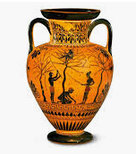  They were often orange with black decoration but you can colour it any way you like.
Music | Design and Technology |  | Geography
Check out the home learning page on the Burnwood website. Mrs Phillips has uploaded a new video and links to tutorials on YouTube. | In Ancient Greece, actors wore masks to show emotions.  Can you create your own mask?  Which emotion are you going to choose?  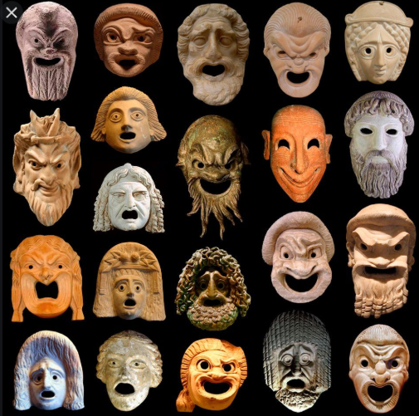 |  | Create a fact file about Greece.  This time you are going to create the questions.  What would you like to find out?  https://www.ducksters.com/geography/country/greece.php
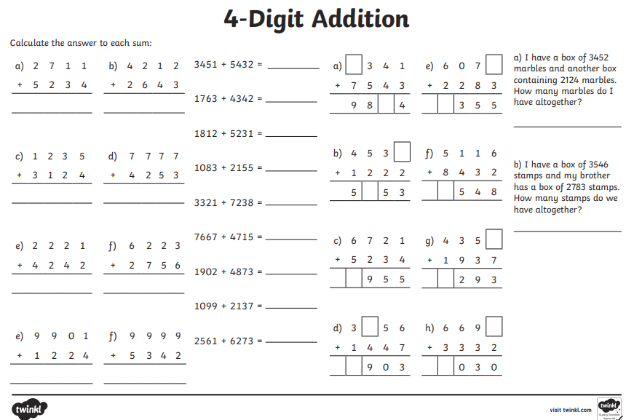
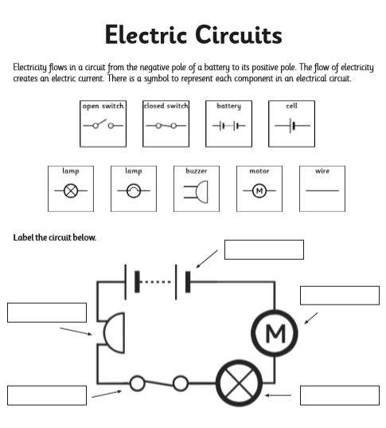
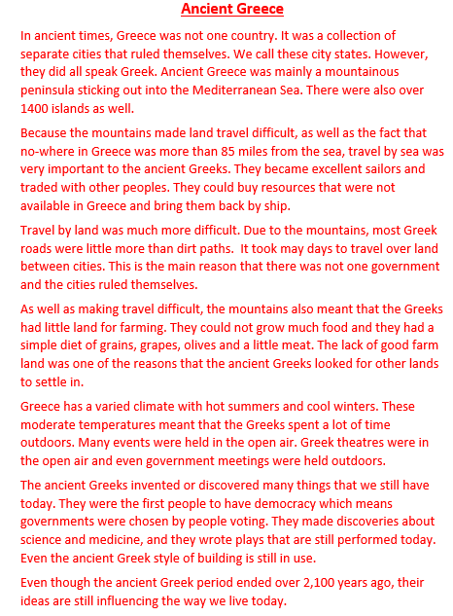
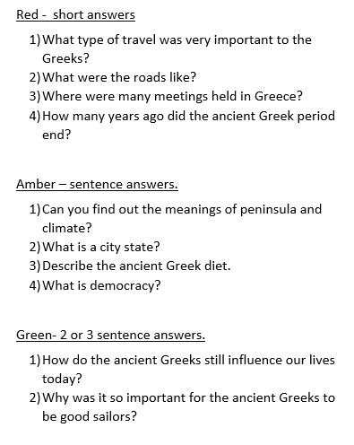
7


